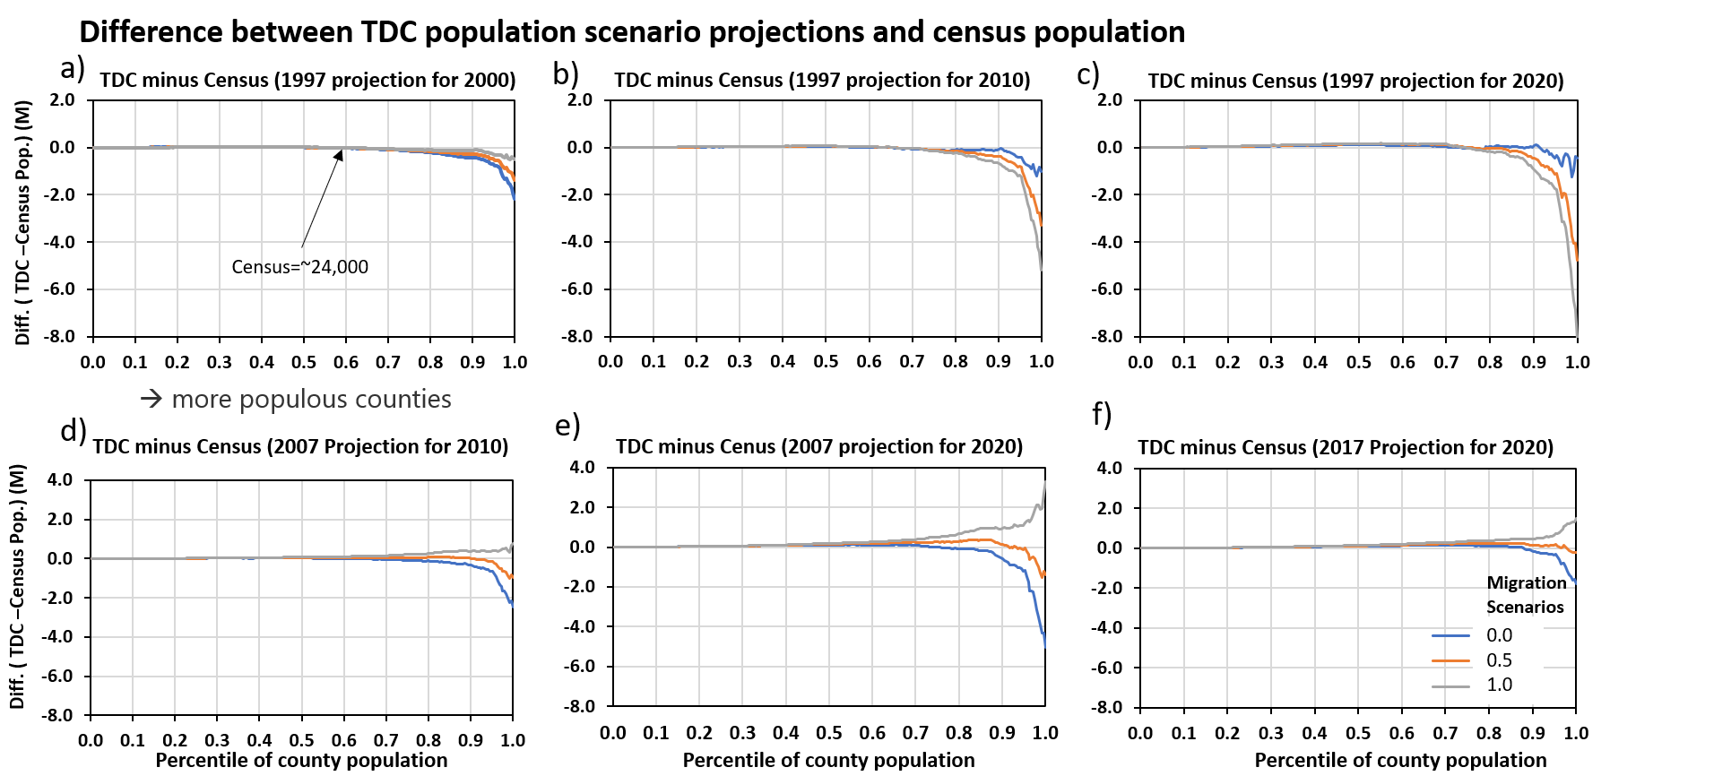
Figure S1: Difference between TDC population scenario projections and US census population

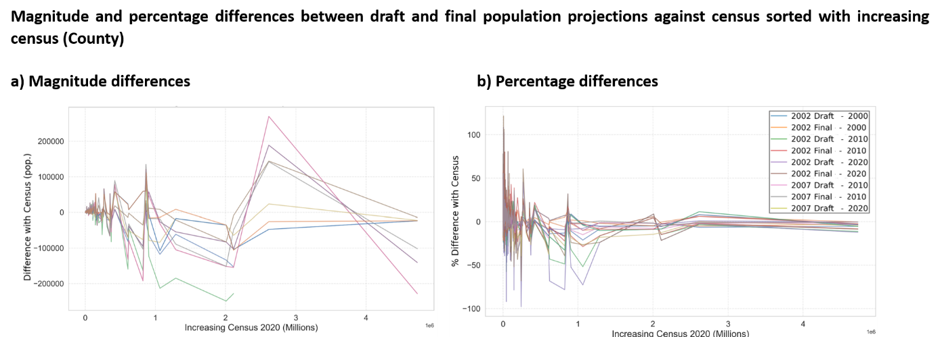
Figure S2: Magnitude and percentage differences between draft and final population projections against census sorted with increasing census (County)
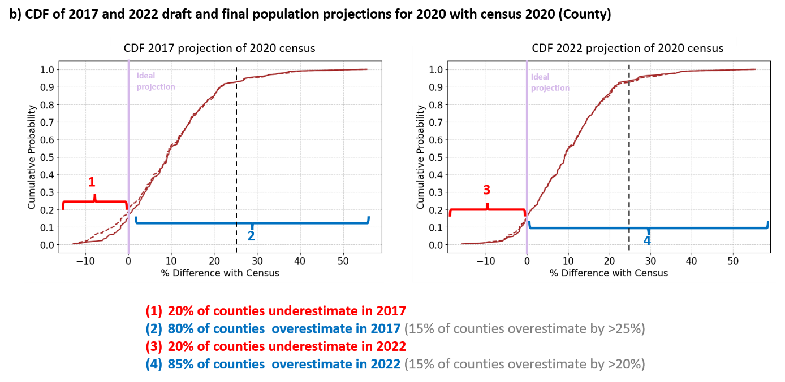
Figure S3: County level Cumulative Distribution Function (CDF) of magnitude and percentage differences between draft and final population projections against census zoomed to recent projections (2017 and 2022)
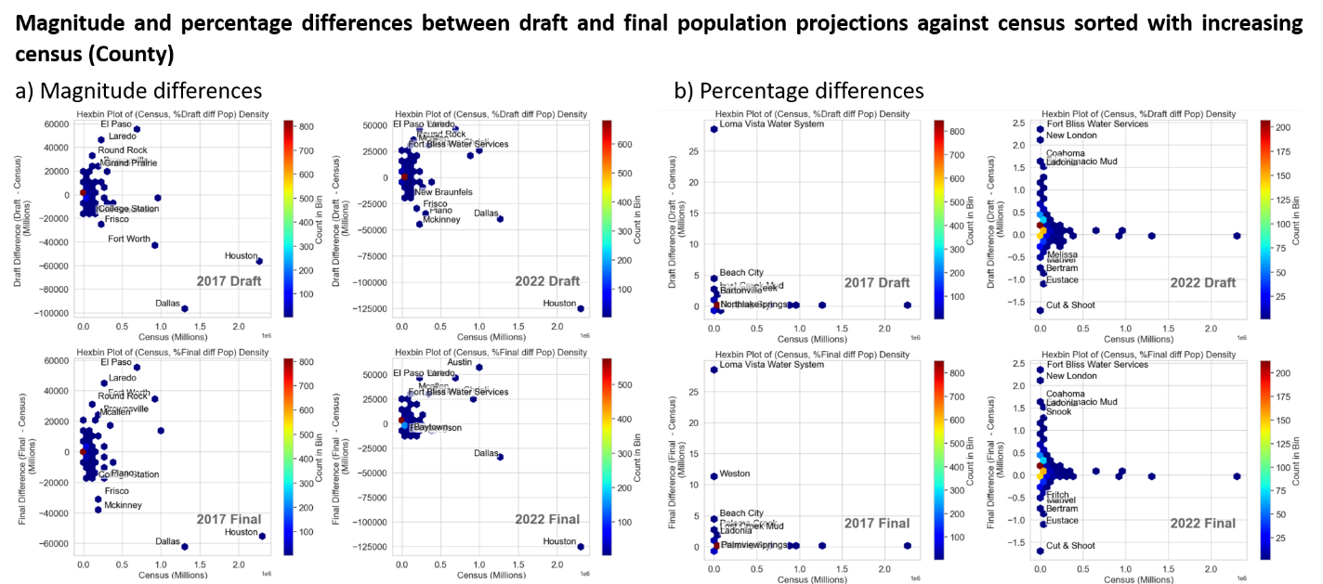
Figure S4: Magnitude and percentage differences between draft and final population projections against census sorted with increasing census (WUGs)
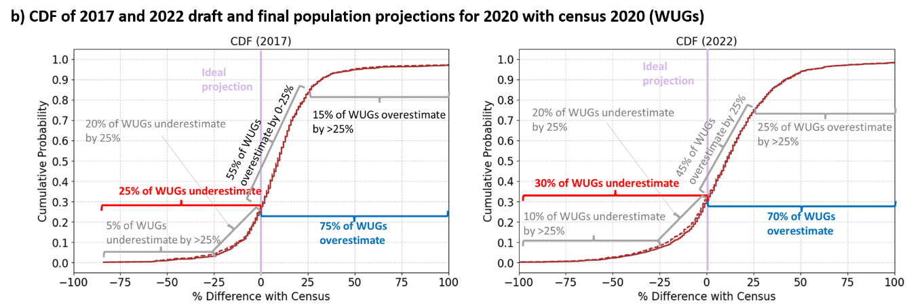
Figure S5: Difference between final (F) and draft (D) population projection and census at WUG level. a) comparison across all plans b) comparison between absolute differences c) comparison in recent plans (2017,2022)
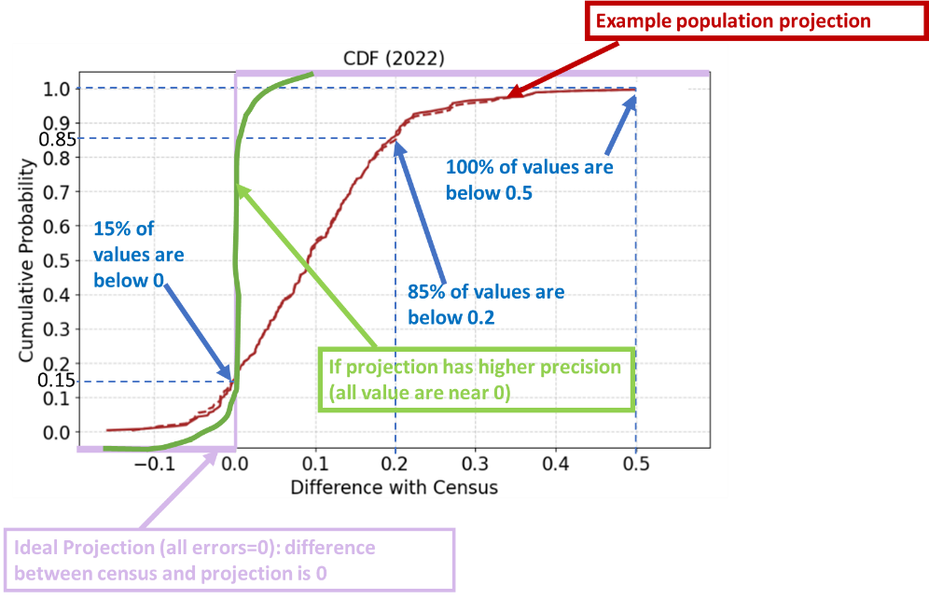
Figure S6: CDF Interpretation example using random population data
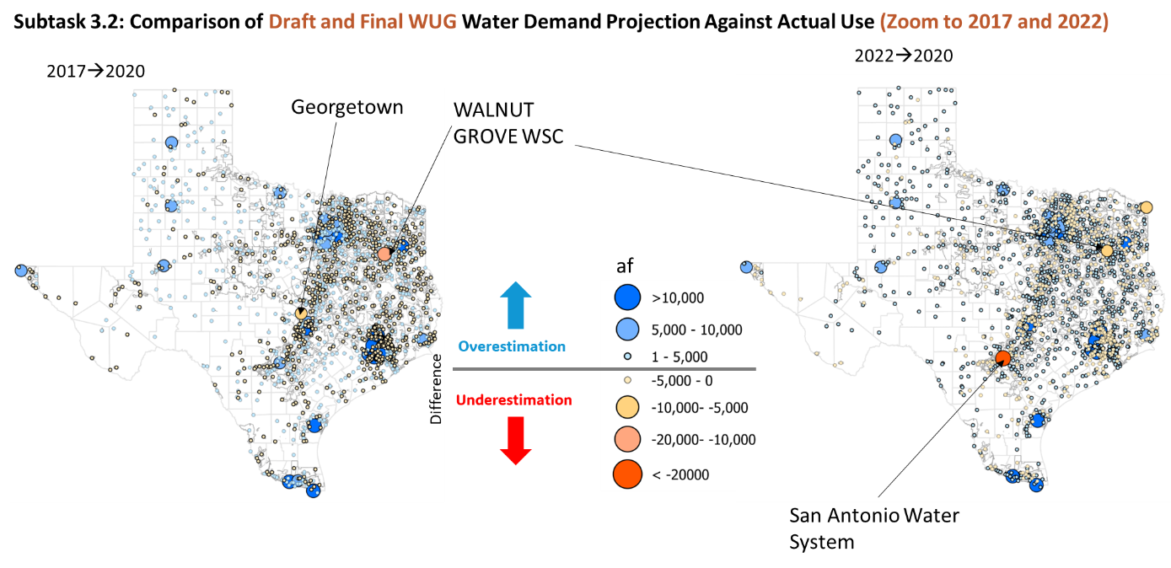
Figure S7: Comparison of percentage differences Final WUG Water use Projection against a) Actual b) 2011 use c) maximum use 2000, 2010, and 2020 d) magnitude differences in recent plans (2017,2022) against actual use

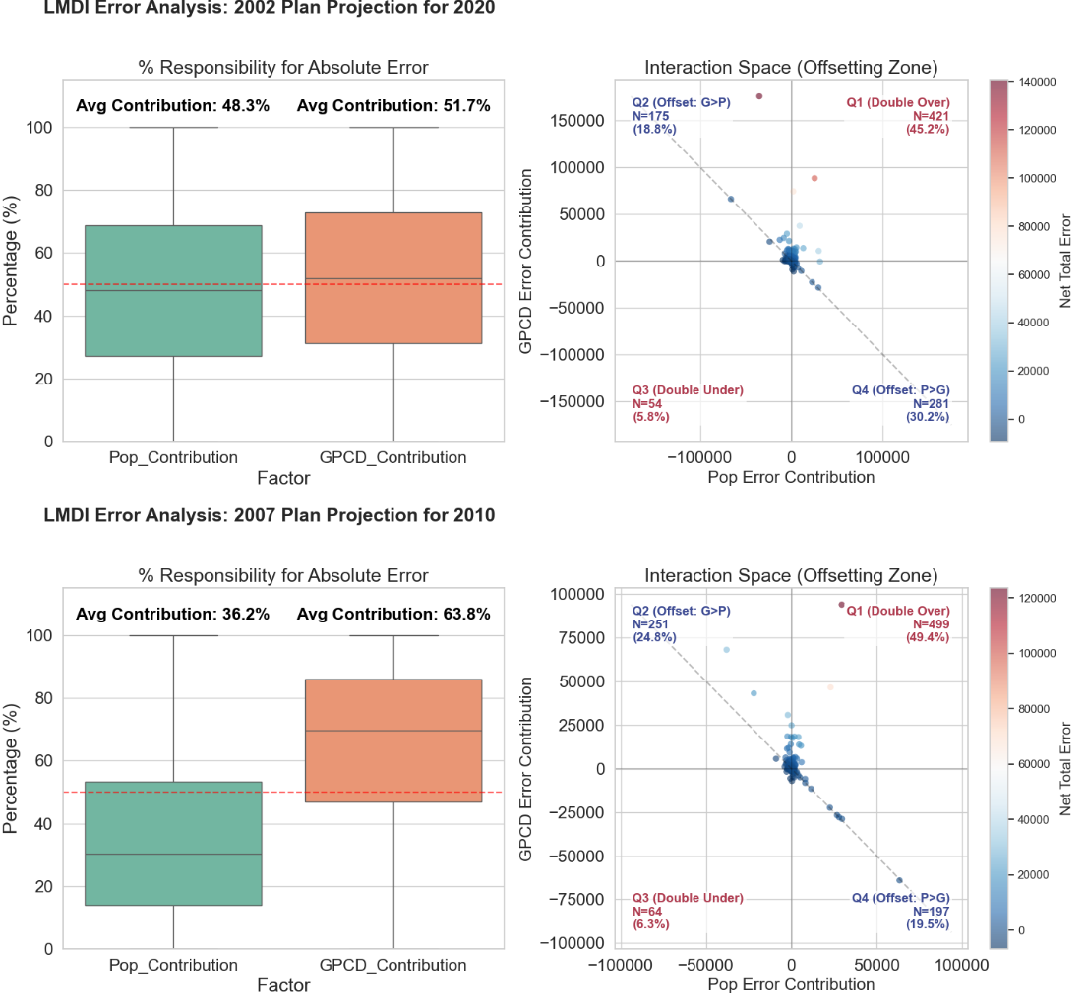
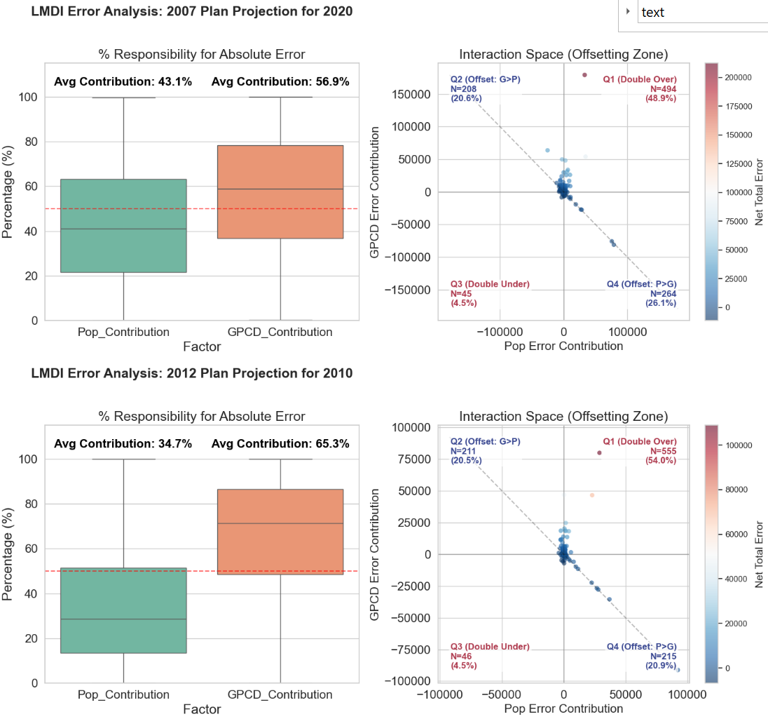
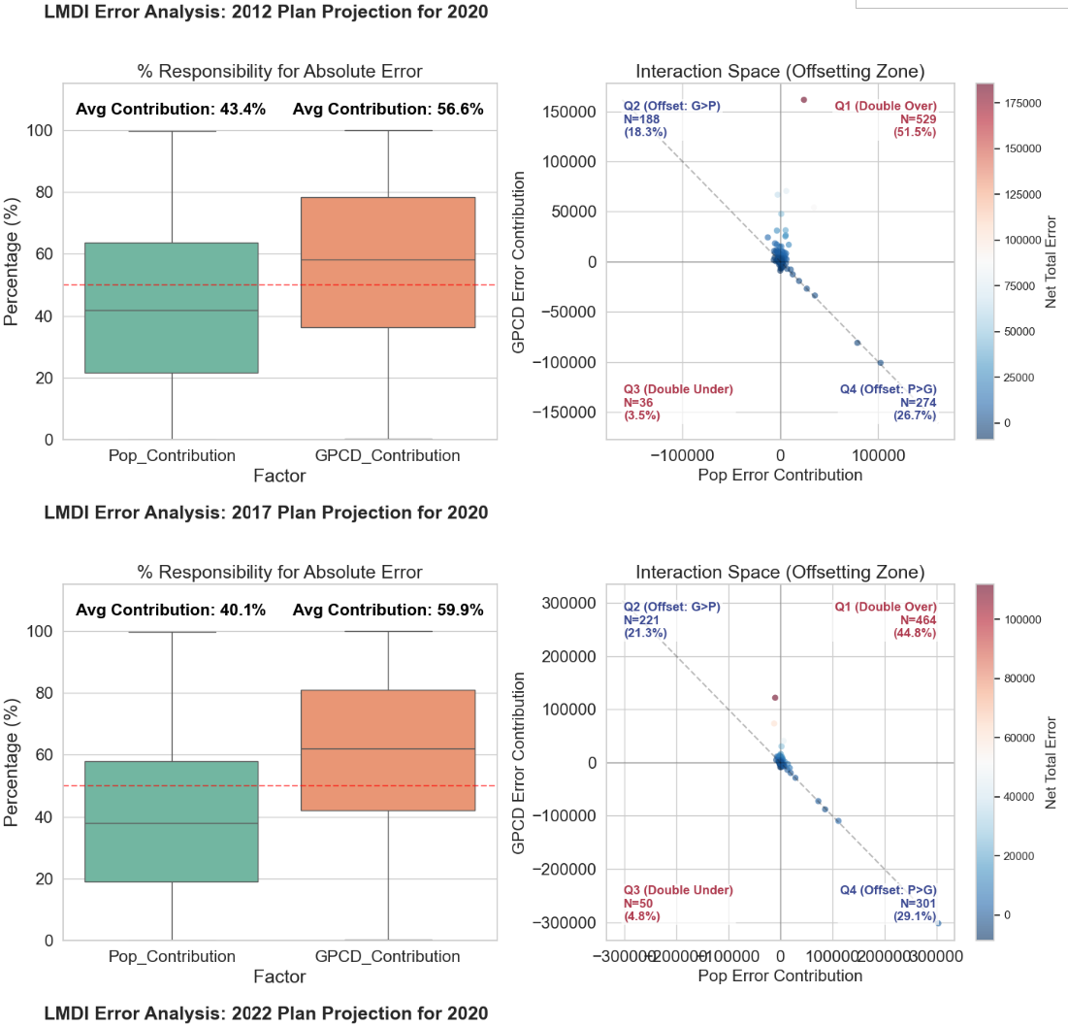
Figure S8: Population and Gallons Per Capita per Day (GPCD) error attribution: Logarithmic Mean Divisia Index (LMDI) Decomposition Analysis 2002-2017

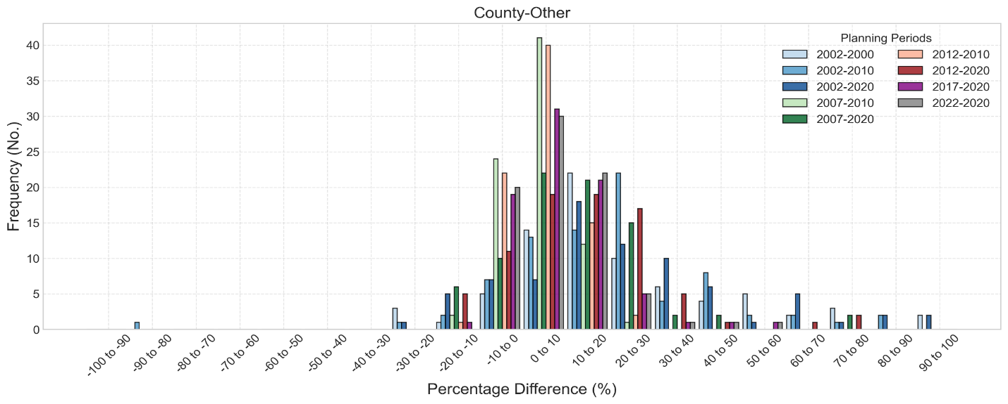
Figure S9: Histogram of percent difference between County Other WUGs projection comapred to census

a)
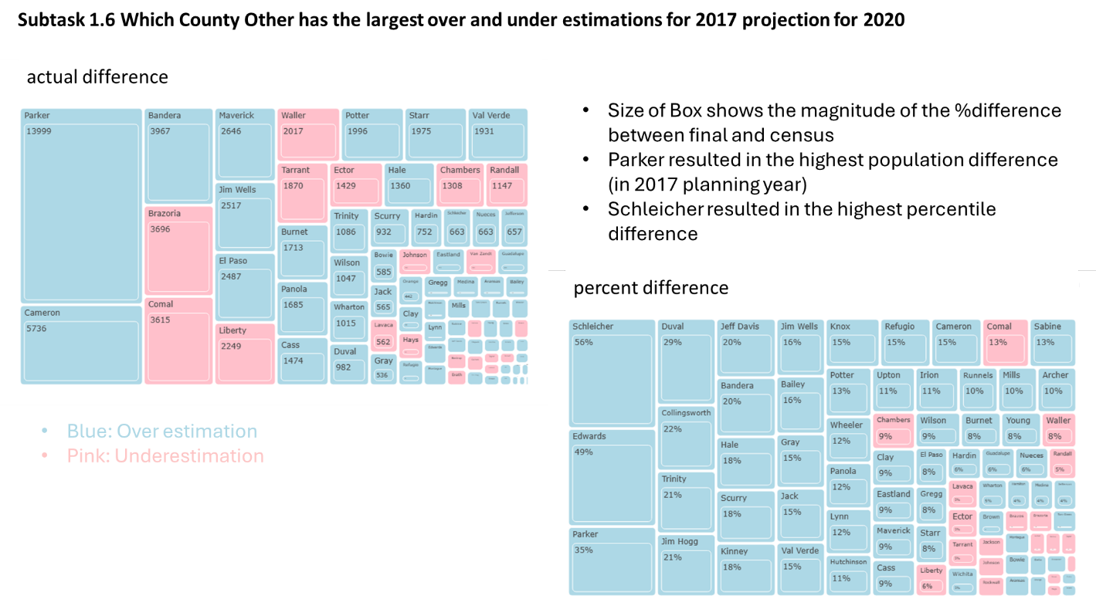
b)
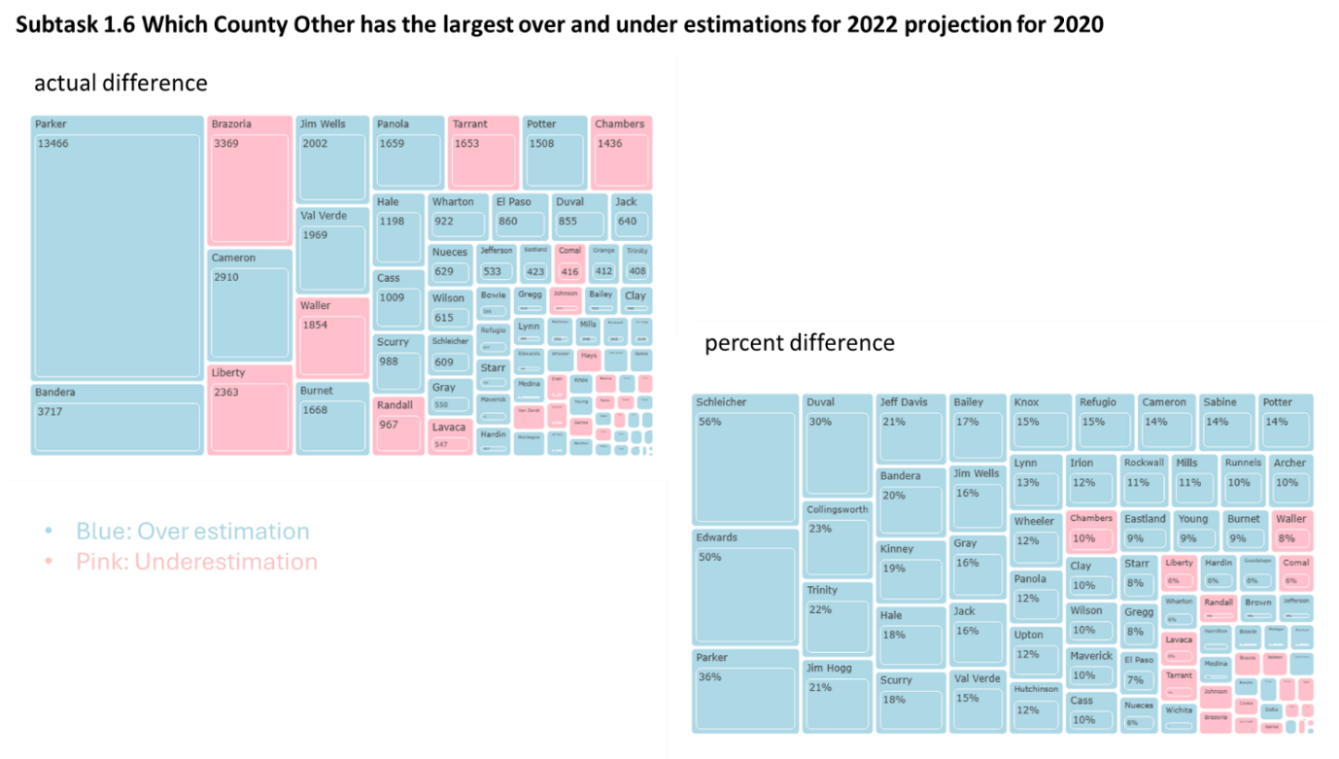
Figure S10: Difference between SWP Population projections against census in County Other WUGs for 2017 and 2022 plan

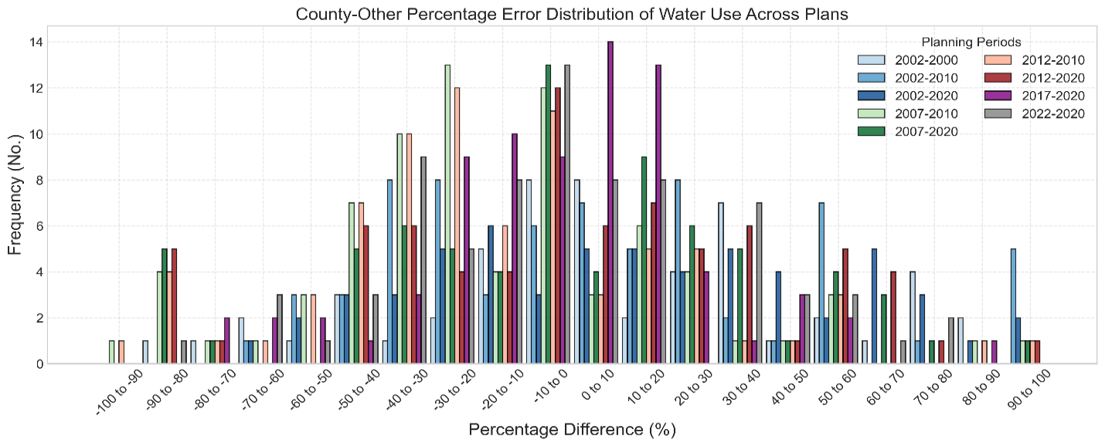
Figure S11: Histogram of percent difference between County Other WUGs projection comapred to census County Other WUGs Population and Water use Comparision Analysis

a)
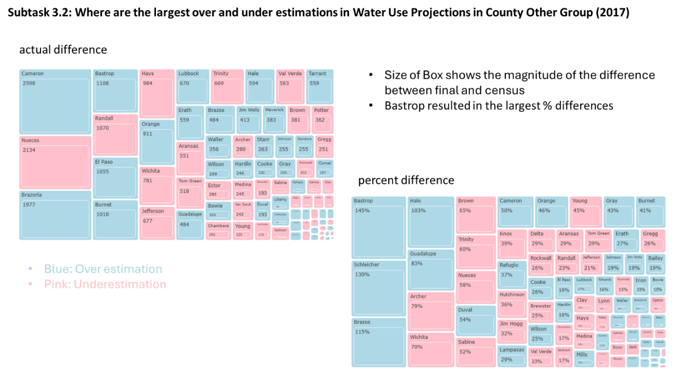
b)
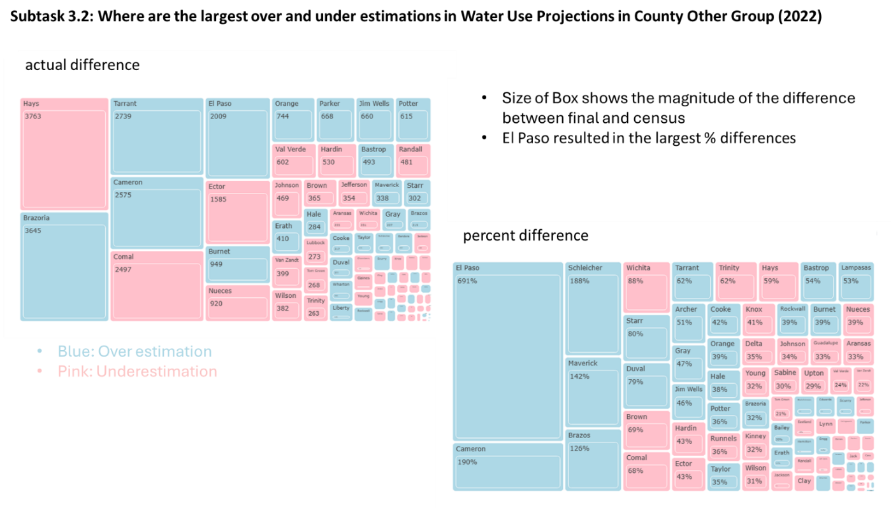
Figure S12: Difference between SWP water demand projections against actual water use in County Other WUGs for 2017 and 2022 plan

Supplementary Text:
Some census values were inconsistent with water-use values, and the totals did not align (for example some city IDs are associated with multiple names, e.g. ID 530). Nevertheless, for trend analysis, all duplicate entries and corresponding outlier values were removed. The duplicates consistently aligned with extreme values, so eliminating both ensured more reliable data.

