Response of Oxbow Lake Biota to Hydrologic Exchanges

with the Brazos River Channel

Final Project Report
(2003-483-493, 2003-483-006)

Submitted to
Texas Water Development Board

By
Texas Agricultural Experiment Station & Texas State University

Dr. Kirk O. Winemiller (TAES),
Dr. Frances P. Gelwick (TAES),
Dr. Timothy Bonner (TSU),
Steven Zeug (TAES),
Casey Williams (TSU)

15 December, 2004

Dr. Kirk O. Winemiller, Dept. of Wildlife and Fisheries Sciences, Texas A&M University, College Station, TX 77843-2258 (k-winemiller@tamu.edu)

Dr. Frances P. Gelwick, Dept. of Wildlife and Fisheries Sciences, Texas A&M University, College Station, TX 77843-2258 (fgelwick@tamu.edu)

Dr. Timothy H. Bonner, Dept. of Biology, Southwest Texas State University, 206 Freeman Building, San Marcos, TX 78666 (tbonner@swts.edu)

Abstract

Fishes and aquatic habitat variables were sampled between June 2003 and September 2004 to obtain information on the ecological dynamics associated with river channel–oxbow lake connectivity in relation to instream flows. The ecological study complemented a concurrent research effort undertaken by the Texas Water Development Board to document geomorphological and hydrological features that determine degrees of oxbow to channel connectivity. The ecological study also examined fish population structure and dynamics at two river channel sites in the lower Brazos River upstream and downstream of the site selected for the Allen’s Creek reservoir. Standardized fish samples were collected using seines and gillnets, with data analyzed separately as catch per unit effort. Statistical ordination techniques revealed a strong gradient of fish assemblage structure that contrasted oxbow samples from river channel samples. A secondary gradient was associated with seasonal variation in oxbow lakes. In contrast to the river channel, oxbow lakes contained high densities of white crappie (Pomoxis annularis), sunfishes (Lepomis spp.), and shads (Dorossoma spp.). A number of minnow species (e.g., Hybognathus nuchalis, Macrhybopsis hyostoma) appear to be fluvial specialists that always or almost always were collected from the river channel. Several of these fluvial specialists were more abundant one to two months after periods of peak flow. For species common in oxbow lakes, density tended to decline following periods of peak flow, which indicates a net export of individuals from oxbows to the river channel during floods that connect these habitats. Consistent with this view were patterns of higher densities of these species in the river channel following periods of peak flow. Fluvial specialists appeared in oxbow lakes in low to moderate numbers during periods of peak flow, but these sub-populations generally did not persist more than a month or two. Densities of phytoplankton, zooplankton, and fish were much higher in oxbow lakes than in the river channel, and more so following prolonged periods of isolation. Oxbow lakes that were formed more recently and that are located closer to the river channel had lower “control points” in the natural levee, and as a result flooded at lower discharge levels. It is concluded that oxbow lakes of variable ages and geomorphological structures provide essential habitats that function to increase overall fish species diversity in the lower Brazos River.

Introduction

The importance of natural flow regimes for the maintenance of ecological processes in lotic systems is well recognized (Sparks 1995; Poff and Allan 1995; Poff et al 1997; Bunn and Arthington 2002; Bowen et al. 2003), and conceptual models of biological productivity in large rivers, such as The Flood Pulse Concept (Junk et al. 1989) and The Low Flow Recruitment Hypothesis (Humphries et al. 1999), suggest that flood dynamics significantly influence interannual variation in fish recruitment. Periodic inundation provides opportunities for aquatic organisms to move into off-channel floodplain habitats, such as oxbow lakes, sloughs, and marshes that appear to be more favorable for growth and reproduction of some species (Swales et al. 1999; Winemiller et al. 2000; Sommer et al. 2001; Sommer et al. 2004) and that may be major sources of fish production in these systems (Welcomme 1979).

In North America, most floodplain rivers have been impacted by the construction of dams and levees that modify natural flow regimes crucial for fish reproduction (Junk et al. 1989; Humphries et al. 2002) and disconnect productive off-channel habitats from the active river channel (Bayley 1991). Modification of natural flow regimes has been implicated in the establishment of exotic species (Moyle and Light 1996) and changes in fish distribution, abundance, and assemblage structure (Feyrer & Healy 2003; Sommer et al 2004). Restoration strategies for these systems include reestablishment of relatively natural flow regimes (Trexler 1995; Richter 1997) and increased connectivity with off-channel aquatic habitats (Amoros and Bornette 2002; Tockner and Stanford 2002). The primary method used by resource agencies to meet these goals is estimation of instream flows necessary to maintain ecosystem integrity (Instream flow council 2002).

Various methods of instream flow assessment focus on minimum flow, flow variability or habitat availability and may produce conflicting assessments depending on the method used (Jowett 1997). While the measurement of physical and hydrologic variables have improved with new technologies (Gard and Ballard 2003), there remains a lack of ecological data relevant to instream flow allocation in most river systems (Naiman 1995; Sparks 1995). Species inhabiting river-floodplain systems possess a wide range of life history strategies that allow them to take advantage of the spatial heterogeneity and flow variability of these systems (Winemiller 1996), and fish assemblage structure is strongly influenced by the physicochemical characteristics of habitats that result from succesional processes and fluvial dynamics. Schemes that focus on indicator species may create optimal conditions for one species while degrading conditions for species that depend on alternate conditions (Sparks 1995).

This report provides findings from a research project that examined responses of fish assemblages and individual species to hydrologic variability in channel and floodplain habitats of the lower Brazos River. The project was funded by the Texas Water Development Board in consultation with the Texas Commission for Environmental Quality and the Texas Parks and Wildlife Department. The project was designed to supplement existing environmental information (Winemiller et al. 2000; Gelwick & Li 2002), particularly with regard to ecological responses to instream flow variation, and was motivated by pending water development plans in the lower Brazos River Basin. Our goals were to identify fish taxa that may benefit from, or otherwise respond to, floodplain connectivity, to explore how fish biodiversity (species assemblages) in oxbow lakes with variable connection frequencies are influenced by periodic flood events, and to document fish assemblages in the main channel, with emphasis on flow-sensitive species.

Methods

Oxbow lakes and Brazos River at highway 21(reference site)

The main stem of the Brazos River originates in Stonewall County, Texas at the confluence of the Salt Fork and Double Mountain Fork. The river flows southeast for 1485 kilometers before entering the Gulf of Mexico 2 kilometers south of Freeport, Texas. The present study was conducted on the middle and lower Brazos River between Bryan, Texas and Lake Jackson, Texas. In this region the Brazos is a meandering lowland river with forest and agricultural lands dominating the catchment. The Brazos is partially regulated by dams in and above the city of Waco, Texas however discharge is primarily influenced by local runoff and current flow dynamics are relatively similar to those prior to river regulation (Figure 1). Oxbow lakes are common on the floodplain of the middle Brazos with over forty identified in aerial surveys by Winemiller et al. (2000).

In this study, six oxbow lakes and three sites in the Brazos River channel were surveyed between June 2003 and September 2004. Two oxbows (Big Bend Oxbow, Moehlman Slough) and the Brazos River at the State Highway 21 Bridge were surveyed monthly. Hog Island Oxbow was surveyed quarterly. Perry Lake, Cut Off Lake, Korthauer Bottom, and the Brazos River at the Interstate Highway 10 and Highway 521 bridges were surveyed once during summer 2003 (Figure 2). For a complete description of oxbow locations and physical characteristics see hydrology section.

High flows in the Brazos River prevented gillnetting at the Highway 21 site during February and April 2004, and no sample was collected from this location in June 2004 due to flooding. Gillnets were not deployed at Cut Off Lake due to high densities of submerged and emergent vegetation. An equipment malfunction prevented zooplankton collections at Big Bend Oxbow, Moehlman Slough and the Brazos River at I-10 and Highway 21 during June 2003.
Figure 1. Mean monthly stream flow in the Brazos River at the State Highway 21 over-crossing for all years prior to river regulation, and for the last 20 years of record.

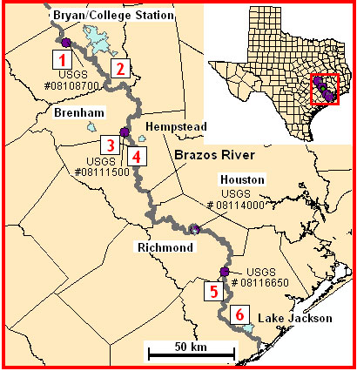
Figure 2. Map depicting the location of oxbow lakes in the study region, 1 = Moehlman Slough, 2 = Big Bend Oxbow, 3 = Korthauer Bottom, 4 = Perry Lake, 5 = Hog Island Oxbow and 6 = Cut Off Lake.
Map created by Tim Osting TWDB.

A suite of physico-chemical parameters were measured during each survey. Temperature (⁰C), dissolved oxygen concentration (mg/L), and conductivity (μs) were measured using a YSI model 85, and pH was measured with an electronic handheld meter. Maximum water depth was determined by conducting a series of measurements with a weighted tape measure along the length of the oxbow. Transparency was measured using a limnological Secchi disk 20 cm in diameter. Flow data for the Brazos River was obtained from USGS gauge 08108700 at the Texas State Highway 21 Bridge. Estimates of Brazos River flow needed to connect oxbow habitats with the active channel were provided by the Texas Water Development Board. Zooplankton was sampled using a 10-liter Schindler trap, fixed in a 5% formalin solution, and identified to the lowest feasible taxonomic level. Densities were determined from two 1ml sub-samples using a Sedgwick-Rafter counting cell. For estimation of water-column chlorophyll a concentration, 100 ml of flowing water was filtered through a membrane filter (0.45 um pore size) and stored on ice. Samples were frozen upon returning to the laboratory. Chlorophyll a was extracted 90% alkaline acetone solution and quantified flourometrically according to methods described by Wetzel and Likens (1991).

Small fish were sampled using a 10-m by 2-m bag seine with 0.64-cm mesh in the wings and 0.32-cm mesh in the bag. Seines were conducted perpendicular to shore at unique locations within the habitat until no new species were collected. The distance traveled by each seine haul was estimated for catch-per-unit effort calculations [species number or biomass per meter seined(50 red shiner/ 60 m seine haul = 0.83 red shiner/m)]. Two multifilament experimental gillnets were deployed at each location to sample large-bodied fishes. Each gillnet consisted of three 16.5 m by 2 m panels with 2.54-, 5.1-, and 7.6 cm bar mesh. Gillnets were deployed between 1600 h and 0800 h the next day at sites that were surveyed monthly. At all other sites, gillnets were set between 1300 h and 1700 h. The time of each gillnet set was recorded for catch-per-unit effort calculations (species number or biomass per hour). All fishes collected were euthanized by emersion in MS-222. Small fishes were fixed in 10% formalin and transferred to 70% ethanol for storage. Large fishes were transported to the lab on ice and stored frozen for later analysis. Each individual was counted and weighed to the nearest 0.1 gram.

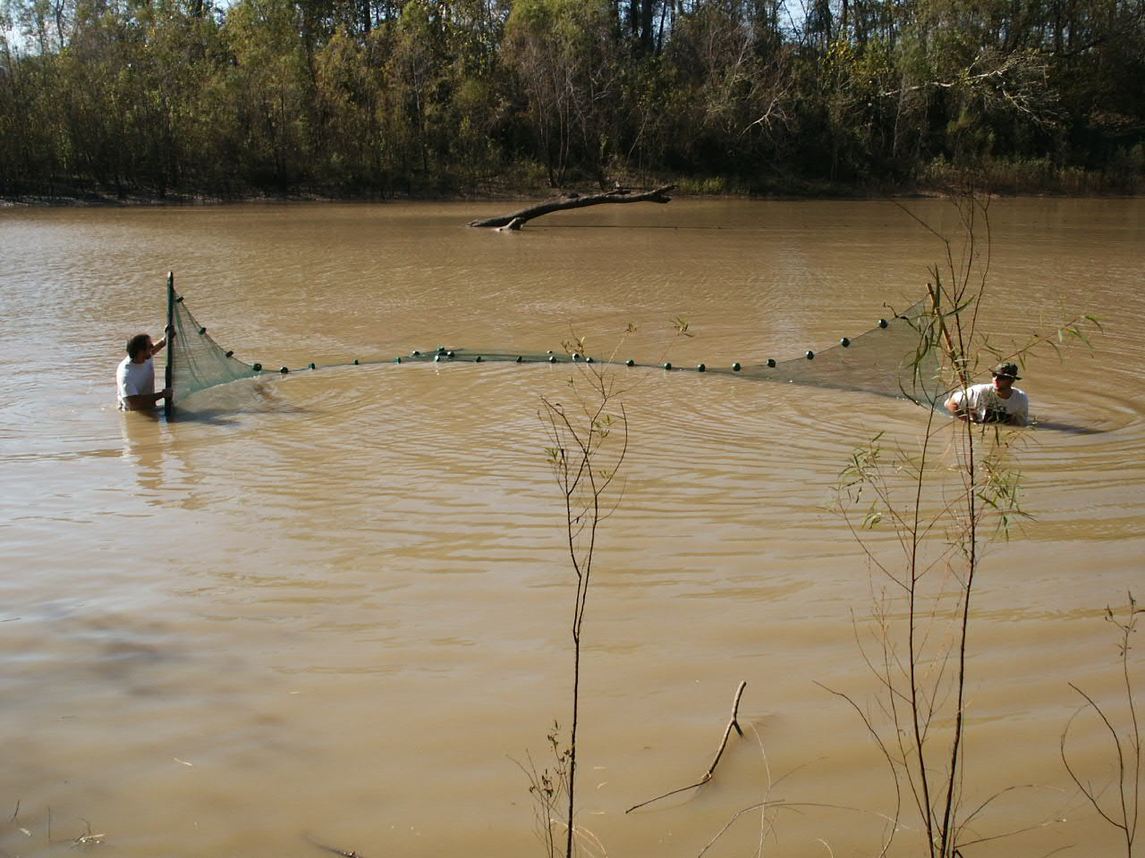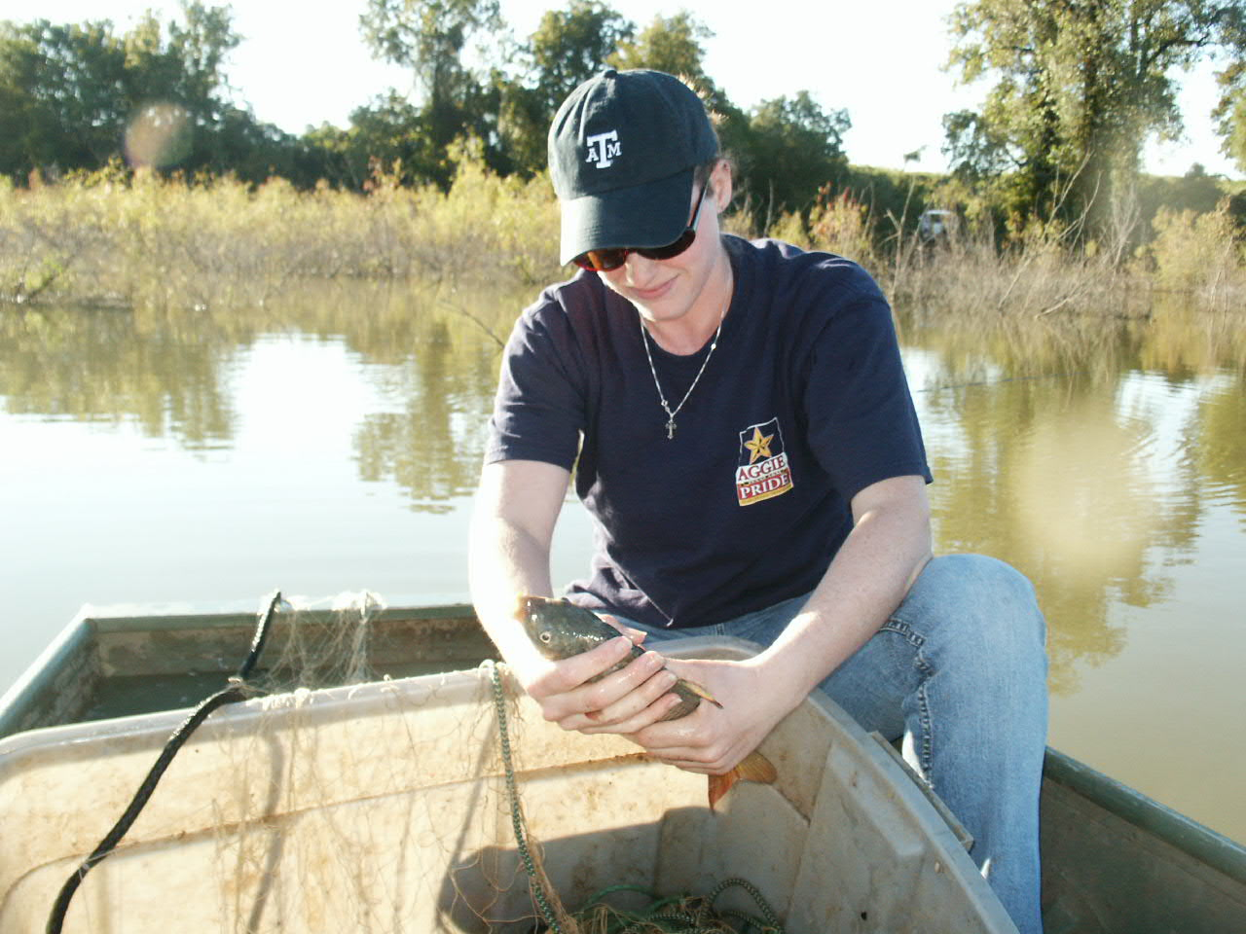
Figure 3. Seines and gillnets were the primary methods used to collect fishes from oxbow and channel habitats.

Data Analysis

For each survey, diversity calculations were performed on seine and gillnet numerical CPUE values using the reciprocal of Simpson’s Index

N₂ = 1/Σ p_{i}²

where p_{i} is the proportion of species numerical CPUE in each sample. Species richness was estimated as the number of species collected in each seine or gillnet sample.

Principle components analysis (PCA) was used to explore variation in physicochemical characteristics among sites and seasons. Canonical correspondence analysis (CCA) was performed on the seine numerical CPUE-by-site matrix to explore species-environment relationships. CCA is a direct gradient technique that ordinates species and sample scores along gradients of environmental variation. Correspondence analysis (CA) was used to examine variation in species numerical CPUE among all sites. CA is an indirect gradient technique that ordinates species and sample scores based on turnover of species relative abundance without the influence of environmental variables. Detrended correspondence analysis was performed on the gill net numerical CPUE-by-site matrix due to an arch effect in the CA ordination.

For all multivariate analyses, species were excluded if they were collected on three or less occasions. Samples collected during June 2003 were excluded from CCA and PCA due to the lack of zooplankton data. Perry Lake, Cut Off Lake, and the Brazos River at the Highway 521 bridge were excluded from CCA and CA analyses. Landowner interviews indicated that the two oxbow lakes dried out in the late 1990’s and had not connected with the active channel prior to sampling. The fish assemblage at the Highway 521 site was dominated by estuarine associated species as a result of low flows in the Brazos River that allowed a salt wedge to penetrate to the highway 521 site (salinity = 4.0 ppt).

To examine the response of fish species to hydrologic variability in each habitat, cross correlation analysis was performed (Box et al. 1994). This technique examines the correlation between two variables (R_{x},_{y(k)}) where x is lagged by k observations. Species CPUE values from seine collections were standardized by log transformation (log₁₀ CPUE + 1) to a monthly mean of 0 and unit standard deviation. Monthly mean flow and monthly peak discharge were similarly transformed for the length of the study period. Cross correlations were performed with time lags of 0, 1, and 2 months and statistical significance was assessed at α = 0.10.

Brazos River- lower channel sites
Two sites were sampled on the lower Brazos River each month from November 2003 through August 2004 (excluding June 2004 because of high flow conditions). The upper site was located upstream from Hwy 290 crossing (Washington County) west of Hempstead, Texas. The lower site was located upstream from FM 1462 crossing (Brazoria County) west of Rosharon, Texas. Sites were selected to include a sampling location upstream and a sampling location downstream from the pending Allen’s Creek Reservoir.

Fishes were collected with three, 30 to 40-m seine hauls and two, overnight gillnet sets. At each site, two wadeable, point sand-bar habitats and one protected eddy habitat were sampled with a 2 x 30 m bag seine (wing mesh size= 7 mm; bag mesh size= 3 mm). Point sand bars were sampled near shore (shallow seine haul) and in higher current velocity (deep seine haul). Protected eddy habitats were typically downstream of the point sandbars in deep water with sluggish current velocity. Fishes captured in each seine haul were anesthetized with MS-222 and fixed with 10% formalin. Percent substrate type (i.e., sand, silt, gravel) was estimated for each seine haul. Current velocity (m/s) and depth (m) were measured at four points across one transect. In the laboratory, fish were identified to species; total lengths (TL) of 30, randomly-selected individuals of each species were measured to construct length-frequency histograms. Two gill nets (identical to those used to survey oxbows) were set overnight in areas of sluggish flow and deep water. Captured fish were measured (TL) and released.

At each site, three macroinvertebrate samples were taken from sand and silt substrates with a Hess Sampler (area = 0.086 m²) and a 3-minunte sediment stir. Smaller invertebrates were collected with a plankton tow net (12-cm diameter) pulled for 10 m. Contents acquired from the Hess Sampler and tow nets were preserved in 70% ethanol. Macroinvertebrates and zooplankton were sorted and identified to the lowest practical taxon. For chlorophyll a, 100 ml of flowing water was filtered through a membrane filter (0.45 um pore size) and stored on ice. Samples were frozen upon returning to the laboratory. Chlorophyll a was extracted 90% alkaline acetone solution and quantified according to methods described by Wetzel and Likens (1991).

Mean daily discharge and peak discharge were obtained from USGS Station Gauging stations #08111500 (Hwy 290 crossing) and #08116650 (FM1642 crossing). From September 1, 2003 through August 31, 2004, mean daily discharge between to the two gauging stations were strongly correlated (r = 0.88) so only discharge data from Gauging Station #08116650 (FM1642 crossing) was used for correlation analyses between discharge and fish density in this study. Likewise, mean daily discharge and peak discharge from Gauging Station #08116650 (FM1642 crossing) were strongly correlated (r = 0.98) so peak discharge was selected for correlation analyses. Seasonal trends in mean daily discharge during our collections were similar to long-term trends; discharge is elevated from January through June (Figure 4). However, high flows extended into July during our study.

Densities (numerical catch-per-effort; C/E), relative abundances (% numerical), taxa richness (S), diversity (N₂), evenness, similarities and turnover of fish capture with seines were calculated for each site and month. Density was calculated as the number of fish captured per length of seine haul. The reciprocal of Simpson’s Index used to calculate diversity, and Gibson’s E (E = e^{H}/S) was used to calculate evenness. Renkonen similarity indices (RSI) were used to calculate similarities between sites and turnover within each site. Density and taxa richness were correlated (Pearson correlation coefficient) with monthly peak discharge directly and with a one-month lag time (e.g., November peak discharge x December fish density) and two-month lag time (e.g., November peak discharge x fish density in January). Species associations with habitat parameters were assessed with canonical correspondence analysis (CCA). Rare species (N < 18) were excluded from the analyses. Habitat parameters were mean current velocity (per seine haul), mean depth, and percent substrate type (e.g., silt, sand, and gravel).

CMS
Figure 4. Hydrograph representing daily stream discharge for the lower Brazos River (Hwy 1462 crossing) from September 1, 2003 through August 31, 2004. The symbol (+) represents mean monthly discharge from 1967 through 2004. The symbol (•) represents sampling dates.

Results

Oxbow lakes and Brazos River at highway 21

Habitat

Principle components analysis yielded two axes that modeled 81% of the variation in physicochemical characteristics among sites and sample periods. Axis 1 explained 70% of the variation and differentiated the river channel that had greater depth and conductivity from oxbow lakes that had greater zooplankton densities and chlorophyll concentrations. Axis 2 explained 11% of the variation and described a weak seasonal gradient at all sites where positive scores corresponding to summer and fall samples were correlated with greater conductivity and chlorophyll concentrations (Figure 5). Perry Lake and Cut Off Lake had scores similar to those of Big Bend whereas Korthauer Bottom was more similar to Moehlman Slough and Hog Island (Figure 5). The Brazos River at 521 had a score on axis 1 similar to the highway 21 site but was high on axis 2 due to greater conductivity.

Figure 5. Plot of sample scores from Principle Components Analysis of oxbow and channel habitat characteristics.

Among sites surveyed monthly, oxbow lakes were more similar to each other than the river channel. The Brazos River possessed greater mean values for depth, conductivity, Secchi depth and dissolved oxygen concentration (Table 1). Oxbows had greater mean values for temperature, chlorophyll a concentration and densities of all zooplankton taxa (Table 1). Among oxbows, Big Bend was shallower, more turbid, and possessed greater densities of zooplankton. Moehlman Slough had greater chlorophyll a concentrations, dissolved oxygen and temperature (Table 1). Hog Island Oxbow and Korthauer Bottom possessed characteristics similar to Big Bend and Moehlman Slough whereas Perry Lake and Cut Off Lake possessed some characteristics more similar to each other than other oxbows. Perry Lake and Cut Off Lake were both relatively clear and contained higher densities of submerged and emergent vegetation (Figure 6).

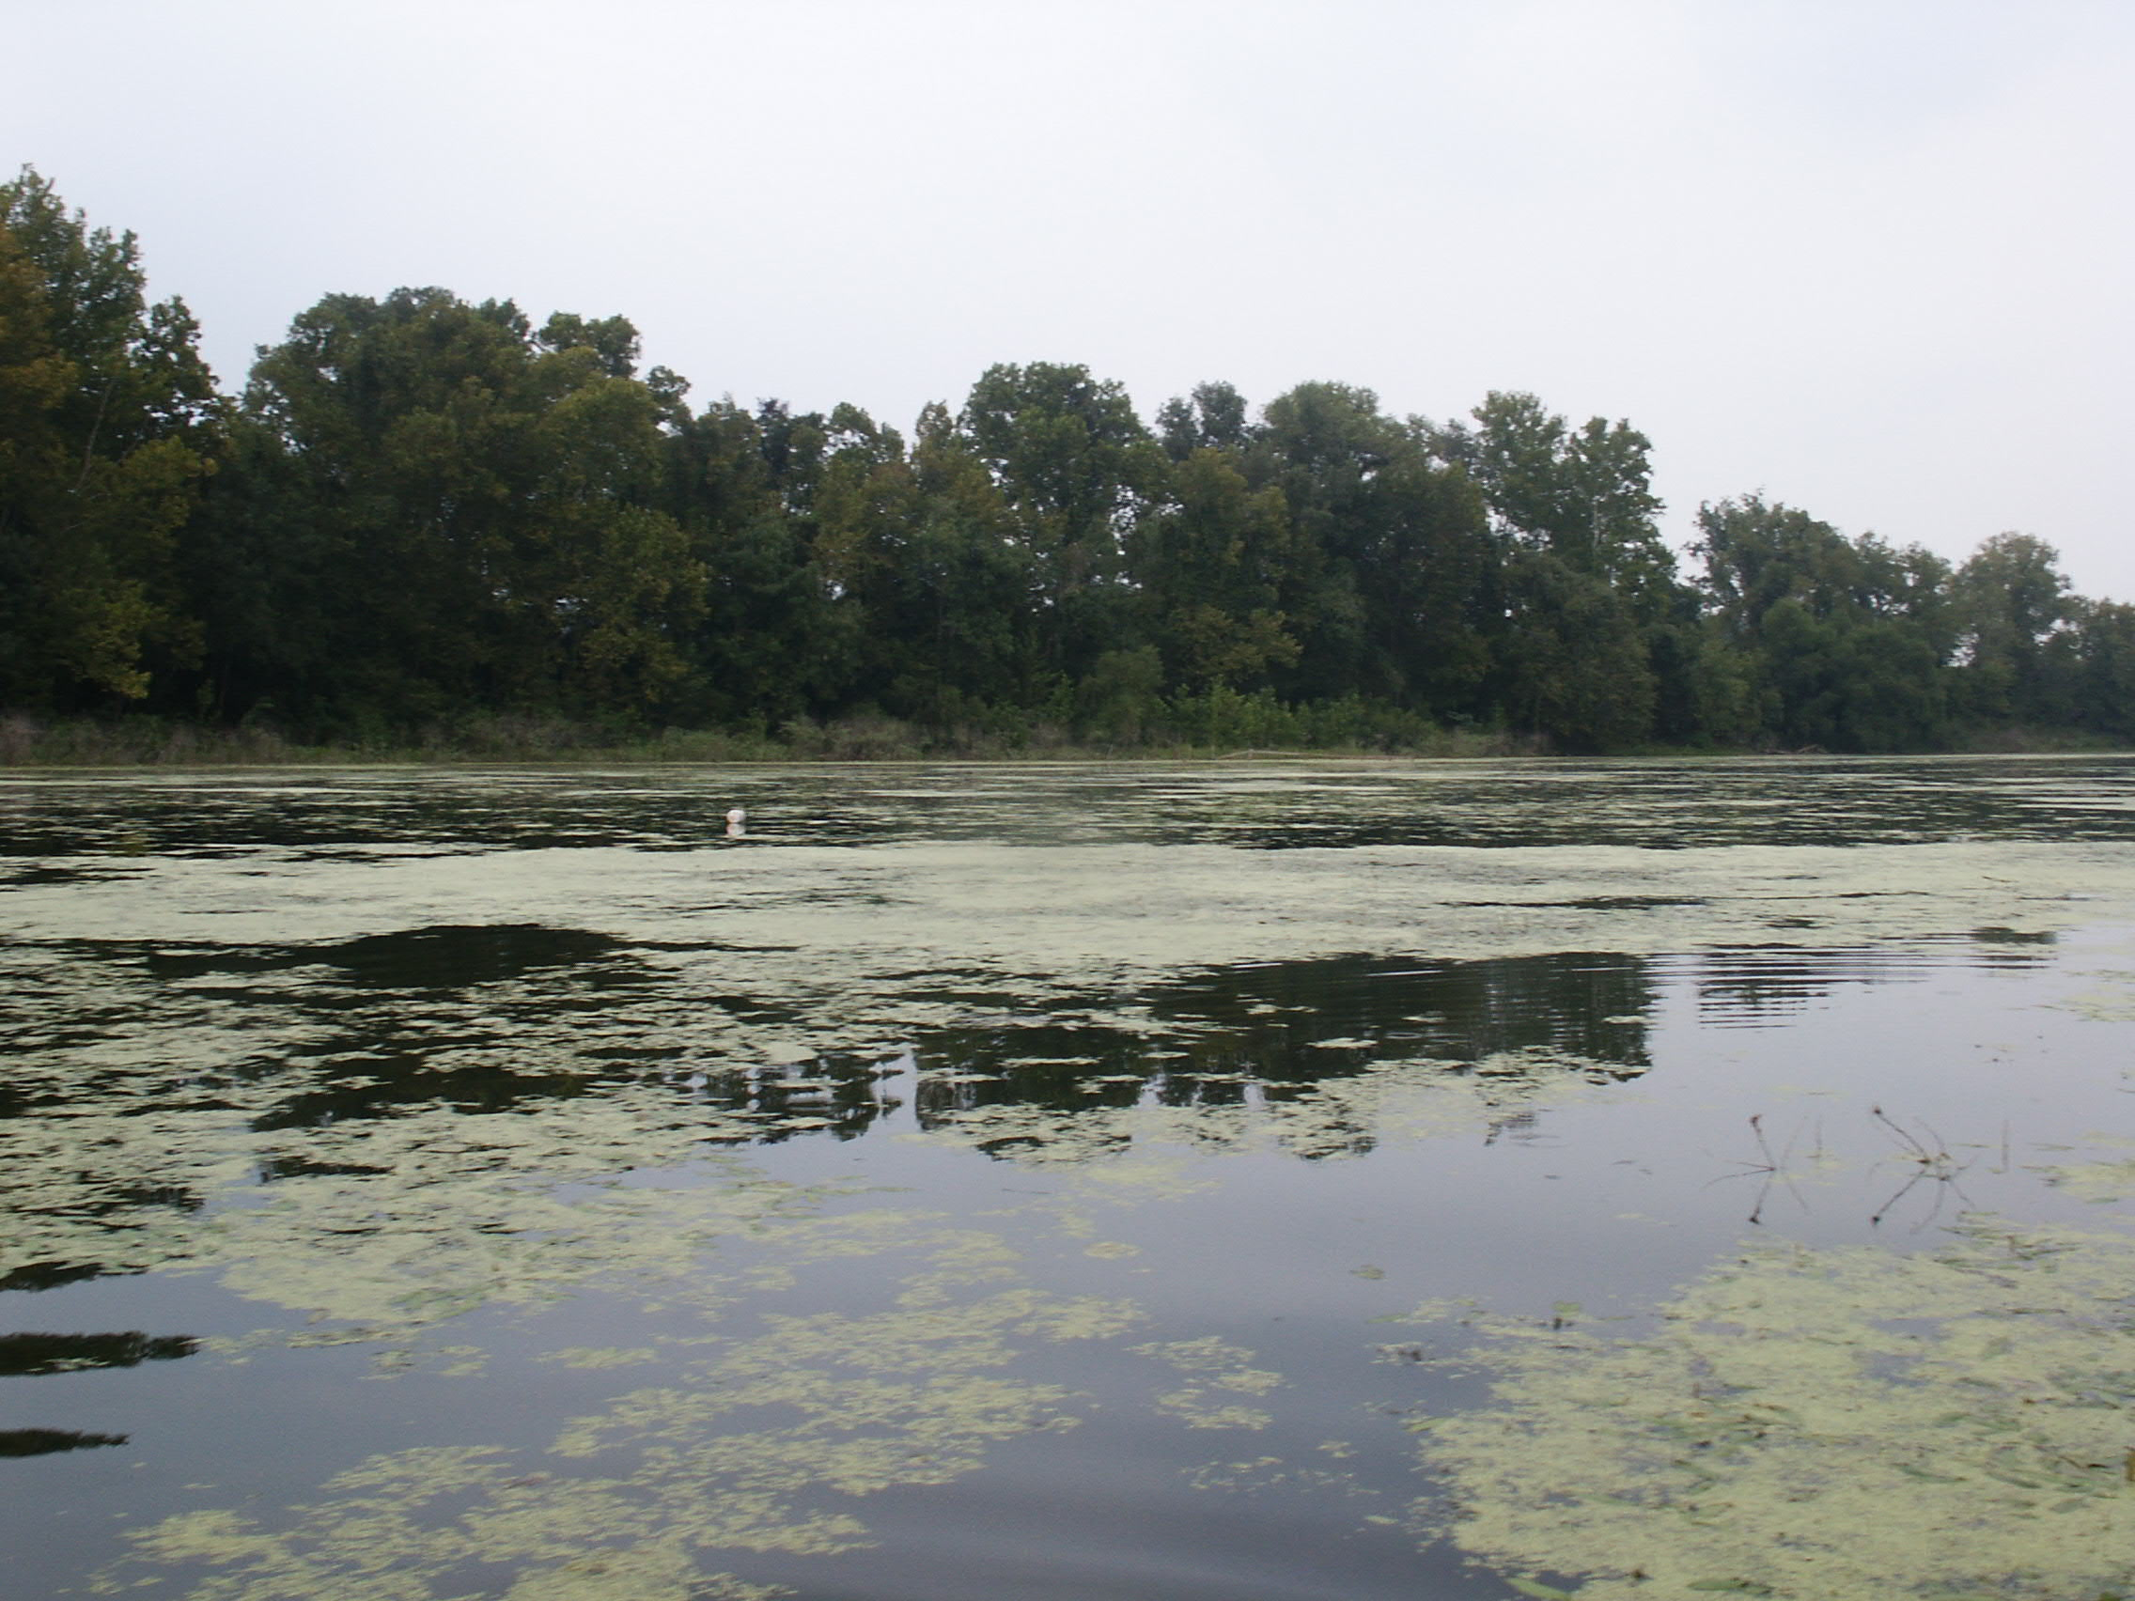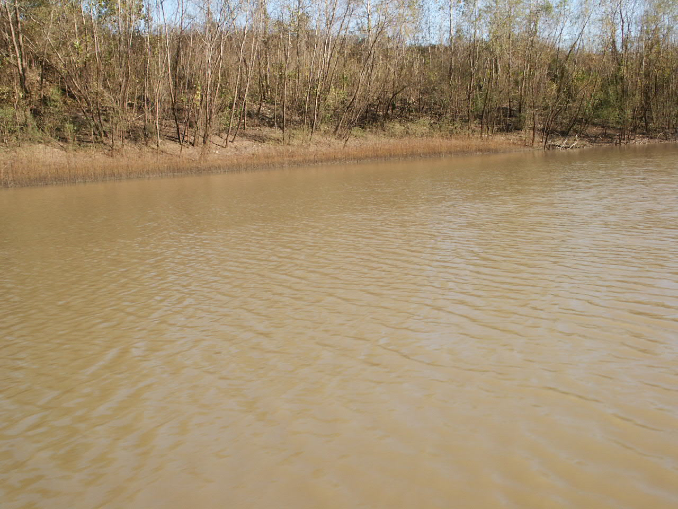
Figure 6. Clear water and an abundance of submerged and emergent vegetation characterized Perry Lake (left) and Cut Off Lake, whereas high turbidity and sparse aquatic vegetation generally characterized more recently connected oxbows such as Hog Island (right).

Table 1. Ranges and mean values of physicochemical parameters, chlorophyll concentrations and zooplankton densities measured during the study period. Abbreviations: BB = Big Bend Oxbow, MO = Moehlman Slough, BR 21 = Brazos River at Highway 21, HIO = Hog Island Oxbow, COL = Cut Off Lake, PL = Perry Lake, KB = Korthauer Bottom, and BR 521 = Brazos River at Highway 521.

Parameter |  | BB | MO | BR 21 | HIO
Temperature ⁰C |  | 24.5 | 25.5 | 23 | 25.1
Temperature ⁰C |  | (13.2 - 32.6) | (10.7 - 34.5) | (11.9 - 33) | (18 - 33)
Secchi depth (cm) |  | 18.6 | 27.8 | 30.5 | 25
Secchi depth (cm) |  | (9 - 40.7) | (9.5 - 42) | (5.7 - 103) | (11.8 - 43.1)
Conductivity ms |  | 341.1 | 319.4 | 783 | 577
Conductivity ms |  | (162 - 440) | (189 - 407) | (150 - 1472) | (357 - 972)
Dissolved oxygen mg/L |  | 7.12 | 7.68 | 9.2 | 8.47
Dissolved oxygen mg/L |  | (3.16 - 11.28) | (3.60 - 11.20) | (6.48 - 11.39) | (6.71 - 9.90)
pH |  | 8.5 | 8.5 | 8.6 | 8.5
pH |  | (7.6 - 9.6) | (7.6 - 9.4) | (8.1 - 9.0) | (8.1 - 9.1)
Maximum depth (cm) |  | 139 | 165 | 310 | 476
Maximum depth (cm) |  | (42 - 142) | (125 - 258) | (176 - 1041) | (365 - 607)
Chlorophyll mg/L |  | 15.1 | 16.3 | 10.1 | 34.2
Chlorophyll mg/L |  | (2.8 - 44.3) | (5.4 - 39.7) | (1.9 - 26.1) | (14.5 - 76.7)
Rotifera/ L |  | 531 | 438.7 | 31 | 172.5
Rotifera/ L |  | (37.5 - 2100) | (26.25 - 2853.8) | (0- 130) | (22.5 - 251.3)
Nauplii/ L |  | 169.3 | 63.9 | 1.8 | 18.75
Nauplii/ L |  | (33.8 - 476.3) | (0 - 423.8) | (0 - 10.0) | (0 - 37.5)
Copepoda/ L |  | 132.3 | 9 | 0.6 | 0
Copepoda/ L |  | (0 - 678.8) | (0 - 67.5) | (0 - 3.75) | -
Cladocera/ L |  | 70.5 | 9.8 | 1.3 | 2.8
Cladocera/ L |  | (7.5 - 191.3) | (0 - 63.8) | (0 - 7.5) | (0 - 11.25)
Total zooplankton/ L |  | 903.1 | 521.4 | 35.1 | 194
Total zooplankton/ L |  | (258.8 - 2208.8) | (40 - 2861.25) | (0 - 132.5) | (22.5 - 251.25)

Table 1 cont.

Parameter |  | COL | PL | KB | BR 10 | BR 521
Temperature ⁰C |  | 34.3 | 27.4 | 35.3 | 30.4 | 32.7
Temperature ⁰C |  | - | - | - | - | -
Secchi depth (cm) |  | 41.5 | 66.5 | 21 | 33 | 58
Secchi depth (cm) |  | - | - | - | - | -
Conductivity ms |  | 172 | 223 | 389 | 919 | 8400
Conductivity ms |  | - | - | - | - | -
Dissolved oxygen mg/L |  | 10.02 | 9.45 | 7.5 | 11.74 | 7.41
Dissolved oxygen mg/L |  | - | - | - | - | -
pH |  | 9.6 | 9.3 | 8.6 | 8.9 | 8.5
pH |  | - | - | - | - | -
Maximum depth (cm) |  | 51 | 120 | 175 | 254 | 680
Maximum depth (cm) |  | - | - | - | - | -
Chlorophyll mg/L |  | 14.4 | 29.8 | 14 | 66.2 | 15.2
Chlorophyll mg/L |  | - | - | - | - | -
Rotifera/ L |  | 585 | 596.3 | 161.3 | - | 18.75
Rotifera/ L |  | - | - | - | - | -
Nauplii/ L |  | 37.5 | 521.25 | 15 | - | 7.5
Nauplii/ L |  | - | - | - | - | -
Copepoda/ L |  | 22.5 | 195 | 3.8 | - | 0
Copepoda/ L |  | - | - | - | - | -
Cladocera/ L |  | 0 | 0 | 0 | - | 0
Cladocera/ L |  | - | - | - | - | -
Total zooplankton/ L |  | 645 | 1312.5 | 180 | - | 26.3
Total zooplankton/ L |  | - | - | - | - | -

Hydrology and habitat connectivity

Daily stream flow data indicated that Big Bend Oxbow connected with the river channel six times over the study period yielding at least 19 total days of connectivity (Figure 7). Moehlman Slough connected on three occasions for a total of 6 days (Figure 7 & 8). Hog Island Oxbow (Figure 9) was connected for a greater number of days than it was isolated. Prior to surveys in August 2003, Korthauer Bottom was last connected in April 2003 and Cut Off Lake was last connected in November 1998. Measurements of flood dynamics in Perry Lake were not available, however landowner interviews indicated that flood dynamics were similar to those in Cut Off Lake. Isotopic analysis performed by TWDB indicated that surface connections with the river channel were the primary source of oxbow water and although some oxbows had small tributaries, it is unlikely that they have significant impacts on oxbow water level (Chowdhury 2004). A more detailed analysis of Brazos River oxbow lake connectivity in response to hydrologic variation appears in a report by Osting et al. (2004).
Figure 7. Daily stream flow hydrograph for the Brazos River at the Texas State Highway 21 Bridge (USGS gauge 08108700). Solid lines indicate flows required to connect Big Bend Oxbow (bottom), and Moehlman Slough (top).

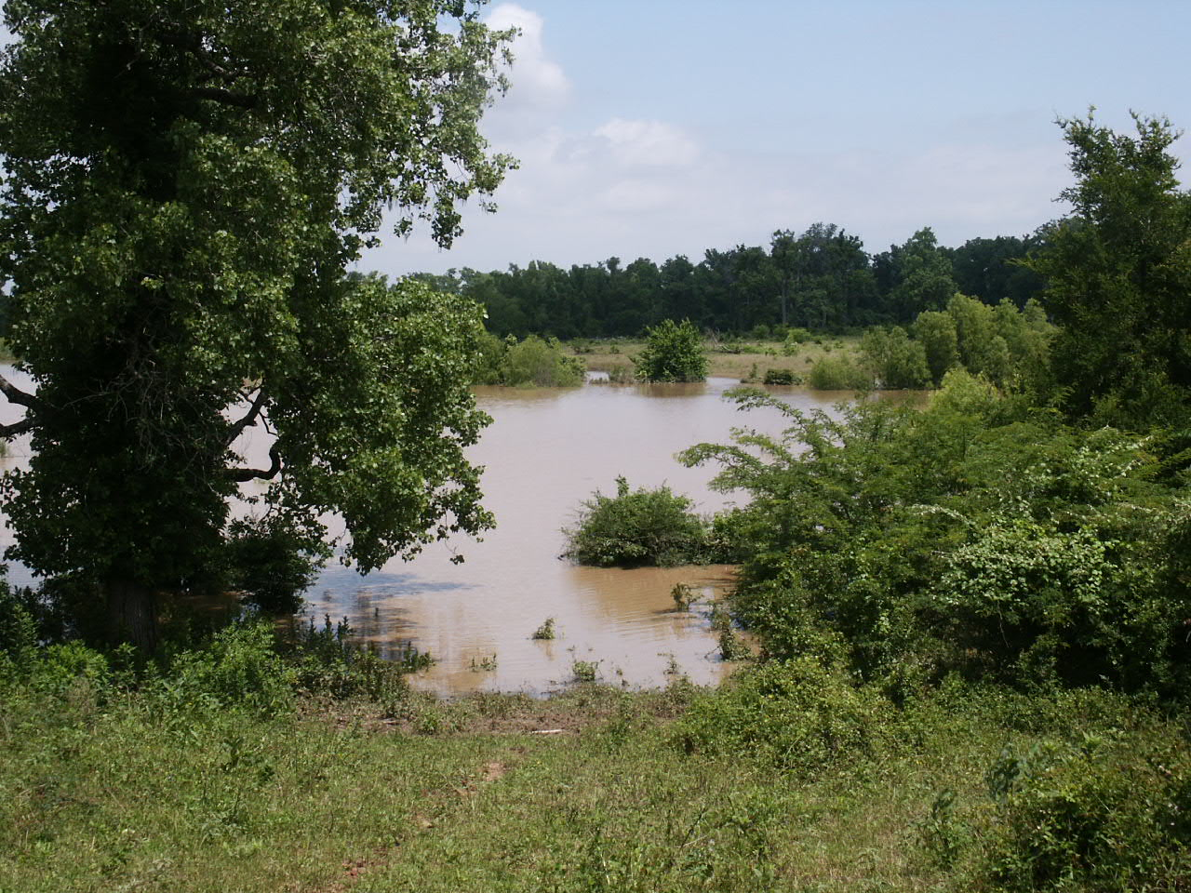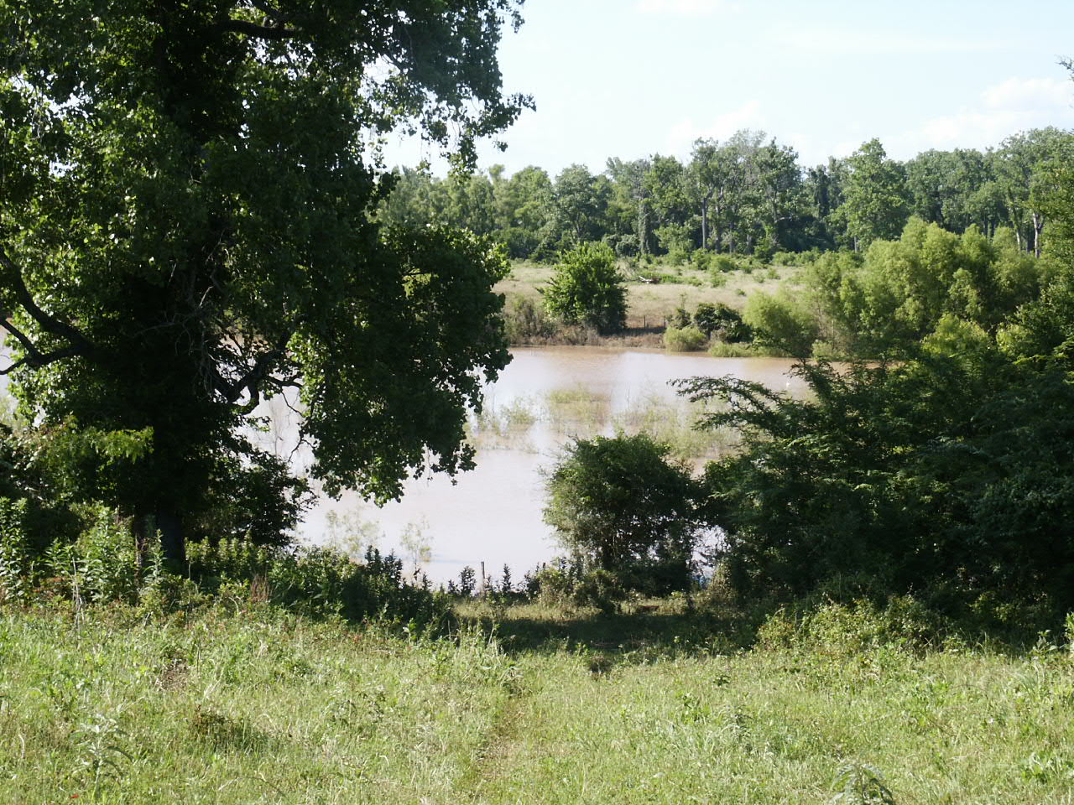
Figure 8. Moehlman Slough during a flood event in May 2004 (left) and during isolation in July 2004 (right).

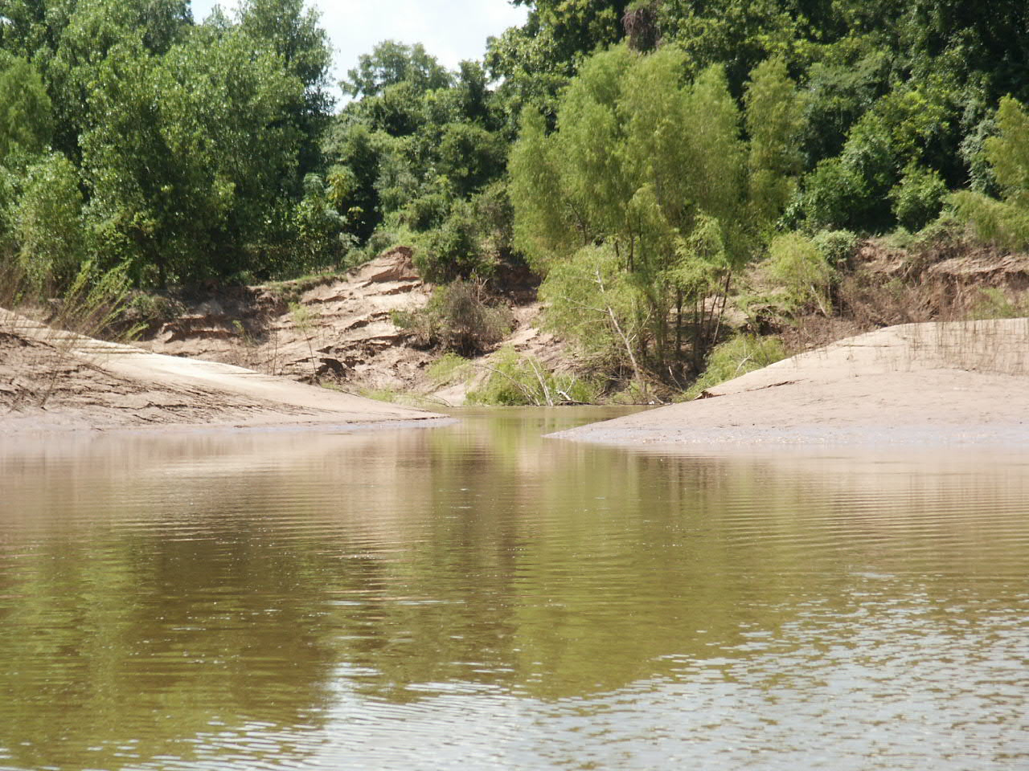
Figure 9. Confluence of the Brazos River and Hog Island oxbow. The River can be seen in the background through the notch in the natural levee.

Fish diversity and abundance

Across all sites and surveys, 90,682 individuals were collected representing 21 families and 66 species (Appendices 1 and 2). Among sites surveyed monthly, the Brazos River at Highway 21 had the greatest species richness (39) followed by Big Bend (31) and Moehlman Slough (27). Four surveys of Hog Island Oxbow yielded 38 species, and 13 species were collected from the remaining habitats that were not collected during monthly or quarterly surveys (Appendices 1 and 2). Individual surveys generally yielded between 10 and 20 species in seine collections and 4-10 species in gillnet collections (Appendices 1 and 2). Mean richness from seine samples was greatest in Hog Island and lowest in the Brazos River whereas mean gillnet richness was highest in Moehlman Slough and lowest in the Brazos River. Plots of species accumulation in Big Bend, Moehlman Slough and the Brazos River suggested that species richness increased in oxbow lakes in response to flooding whereas surveys of the Brazos River consistently collected new species (Figure 10). Richness values for the single survey sites were similar to oxbow and channel habitats surveyed more frequently with the exception of Perry Lake where few species were collected (Table 2).

Figure 10. Plot of species accumulation in Big Bend Oxbow, Moehlman Slough and the Brazos River at SH 21 from June 2003 to September 2004. Dashed lines indicate floods that connected Big Bend, and solid lines indicate floods that connected Big Bend and Moehlman Slough. Richness increased in both oxbow lakes following floods in late spring and early summer 2004.

Assemblage diversity in seine and gillnet collections was generally higher in oxbows than the river channel. Hog Island had the highest mean diversity in seine collections followed by Big Bend, Moehlman Slough and the Brazos River. Diversity of gillnet samples was highest in Big Bend and Moehlman Slough and lowest in the river channel. Diversity values for Korthauer Bottom, Cut Off Lake, Perry Lake, and the two lower Brazos River sites fell within the range of values calculated for more frequently sampled habitats (Table 2).

Numerical and biomass CPUE values from seine collections indicated that the Brazos River tended to have many small fish whereas oxbows have fewer, larger fishes. Mean numerical CPUE in the river channel was more than double the mean value from oxbow lakes, however biomass CPUE was lower than all oxbows (Table 2). Numerical CPUE in gillnet samples was highest in Moehlman Slough and biomass CPUE was greatest in Hog Island. The river channel ranked last in both numerical and biomass CPUE from gillnet samples (Table 3). The remaining sites had values within the range calculated for sites surveyed monthly or quarterly, with the exceptions of Perry Lake that had a seine numerical CPUE lower than any other oxbow collection, and the Brazos River at Highway 521 that had a gillnet biomass CPUE value less than any other river channel collection.

Table 2. Ranges (in parentheses) and mean estimates of species richness, diversity and CPUE from oxbow and Brazos River channel seine surveys.

Location | Species Richness |  | Diversity |  | Numerical CPUE |  | Biomass CPUE (g)
Big Bend Oxbow | 15.1 |  | 3.8 |  | 24.5 |  | 43.7
Big Bend Oxbow | (9 - 22) |  | (1.29 - 5.99) |  | (4.02 - 80.65) |  | (5.11 - 109.41)
Brazos River at 21 | 11.7 |  | 1.8 |  | 89.2 |  | 27.8
Brazos River at 21 | (6 - 17) |  | (1.25 - 2.42) |  | (9.35 - 233.30) |  | (7.39 - 101.64)
Moehlman Slough | 13.3 |  | 3.4 |  | 29.6 |  | 31.7
Moehlman Slough | (8 - 17) |  | (1.33 - 5.60) |  | (6.07 - 80.30) |  | (6.38 - 68.48)
Hog Island Oxbow | 21.3 |  | 4.0 |  | 35.1 |  | 33.5
Hog Island Oxbow | (13 - 26) |  | (2.83 - 5.37) |  | (20.14 - 44.83) |  | (12.94 - 65.08)
Brazos River at I-10 | 13.0 |  | 1.5 |  | 25.3 |  | 13.3
Brazos River at I-10 | - |  | - |  | - |  | -
Cut Off Lake | 7.0 |  | 1.2 |  | 10.5 |  | 19.4
Cut Off Lake | - |  | - |  | - |  | -
Perry Lake | 3.0 |  | 2.0 |  | 2.0 |  | 66.7
Perry Lake | - |  | - |  | - |  | -
Brazos River at 521 | 14.0 |  | 5.3 |  | 5.7 |  | 16.6
Brazos River at 521 | - |  | - |  | - |  | -
Korthauer Bottom | 13.0 |  | 2.5 |  | 18.2 |  | 59.2
Korthauer Bottom | - |  | - |  | - |  | -

Table 3. Ranges (in parentheses) and mean estimates of species richness, diversity and CPUE from oxbow and Brazos River channel gillnet surveys.

Location | Species Richness |  | Diversity |  | CPUE Numerical |  | CPUE Biomass (g)
Big Bend | 8.69 |  | 6.57 |  | 1.96 |  | 1572
Big Bend | (4 - 15) |  | (3.13 - 11.48) |  | (0.73 - 4.20) |  | (688 - 5925)
Brazos River at 21 | 3.69 |  | 3.13 |  | 0.49 |  | 763
Brazos River at 21 | (1 - 7) |  | (1.00 - 5.72) |  | (0.13 - 0.86) |  | (172 - 1474)
Moehlman Slough | 8.81 |  | 6.27 |  | 2.37 |  | 950
Moehlman Slough | (6 - 11) |  | (3.45 - 9.21) |  | (0.97 - 3.81) |  | (310 - 2157)
Hog Island Oxbow | 6 |  | 5.16 |  | 1.84 |  | 2228
Hog Island Oxbow | (2 - 10) |  | (1.80 - 8.22) |  | (0.41 - 3.48) |  | (124 - 5124)
Brazos River at I-10 | 3 |  | 2.96 |  | 0.5 |  | 833
Brazos River at I-10 | - |  | - |  | - |  | -
Perry Lake | 4 |  | 3.13 |  | 1.41 |  | 777
Perry Lake | - |  | - |  | - |  | -
Brazos River at 521 | 5 |  | 3.6 |  | 0.57 |  | 157
Brazos River at 521 | - |  | - |  | - |  | -
Korthauer Bottom | 10 |  | 7.58 |  | 2.33 |  | 2134
Korthauer Bottom | - |  | - |  | - |  | -

Ordination of fish assemblages

Correspondence analysis of the seine numerical CPUE-by-site matrix yielded two axes that explained 41% of the variation in species CPUE. Axis 1 (eigenvalue 0.65) modeled 24.9% of the variation and described a gradient between all Brazos River sites that contained more speckled chub (Macrhybopsis hyostoma), ghost shiner (Notropis buchanani), and bullhead minnow (Pimephales vigilax) compared with oxbow sites that contained more centrarchids, clupeids, and ictalurid catfishes. Axis 2 (eigenvalue 0.43) modeled 16.5% of the variation and differentiated Big Bend Oxbow that contained more white crappie (Pomoxis annularis), blue catfish (Ictalurus furcatus), and inland silverside (Menidia beryllina), from Moehlman Slough that contained more threadfin shad (Dorosoma petenense), green sunfish (Lepomis cyanellus), and bluegill sunfish (Lepomis macrochirus). A group of sample scores in the middle of the ordination contained two river channel samples and two Big Bend samples collected following flood events in the Brazos River. Three of four Hog Island samples grouped here, and this oxbow was more frequently connected to the active channel than any other oxbow. The March 2004 sample in Big Bend also grouped here as a result of relatively high abundance of red shiner following a reproductive event in early spring (Figure 11).

Figure 11. Plot of sample scores from correspondence analysis of seine CPUE values. Samples within the circle were collected following flood events in the Brazos River.
July 04
May 04
October 03

Canonical Correspondence Analysis yielded species-environment relationships that supported results from the CA ordination (Figure 12). Axis 1 (eigenvalue 0.45) explained 65.1% of the variation in species-environment relationships. Lotic adapted cyprinids characteristic of the river channel had high scores on axis 1 correlated with greater depth, pH, and conductivity. Centrarchids, clupeids and ictalurids generally had low scores on axis one correlated with higher temperature, chlorophyll, and zooplankton density; characteristics that were typical of oxbow lakes. Axis 2 (eigenvalue 0.087) explained 12.4% of the variation and generally described differences between species that were more abundant in Big Bend (Ameiurus melas, Pomoxis annularis) where zooplankton density and conductivity were higher, and species that were more abundant in Moehlman Slough (Lepomis cyanellus, Dorosoma petenense).

Figure 12. Plot of species scores from canonical correspondence analysis. Species codes are the first three letters of the genus and species.

Detrended correspondence analysis of the gillnet CPUE-by-site matrix produced two axes that modeled 48.8% of the variation in CPUE (Figure 13). Axis 1 (eigenvalue 0.57) explained 32% of the variation and described a gradient from the river channel and most frequently connected oxbows to the most isolated oxbow (Moehlman Slough). River channel samples contained more longnose gar (Lepisosteus osseus), blue catfish, and freshwater drum (Aplodinotus grunniens) whereas Moehlman Slough contained more white crappie, black bullhead (Ameiurus melas), and smallmouth buffalo (Ictiobus bubalus). Fish assemblages in Hog Island, Big Bend and Korthauer Bottom contained species common in the river channel and Moehlman Slough. One Big Bend sample score grouped with Hog Island and this sample was collected in June 2004 when Big Bend was connected with the river channel.
June 04
Figure 13. Plot of site scores from detrended correspondence analysis.

Cut Off Lake and Perry Lake both dried out in the late 1990’s and had not connected with the river channel prior to surveys in summer 2003. The fish assemblage in Cut Off Lake was dominated by western mosquitofish and contained several species that were not collected in any other habitat (Appendix 1). This oxbow receives flow from a highly managed lake via a small creek and this is the likely source of fishes captured in Cut Off Lake. Perry Lake was dominated by largemouth bass (Micropterus salmoides) and bluegill sunfish; species that have been stocked into a nearby pond that flows into the oxbow during periods of heavy precipitation. Flow in the Brazos River was low in August 2003 and salinity was relatively high at the Highway 521 site (4.0 ppt). As a result, the species assemblage was dominated by estuarine associated species that were not collected in any other channel or oxbow habitat (Appendices 1 and 2).

Species responses to habitat hydrology

Cross correlation analysis of deviations in Brazos River species CPUE and hydrologic variables yielded positive correlations with species common in oxbow lakes but relatively rare in the river channel. White crappie, gizzard shad (Figure 14), threadfin shad and silverband shiner (Notropis shumardi) had positive correlations with hydrologic variables and no time lag. With a one-month time lag, positive correlations strengthened for white crappie and threadfin shad, and the correlation with gizzard shad and silverband shiner was no longer significant. Silverband shiners are much more abundant in the river than oxbows, and floods may provide opportunities for these minnow to return to the channel. Threadfin shad and blackspot shiner (Cyprinella venusta) were the only species positively correlated with a two-month time lag.

Significantly negative correlations were found between hydrologic deviations and CPUE of dusky darter (Percina sciera), and sharpnose shiner (Notropis oxyrhynchus) with no time lag. With a one-month lag, negative correlations strengthened for the dusky darter and bullhead minnow (Pimephales vigilax). The sharpnose shiner was not significantly correlated at any other time lag. The red shiner (Cyprinella lutrensis) and ghost shiner had negative correlations with a two-month time lag, and the negative correlation of the bullhead minnow strengthened with a lag of two months (Appendix 3).

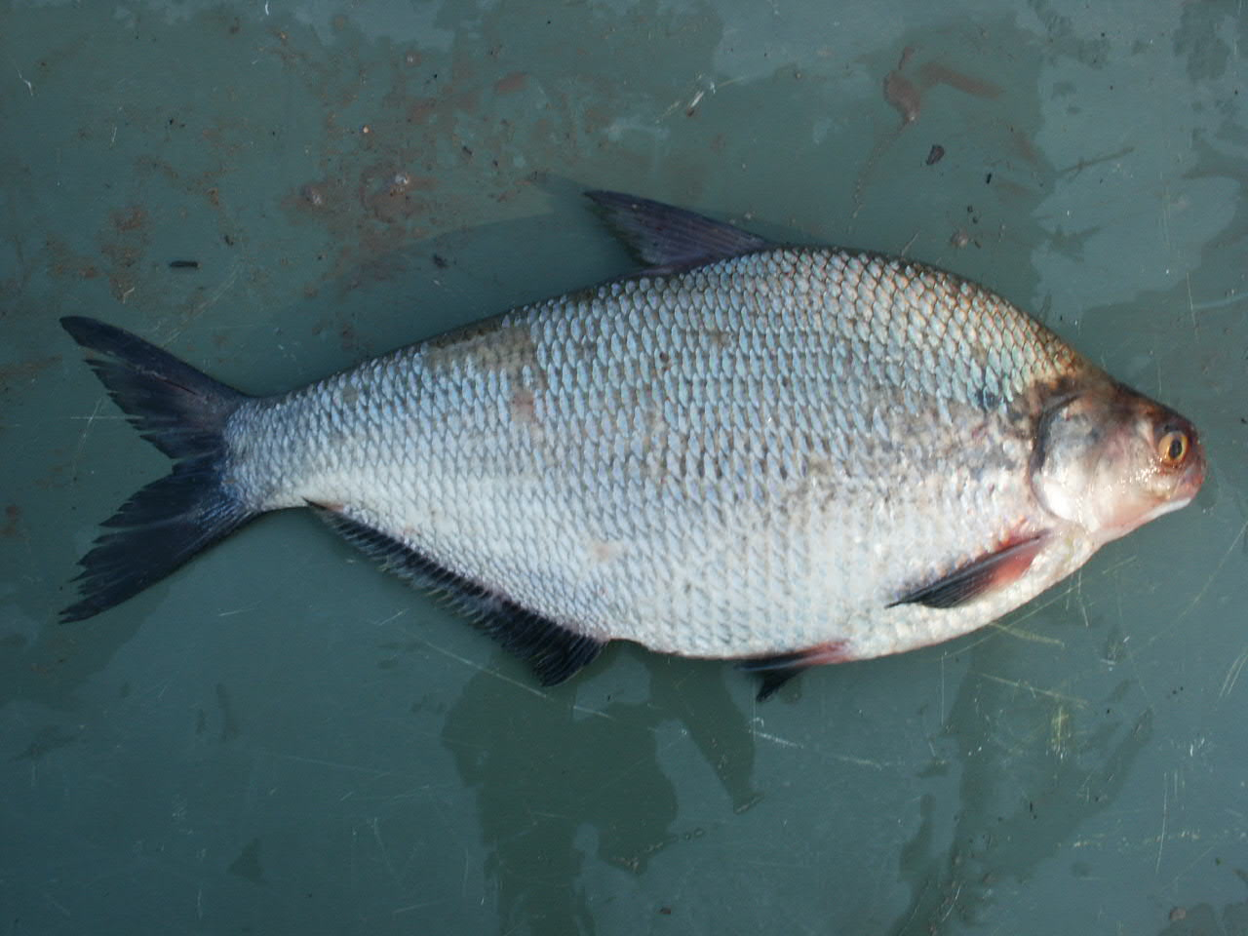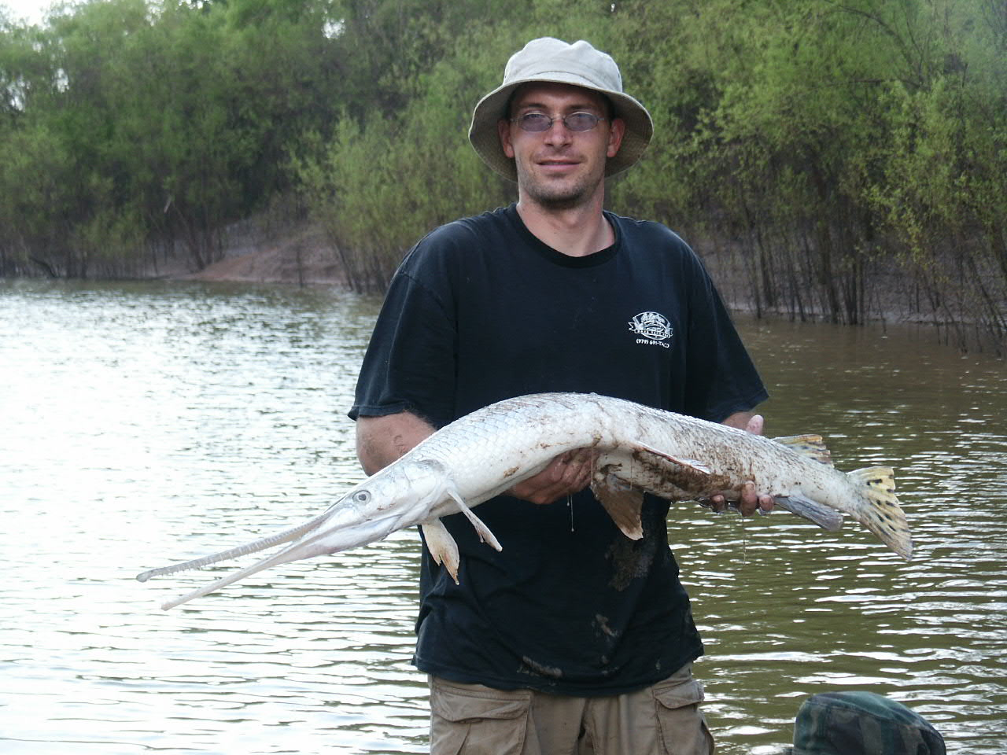
Figure 14. Shad had strong positive correlations with hydrology in the Brazos River channel. Longnose gar are common in the river but may move into oxbows during floods to feed on shad.

In Big Bend Oxbow, cross correlation with no time lag produced positive correlations between hydrologic variables, spotted gar (Lepisosteus oculatus) and pugnose minnow (Opsopoeodus emiliae). Negative correlations were found for the black bullhead, orangespot sunfish (Lepomis humilis), and longear sunfish (Lepomis megalotis). Species richness was positively correlated, and the bullhead minnow was negatively correlated with mean monthly flow but not peak discharge. A one-month time lag yielded positive correlations with species richness and abundance of threadfin shad, blue catfish, channel catfish (Ictalurus punctatus), spotted gar, and pugnose minnow. Seine biomass CPUE and the bullhead minnow were negatively correlated with hydrologic deviations lagged by one month. Gillnet biomass was negatively correlated with both hydrologic variables, and seine biomass CPUE was negatively correlated with monthly flow with a two-month lag. Species richness, threadfin shad, slough darter (Etheostoma gracile) and channel catfish were positively correlated with a 2-month lag, and blue catfish were positively correlated with monthly flow only (Appendix 4).

In Moehlman Slough, the bullhead minnow was the only species positively correlated with no time lag. With a one-month lag, species richness, bullhead minnow and orangespot sunfish were positively correlated with hydrologic variables. These variables and longear sunfish were also positively correlated with a two-month lag. Gizzard shad and green sunfish were negatively correlated with hydrologic variables at all time intervals. Bluegill sunfish, slough darter and western mosquito fish (Gambusia affinis) were negatively correlated with no lag and had no significant correlations at any other time interval. The golden shiner (Notemigonus crysoleucas) was negatively correlated with no lag and this relationship strengthened with a one-month lag. Gillnet biomass CPUE, gizzard shad CPUEand green sunfish CPUE were negatively correlated with a two-month lag (Appendix 5).

Brazos River- lower channel sites

Assemblage structure

A total of 111,962 fishes representing 39 species and 14 families were collected with seines from Hwy 290 and FM 1642 crossings (Table 4); 100,415 fishes and 32 species were collected from Hwy 290 crossing, and 11,547 fishes and 31 species were collected from FM 1642 crossing. Cyprinella lutrensis was the most abundant fish (61% in relative abundance) at Hwy 290 crossing, followed by Notropis buchanani (18%), Pimephales vigilax (15%), and Notropis shumardi (5%). Mugil cephalus was the most abundant fish (32%) at FM 1642 crossing, followed by Cyprinella lutrensis (32%), Gambusia affinis (11%), and Notropis shumardi (6.4%). Fishes of regional importance included two Brazos River endemics (Notropis oxyrhynchus, N = 2; and Notropis potteri, N = 29) and two species (Notropis shumardi, N = 5,201; Macrhybopsis storeriana, N = 48) with disjunct populations in the Brazos River.

At Hwy 290 crossing, mean (±SE) taxa richness was 13.9 (1.62), diversity was 2.56 (0.78), and evenness was 0.24 (0.015) among months. Mean turnover (RSI) was 0.71 (0.043). At FM 1462 crossing, mean taxa richness was 12.6 (1.17), species diversity was 2.89 (1.31), and evenness was 0.312 (0.045). Mean turnover (RSI) was 0.41 (0.062). Collectively, fewer individuals and taxa were collected at FM 1462 crossing however the fish assemblage was more diverse, even, and variable in taxonomic composition and density through time compared to the assemblage at Hwy 290 crossing.

Between sites, mean similarity (RSI; ±SE) was 0.52 (0.064). Twenty-three species were common to both sites, nine species were unique to Hwy 290 crossing, and eight species were unique to FM 1462 crossing. Likewise, abundances differed between sites. Four species (Cyprinella lutrensis, Notropis buchanani, Pimephales vigilax, and Notropis shumardi) comprised 99% of the fish assemblage at Hwy 290 crossing, whereas these four species comprised only 45% of the fish assemblage at FM 1462 crossing. Instead, abundance of euryhaline Mugil cephalus and Gambusia affinis (collectively 44% of the fish assemblage) were greater at FM 1462 crossing.

Table 4. Number and relative abundances (%) of fishes collected from two sites on the lower Brazos River from November 2003 through August 2004.

Species associations and habitat

Point sand bar habitats primarily consisted of sand substrate with some gravel (Table 5). Protected eddy habitats primarily consisted of silt habitat with small amounts of woody debris and leaves. Collectively, mean depth was 0.65 m and mean current velocity 0.34 cm/s of habitats sampled.

Table 5. Descriptions of habitats sampled from two sites on the lower Brazos River from November 2003 through August 2004.

Twenty percent (P < 0.05) of the fish assemblage variation from CCA (total inertia = 0.986) was attributed to habitat (e.g., substrate, depth, and current velocity; sum of all canonical eigenvalues = 0.169). Habitat variables with positive loadings on the first environmental axis in descending order were current velocity (0.81), depth (0.57), sand (0.44), and gravel (0.18). Silt substrate had a negative loading (0.43). Consequently, the first environmental axis described a gradient from swift and deep water with sand and gravel substrate to sluggish and shallow water with silt substrate. Fishes positively associated with axis 1 (in descending order) were Aplodinotus grunniens (2.1), Macrhybopsis storeriana (1.7), Ictalurus furcatus (0.95), Ictalurus punctatus (0.6), Mugil cephalus (0.36), Macrhybopsis hyostoma (0.33), Carpiodes carpio (0.11), Notropis shumardi (0.05), and Notropis potteri (0.01). Fish negatively associated with axis 1 (in descending order) were Micropterus salmoides (-1.1), Poecilia latipinna (-0.91), Lepomis megalotis (-0.89), Pomoxis annularis (-0.82), Gambusia affinis (-0.51), Hybognathus nuchalis (-0.36), Lepomis macrochirus (-0.29), Notropis buchanani (-0.26), Pimephales vigilax (-0.16), Cyprinella lutrensis (-0.12), and Dorosoma petenense (-0.06).

Habitat variables with positive loadings on the second environmental axis in descending order were gravel (0.54), sand (0.46), and current velocity (0.37). Habitat variables with negative loadings were depth (-0.71) and silt (-0.56). Second environmental axis described a gradient from shallow water habitats with gravel substrate to deep-water habitats with silt substrate. Fishes with the highest positive association with axis 2 were Mugil cephalus (0.74) and Notropis potteri (0.43). Fishes with the highest negative association with axis 2 were Aplodinotus grunniens (-3.8), Macrhybopsis storeriana (-2.4), Lepomis macrochirus (-0.34), and Lepomis megalotis (-0.28).

Temporal patterns in fish assemblages

Species diversity and richness generally increased from winter to summer (Figure 14). Species diversity was lowest (1.36) in December 2003 attributed in part to >80% of the assemblage consisting of C. lutrensis. Species diversity consistently was high in May (4.13), July (2.61), and August (2.29) attributed in part to the decrease in abundance and density of several dominant species (Cyprinella lutrensis and Notropis buchanani) and the occurrence of several species undetected in previous seining samples (Ictiobus bubalus, Micropterus salmoides, Lepisosteus osseus, Morone chrysops, Etheostoma chlorosomum, and Aplodinotus grunniens). Consequently, species diversity (r = 0.58; P<0.01) and richness (r = 0.65; P = 0.01) were positively correlated with peak discharge, and likely the result of reproduction (e.g., Ictiobus bubalus, Micropterus salmoides, Aplodinotus grunniens were juveniles) and downstream displacement of typical tributary species (e.g., Etheostoma chlorosomum) because of high flows throughout the Brazos River drainage.

Figure 14. Species richness and species diversity (Base e) for fishes collected at two sites of the lower Brazos River from November 2003 through August 2004.

Among the most abundant fishes (Table 6), two general patterns were observed in fish densities through time. First, densities of Cyprinella lutrensis, Notropis buchanani, Pimphales vigilax, and Notropis shumardi generally decreased from winter to summer (Figure 15). Consequently, densities of these species were negatively correlated to peak discharge on a one or two month lag (Table 7). Second, densities of Mugil cephalus, Macrhybopsis hystoma, Gambusia affinis, Ictalurus furcatus, Ictalurus punctatus, and Hybognathus nuchalis generally increased from winter to summer (Figure 16; M. cephalus and G. affinis not shown) and were positively correlated to peak discharge (Table 7). Although densities of the most dominant fishes were correlated to peak discharge, biological factors such as life history characteristics, reproductive modes, and competition are not excluded from effecting changes in fish density changes through time.

Figure 15. Relative abundance (%) and density (catch/effort) for Cyprinella lutrensis, Notropis buchanani, Pimephales vigilax, and Notropis shumardi collected from the lower Brazos River from November 2003 through August 2004.

Table 6. Number of individuals and relative abundance (%) for the most abundant fish species collected from two sites on the lower Brazos River from November 2003 through August 2004.

Table 7. Direct and lag correlations between peak discharge and taxa richness, diversity, and species densities for fishes collected from two sites on the lower Brazos River from November 2003 through August 2004.

Figure 16. Relative abundance (%) and density (CPUE) for Macrhybopsis hyostoma, Ictalurus furcatus, I. punctatus, and Hybognathus nuchalis collected from the lower Brazos River from November 2003 through August 2004.

Species negatively associated with peak discharge

The C. lutrensis population consisted of at least four age groups (age 0, 1, 2, and 3) in the lower Brazos River (Figure 17a). Age-0 fish (Year class 2004) were first collected in August 2004 and were <25 mm in length. Except for age-0 fish, representatives of each age group were collected throughout the year. Thus, lower densities during the summer apparently occurred in each age group. Density decreases may be attributed to downstream displacement during high flow events, or may simply be a consequence of intense intraspecific competition during the winter and early spring.

The N. buchanani population consisted of at least three age groups (age 0, 1, and 2; Figure 16b). Age-0 fish (Year class 2004) possibly were collected as early as July 2004. Age-1 fish (Year class 2003) were collected throughout the year. Age-2 fish were not collected past May 2004. Few age-2 fish survive through their third summer (Pflieger 1975). Density decreases may be attributed to mortality of older fish or to the movement of age-1 fish into areas of low flow (e.g., tributaries; Pflieger 1975) to seek refuge during summer high flows in the Brazos River main stem.

The P. vigilax population consisted of at least three age groups (age 0, 1, and 2; Figure 18a). Age-0 fish were first collected in July 2004 and was the most common age group found in August 2004. Age-1 fish (Year class 2003) were collected through the year. Age-2 fish were collected through July 2004. A sharp decline in density occurred in April. This may be attributed to natural variation in the population because P. vigilax density in April was similar to that in December. However, the sharp density decline in April also corresponds with reproduction. The male prepares a redd under rocks, woody debris, or other hard substrate in early spring and will guard the nest after the female attaches her adhesive eggs (Parker 1964). Consequently, breeding pairs may move to areas with greater density of suitable substrate (e.g., tributaries) for redd preparation, thus reducing the Brazos River population. High flows may have aided in suppressing P. vigilax densities during the summer because of their preference for areas with slow water currents (Etnier and Starnes 1993).

The N. shumardi population consisted of at least four age groups (age 0, 1, 2, and 3; Figure 18b). Ages 1 (Year class 2003), 2, and 3 were generally common from November 2003 through May 2004. Corresponding with lower densities, the population during the summer consisted primarily of one age group. However, the age of this group is difficult to determine; these fishes may represent age 0 or age 1 fish. Little is known about the life history of N. shumardi. This fish typically is found only in large rivers and breed in swift current over sand or gravel substrates (Robison and Buchanan 1988). However, large specimens were collected from tributaries of the Brazos River during the summer (Leavy 2004). It is feasible that reproductive fish move into tributaries for spawning especially during periods of high flow events in the Brazos River main stem.

Figure 17. Monthly length frequency histograms for (a) Cyprinella venusta and (b) Notropis buchanani collected from the lower Brazos River from November 2003 through August 2004.

Figure 18. Monthly length frequency histograms for (a) Pimephales vigilax and (b) Notropis shumardi collected from the lower Brazos River from November 2003 through August 2004.

Species positively associated with peak discharge

Mugil cephalus were rare (N < 9) among monthly collections except in January (N = 500) and April (N = 3,380). Several mullet species and other marine-spawning fishes move substantial distances upstream in rivers to escape predation pressures in brackish water (Lucas and Baras 2001).

The M. hyostoma population consisted of at least three age groups (age 0, 1, and 2; Figure 19a). Age-0 fish (Year class 2004) were collected May through August 2004. Age-1 fish (Year class 2003) and age-2 fish were collected November 2003 through July 2004. Density of M. hyostoma was consistent through the year and rather weakly associated (r = 0.47; P = 0.05) with peak discharge. Macrhybopsis hyostoma is a broadcast spawner, releasing semi-buoyant eggs in areas of swift current such as the Brazos River main stem (Bottrell et al. 1964).

Gambusia affinis were rare (N < 69) among monthly collections except in May 2004 (N = 1,182) at Hwy 1462 crossing. The population consisted of age-0 and older fish.

Populations of I. furcatus (Figure 19b) and I. punctatus (Figure 20a) consisted of two age classes (age 0 and 1). Older catfishes are common in the lower Brazos River, but inhabit areas not effectively sampled with seines. Age-0 I. furcatus (Year class 2004) were collected in July and August 2004; age-0 I. punctatus were collected from May through August 2004. Positive correlations between peak discharge and catfish densities were attributed to reproduction, availability, and catchability (e.g., preference for shallow water habitats) of age-0 catfish.

The H. nuchalis population consisted of age 0 and one older fish (Figure 20b). Age-0 fish were collected from May through August 2004. Little is known about life history of H. nuchalis, but Hybognathus typically breed in backwater areas and smaller tributary streams with females scattering non-adhesive eggs in vegetation and over bare substrate (Raney 1939). Eggs and larvae are susceptible to downstream displacement during high flows. Hence, H. nuchalis were found only during the summer, and their density was positively correlated to peak discharge. Adult H. nuchalis likely inhabit smaller tributary streams and not the Brazos River main stem. However, main stem rivers may be important to the early development or another aspect of H. nuchalis life history (Etnier and Starnes 1993).

Gillnet data

Fifty-three individuals and five species were captured in gillnets. Lepisosteus osseus was the most common species captured (N = 40), followed by Ictalurus furcatus (N = 6), Dorosoma cepedianum (N = 5), Carpiodes carpio (N = 1) and Ictiobus bubalus (N = 1). Abundances of these species were not included in analyses because few fish were captured and representatives were recorded in seine data.

Figure 19. Monthly length frequency histograms for (a) Macrhybopsis hyostoma and (b) Ictalurus furcatus collected from the lower Brazos River from November 2003 through August 2004.

Figure 20. Monthly length frequency histograms for (a) Ictalurus punctatus and (b) Hybognathus nuchalis collected from the lower Brazos River from November 2003 through August 2004.

Macroinvertebrate and zooplankton

A total of 203 macroinvertebrates were collected from Hwy 290 and FM 1462 crossings. Chironomids (Diptera) were the most common (72% in relative abundance), followed by taxa in the family Ephemeroptera: Baetidae (11%), Heptageniidae (6%), and Tricorythidae (4%). Taxa that were <1% in relative abundance were Diptera (Ceratopogonidae, Simulidae and Tipulidae), Trichoptera (Hydroptilidae), Odonata (Gomphidae), Nematoda (Mermithidae), Bivalva (Corbicula), and Decopoda (Cambaridae).

Mean density (number of organisms/L; ±SD) of zooplankton was 4.5 (4.6). Rotifers were the most common (2.0 ± 1.8), followed by Cladocera (0.36 ± 0.74), Gastrotricha (0.22 ± 0.75), and Copepoda (0.19 ± 0.39).

Discussion

The timing and frequency of periodic flood events interacted with habitat features in determining the structure of oxbow and river channel fish assemblages as evidenced by multivariate ordinations and cross-correlation analyses. In seine CA ordinations, Brazos River and Big Bend oxbow sample scores moved toward each other following periods of connectivity that facilitated exchange of aquatic fauna. In Big Bend, the effect was strongest following a flood in October 2003, whereas the effect was strongest in the Brazos River following floods in late spring and summer. Piscivory may control the ability of small minnows typical of river channel assemblages from colonizing oxbow habitats (Zeug et al. in review), and piscivore abundance was lowest during fall and winter surveys of Big Bend. Most oxbow fishes reproduced prior to floods in May and June 2004, and lateral connectivity allowed juveniles to move from oxbow habitats to the river channel. Fish assemblages in Moehlman Slough appeared relatively stable over the study period, and no seine or gillnet samples grouped near the river channel, however cross correlation analyses suggested faunal exchange. Moehlman Slough was the most distant from the river, and this may have reduced large-scale colonization by small minnows that appear to have influenced Big Bend sample scores.

Species-specific responses to hydrologic variability appeared to be related to abundance patterns in oxbow and channel habitats at the time of connectivity. In oxbow lakes, (Big Bend, Moehlman Slough) species richness was positively correlated, and measures of biomass CPUE were negatively correlated with hydrologic variables suggesting a net movement of biomass from oxbows into the river channel but also colonization of oxbows by some individuals of channel-associated species. Cross-correlation analysis of Brazos River data yielded a pattern of increased abundance of crappie and shad and a decrease in the abundance of small colonizing cyprinids (bullhead minnow, ghost shiner, red shiner) in response to hydrologic connectivity. With the exception of mosquito fish, crappie and shad were the most abundant fishes in Big Bend and Moehlman Slough respectively. Gizzard shad were particularly abundant in Moehlman Slough and negative correlations with this species corresponded to positive correlations in the river channel. Similarly, the bullhead minnow was negatively correlated with hydrology in the river channel and positively in Moehlman Slough. This suggests that oxbow and channel habitats can simultaneously act as source and sink habitats for different species. Conflicting correlations with the same species in different oxbows may indicate that physical factors other than flooding, or biological interactions specific to each oxbow influenced deviations in species CPUE. Spotted gar, blue catfish, channel catfish and pugnose minnow were positively correlated with hydrology in Big Bend but not Moehlman Slough. The effect of distance on colonization frequency has been well recognized and Moehlman Slough was 800 meters farther from the river channel than Big Bend. Longnose gar were abundant in Big Bend gillnet samples during the June 2004 flood, however these fish were rare during subsequent surveys. Gar may enter oxbows during floods to forage and return to the river as water levels fall. Gar species in the Brazos River system selectively feed on clupeids (Robertson et al. unpublished data) that apparently are more abundant in oxbow habitats, and which may provide a resource subsidy for piscivore populations in the river channel.

Winemiller (1996) and Winemiller et al. (2000) discussed how fish life history attributes influence species assemblage structure in Brazos oxbows, and made inferences about which life history strategies are most likely to benefit from periodic connectivity. Fishes were classified by life history strategy according to the model of life history evolution proposed by Winemiller and Rose (1992). Periodic strategists possess attributes (high fecundity, delayed maturation, iteroparity) that allow them to take advantage of large-scale spatiotemporal variation in resource availability and are characterized by strong year classes when conditions are favorable. Fishes with this strategy (e.g. gizzard shad, threadfin shad, crappie) were more abundant in oxbows, and these species had the strongest positive correlations with hydrology in the river channel. Equilibrium strategists, characterized by delayed maturation, low juvenile mortality and parental care (Lepomis sp.) were more abundant in Moehlman Slough where water levels are relatively stable and floods that may disrupt nesting activity are less frequent. Opportunistic species, characterized by small adult size, short generation times, extended breeding seasons, and high reproductive effort tended to be numerically dominant in the river channel and abundant in all habitats. Winemiller et al. (2000) and Zeug et al. (in review) found that these species were more abundant in oxbows that dry out with greater frequency, and during periods of drought when environmental conditions are harsh (low DO, high temperatures).

Multivariate ordinations generally described a gradient of connectivity among oxbow lakes. Oxbows that connect to the active channel more frequently had assemblages that were periodically dominated by species common in the river channel (red shiner, bullhead minnow, longnose gar, river carpsucker) but relatively rare in oxbow lakes during other periods. Hog Island oxbow consistently grouped near the river channel in ordinations based on both habitat characteristics and species CPUE. This oxbow is young (formed in 1996) and remained connected to the river channel at relatively low discharge when other oxbows were isolated, allowing for more frequent exchange of aquatic fauna. Big Bend oxbow connected more frequently than Moehlman Slough, and changes in assemblage structure were pulse like in response to flood events. Korthauer Bottom grouped with Big Bend and Moehlman Slough in seine and gillnet ordinations, however hydrologic analysis conducted by TWDB indicted that the flood dynamics of this oxbow were more similar to Big Bend (Osting et al. 2004). Surveys of this oxbow over longer time periods would likely reveal assemblage responses similar to those observed in Big Bend. Cut Off Lake and Perry Lake are infrequently connected with the river channel, and colonization of these habitats is probably relatively independent of flood dynamics. Winemiller et al. (2000) found that assemblage structure in a highly isolated oxbow (PAC II) was unlike more frequently connected oxbows.

Patterns of species richness were similarly influenced by the frequency of habitat connectivity. Surveys in the Brazos River yielded 39 species and Hog Island, the most frequently connected oxbow, produced 38 species during only 4 surveys. Species richness in Big Bend and Moehlman Slough was 31 and 27, respectively. Petry et al. (2003) found a similar gradient of species richness in isolated and connected floodplain lagoons in Brazil. The position of Hog Island Oxbow in the Brazos River may have influenced estimates of species richness as several estuarine associated species were captured here that were not collected in more northern oxbows. Several species were captured only in oxbow lakes and other species appeared to be entirely restricted to the river channel (Appendices 1 and 2).

Variation in species relative abundance among oxbows during isolation was associated with a gradient of zooplankton density and conductivity. Crappie were more abundant in Big Bend whereas shad were more abundant in Moehlman Slough. Larvae and juveniles of these species are known to compete for zooplankton resources (Guest et al. 1990), and high abundances of one species may preclude high abundances of the other. Trophic interactions were implicated by Winemiller (1996) in structuring fish assemblages in these oxbows. Conductivity was greater in Hog Island where channel associated species (red shiner, bullhead minnow) were more common. Conductivity can be high in the Brazos during periods of high flow (>1400 μs), and Hog Island remained connected to the channel at all but the lowest levels of discharge.

In their survey of ten Brazos River oxbows, Winemiller et al. (2000) found that depth was a significant predictor of assemblage structure in Brazos River oxbows. Shallow oxbows that dry out with greater frequency tend to have more small, colonizing species and would be less likely to function as sources of fish production to the river channel (Zeug et al. in review). The present study was conducted during an unusually wet year which probably otherwise increased the similarity of physicochemical characteristics among oxbow lakes. Depth would be expected to be an important predictor during years when connectivity is low and oxbows exhibit more divergent physicochemical attributes. The influence of physicochemical characteristics on fish assemblage structure in floodplain habitats has been demonstrated in a variety of geographic regions including Brazil (Suarez et al. 2001), California (Feyrer et al. 2004), Canada (Halyk and Balon 1983), Texas (Winemiller et al. 2000), and Venezuela (Rodriguez and Lewis 1997).

Overall, Brazos oxbow fish assemblages were dominated by centrarchids, clupeids and ictalurids. In the Mississippi Basin, Flotemersch and Jackson (2003) found that floodplain habitats were profitable foraging areas for catfish, and Kwak (1988) and Raibley et al. (1997) determined these areas to be important for nest building centrarchids. Blue and channel catfish CPUE was positively correlated with hydrology in Big Bend, and these species may select floodplain habitats during periods of connectivity. Adult and juvenile centrarchids were relatively rare in the river channel, and emigration from oxbow lakes may augment channel populations and provide dispersal corridors between oxbows. Adult gizzard shad were common in the river channel, however juveniles were primarily captured in oxbows following floods. Oxbows may function as rearing habitats for juvenile fishes that feed on zooplankton, a resource that is more abundant in oxbows (Winemiller et al. 2000). In contrast, the river channel may provide better habitat for larger size classes of species that primarily feed on detritus (Schaus et al. 2002).

The influence of habitat connectivity on fish assemblage structure in Brazos River oxbow lakes contrasts with findings from tropical floodplain systems where distance from the channel (Rodriguez and Lewis 1997; Tejerina-Garro et al. 1998) and type of isolation (Tejerina-Garro et al. 1998) were not significant predictors of assemblage structure. Conceptual models of river-floodplain ecology, such as the Flood Pulse Concept, (Junk et al. 1989) and the Flood Pulse Advantage (Bayley 1991), emphasize predictable flood pulses and optimal rates of water rise and fall that maximize biological productivity. The flood dynamics of the Brazos River are relatively unpredictable (Winemiller 1996) compared to tropical river systems where hydrology is driven by predictable precipitation patterns, or temperate systems influenced by spring snow melt. Less regular patterns of response by aquatic biota to this unpredictability is expected (Puckridge et al. 1998). King et al. (2003) found that fishes did not take advantage of flooding for reproduction in an Australian river with unpredictable dynamics, but that fish reproduced in floodplain and channel habitats during periods of isolation. Humphries et al. (1999) proposed the Low Flow Recruitment Hypothesis for rivers with unpredictable flow regiems. This conceptual model postulates that fish in these systems reproduce during periods of low flow when temperatures are warm and food resources are abundant. The ecology of fishes in the Brazos River system appears more closely related to the Low Flow Recruitment Hypothesis than other conceptual models. Brazos oxbows provide favorable habitat for certain species, such as white crappie, that tend to be uncommon in the river channel. Production of these species and others that exploit oxbows facultatively for reproduction (gizzard shad, smallmouth buffalo) is extremely high in oxbows as evidenced by seine and gillnet biomass CPUE values that were consistently greater than the river channel. Periodic flooding seems to be associated with a net movement of fish biomass from oxbows to the river channel.

Results from this study provide strong evidence of faunal exchanges between oxbow and channel habitats. Nonetheless, the analyses were correlative, and there were no direct observations of fish movements. In situ reproduction, competition and predation also may have influenced patterns of abundance correlation. Direct observation such as mark-recapture or radio telemetry would strengthen inferences based on abundance–hydrology correlations, however these techniques were beyond the scope of the current project and would not be feasible for small minnows. Responses of small fishes captured in seines were more reliably documented than those of large-bodied fishes sampled with gillnets. The greater depth and flow of the river channel may have influenced the ability of gillnets to effectively sample the entire assemblage of large-bodied fish. The short temporal scale of this study may have influenced the number of species that had significant correlations with hydrology. Many of the periodic-type fishes that are expected to benefit most from hydrologic connectivity are long lived, and optimal conditions for juvenile recruitment may occur rarely. Surveys conducted over multiple years would likely find large pulses of recruitment by different species in years with different environmental conditions. Our study was of relatively short duration, and additional monthly surveys likely would have strengthened some of the fish abundance–hydrology correlations. Nonethless, abundances of most of the fluvial-adapted species (e.g., Hybognathus nuchalis, Macrhybopsis hystoma) collected from the lower Brazos River sites were significantly correlated with peak discharge based on 10 months of data. Abundances of other species that were common in the channel (e.g., Cyprinella lutrensis, Pimephales vigilax) were negatively correlated with peak flows, which suggests they spawn and recruit more effectively under conditions of stable flow. Although these patterns probably are associated with reproductive requirements of both groups of common channel-dwelling species, other influences, such as competition and predation, cannot be ruled out.

Results clearly demonstrate that Brazos River oxbow lakes support diverse fish species, and play a particularly important role in supporting production of species that are relatively uncommon in the river channel, including sport fish (crappie) and forage species (shad) for channel predators (gar, ictalurid catfishes). Fish assemblage structure in both the river channel and oxbow lakes is influenced by habitat characteristics, and oxbows in various stages of geomorphic succession probably are required to maintain overall fish diversity and productivity on the Brazos River landscape. Modification of flow dynamics that yield oxbow formation and succession, or a reduction in floodplain connectivity would be expected to reduce fish productivity and biodiversity at multiple spatial scales. In addition, other beneficial ecosystem processes provided by floodplain habitats, such as moderation of flood height through water retention and nutrient recycling, would be lost if connectivity is reduced or eliminated by flood control structures (levees) or large-scale pumping. Findings from this study illustrate the importance of natural flow regimes for aquatic biota in the Brazos River system and have obvious implications for future water allocations that might have the potential to influence instream flows.

Acknowledgements

We would like to thank T. Lyons, W. Scasta, T. Moehlman, J. Clinkowski, G. Brandt, W. Taylor, and J. Jones for providing access to their land and sharing historical information. We are grateful to C. Robertson, J. Putegnat, J. Muir, V. Shrevette, D. La Fever, J. Kirk, D. Hoeinghaus, and J. Birnbaum for their assistance in field collections. We thank T. Osting, J. Furnans, and R. Mathews for providing their water level and oxbow connectivity findings. We also thank R. Mathews, T. Osting, B. Austin, M. Fisher, K. Mayes, and R. Moss for valuable advice during the planning stages for this project.

Literature cited

Amoros, C. & G. Bornette. 2002. Connectivity and biocomplexity in waterbodies of riverine floodplains. Freshwater Biology 47:761-776.

Bayley, P.B. 1991. The flood pulse advantage and the restoration of river-floodplain systems. Regulated Rivers: Research and Management 6:75-86.

Bottrell, C.E., R.H. Ingersol & R.W. Jones. 1964. Notes on the embryology, early development, and behavior of Hybopsis hyostoma tetranemous (Gilbert). Transactions of the American Microscopical Society 83:391-399.

Bowen, Z.H., K.D. Bovee, & T.J. Waddle. 2003. Effects of flow regulation on shallow-water habitat dynamics and floodplain connectivity. Transactions of the American Fisheries Society 132:809-823.

Bunn, S.E. & A.H. Arthington. 2002. Basic principles and ecological consequences of altered flow regimes for aquatic biodiversity. Environmental Management 30:492-507.

Chowdhury, A.H. 2004. Hyraulic interaction between groundwater, Brazos river, and oxbow lakes: evidence from chemical and isotopic compositions, Brazos River Basin, Texas. Report to Texas Water Development Board, Groundwater Resources Division.

Etnier, D.A. & W.C. Starnes. 1993. The fishes of Tennessee. University of Tennessee Press, Knoxville, TN.

Feyrer, F. & M. Healey. 2003. Fish community structure and environmental correlates in the highly altered southern Sacramento-San Joaquin Delta. Environmental Biology of Fishes 66:123-132.

Feyrer, F., T.R. Sommer, S.C. Zeug, G. O’Leary & W. Harrell. 2004. Fish assemblages of perennial floodplain ponds of the Sacramento River, California (USA) with implications for the conservation of native fishes. Fisheries Management and Ecology. 11:335-344.

Flotemersch, J.E. & D.C. Jackson. 2003. Seasonal foraging by channel catfish on terrestrially burrowing crayfish in a floodplain-river ecosystem. Ecohydrology and Hydrobiology 3:61-70.

Gard, M. & E. Ballard. 2003. Applications of new technologies to instream flow studies in large rivers. North American Journal of Fisheries Management. 23:1114-1125.

Gelwick, F.P. & R.Y. Li. 2002. Mesohabitat use and community structure of Brazos River fishes in the vicinity of the proposed Allens Creek reservoir. Report to Texas Water Development Board for Contract No. 2001-483-376.

Guest, W.C., R.W. Drenner, S.T. Threlkeld, F.D. Martin & J.D. Smith. 1990. Effects of gizzard shad and threadfin shad on zooplankton and young-of-year white crappie production. Transactions of the American Fisheries Society. 119:529-536.

Halyk, L.C. & E.K. Balon. 1983. Structure and ecological production of the fish taxocene of a small floodplain system. Canadian Journal of Zoology 61:2446-2464.

Humphries, P., A.J. King, & J.D. Koehn. 1999. Fish, flows and flood plains: links between freshwater fishes and their environment in the Murray-Darling River system, Australia. Environmental Biology of Fishes 56:129-151.

Humphries, P., L.G. Serafini, & A.J. King. 2002. River regulation and fish larvae: variation through space and time. Freshwater Biology 47:1307-1331.

Instream Flow Council. 2002. Instream Flows for Riverine Resource Stewardship, Revised Edition. Instream Flow Council, United States.

Jowett, I.G. (1997) Instream flow methods: A comparison of approaches. Regulated Rivers: Research and Management, 13:115-127.

Junk, W.J., P.B. Bayley, & R.E. Sparks. 1989. The flood pulse concept in river-floodplain systems. P. 110-127. In D.P. Dodge (ed.) Proceedings of the International Large River Symposium. Canadian Special Publication of Fisheries and Aquatic Sciences 106.

King, A.J., P. Humphries, & P.S. Lake. 2003. Fish recruitment on floodplains: the role of patterns of flooding and life history characteristics. Canadian Journal of Fisheries and Aquatic Sciences 60:773-786.

Kwak, T.J. 1988. Lateral movement and use of floodplain habitat by fishes of the Kankakee River, Illinois. American Midland Naturalist 120:241-249.

Leavy, T.R. 2004. Relationships among swimming ability, habitat use, and morphology of freshwater fishes from Texas and Louisiana. Unpublished Masters Thesis. Texas State University.

Lucas, M.C. & E. Baras. 2001. Migration of Freshwater Fishes. Iowa State University Press. Ames, IA.

Moyle, P.B. & T. Light. 1996. Biological invasions of fresh water: empirical rules and assembly theory. Biological Conservation 78:149-161.

Naiman, R.J., J.J. Magnuson, D.M. McKnight & J.A. Stanford. 1995. The Freshwater Imperative: A Research Agenda. Island Press, Washington D.C.

Osting, T., J. Furnans, A. Chowdhury, & R. Mathews. 2004. Brazos River oxbow lakes: hydrologic connections and source water. Report to Texas Water Development Board.

Parker, H.L. 1964. Natural history of Pimephales vigilax (Cyprinidae). Southwestern Naturalist 8:228-235.

Petry, A.C., A.A. Agostinho, & L.C. Gomes. 2003. Fish assemblages of tropical floodplain lagoons: exploring the role of connectivity in a dry year. Neotropical Icthyology 1:111-119.

Pflieger, W.L. 1975. The fishes of Missouri. Missouri Department of Conservation, Jefferson, City, MO.

Poff, L.N. & D.J. Allan. 1995. Functional organization of stream fish assemblages in relation to hydrological variability. Ecology 76:606-627.

Poff, L.N., D.J. Allan, M.B. Bain, J.R. Karr, K.L. Prestegaard, B.D. Richter, R.E. Sparks, & J.C. Stromberg. 1997. The natural flow regime. BioScience 47:769-784.

Puckridge, J.T., F. Sheldon, K.F. Walker, & A.J. Boulton. 1998. Flow variability and the ecology of large rivers. Marine and Freshwater Research 49:55-72.

Raibley, P.T., K.S. Irons, T.M. O’Hara, K.D. Blodgett, & R.E. Sparks. 1997. Winter habitats used by largemouth bass in the Illinois River, a large river-floodplain ecosystem. North American Journal of Fisheries Management 17:401-412.

Raney, E.C. 1939.The breeding habits of the silvery minnow, Hybognathus regius Girard. American Midland Naturalist 21: 674-680.

Richter B.D., J.V. Baumgartner, R. Wigington & D.P. Braun. 1997. How much water does a river need? Freshwater Biology 37:231-249.

Robison, H.W. & T.M. Buchanan. 1988. Fishes of Arkansas. University of Arkansas Press, Fayetteville, AR.

Rodriguez, M.A. & W.M. Lewis. 1997. Structure of fish assemblages along environmental gradients in floodplain lakes of the Orinoco River. Ecological Monographs 67:109-128.

Schaus, M.H., M.J. Vanni & T.E. Wissing. 2002. Biomass-dependent diet shifts in omnivorous gizzard shad: implications for growth, food web and ecosystem effects. Transactions of the American Fisheries Society. 113:40-54.

Sommer, T., W. Harrell, R. Kurth, F. Feyrer, S.C. Zeug, & G. O’Leary. 2004. Ecological patterns of larval fishes in a river-floodplain of the San Francisco Estuary. In F. Feyrer, L. Brown & J. Orsi (eds.). Early life history of fishes in the San Francisco Estuary and Watershed. American Fisheries Society Symposium. Bethesda, Maryland.

Sommer, T.R., M.L. Nobriga, W.C. Harrell, W. Batham & W.J. Kimmerer. 2001. Floodplain rearing of juvenile Chinook salmon: evidence of enhanced growth and survival. Canadian Journal of Fisheries and Aquatic Sciences. 58:325-333.

Sparks, R.E. 1995. Need for ecosystem management of large rivers and their floodplains. BioScience 45:168-182.

Suarez, Y.R., M. Petrere & A.C. Catella. 2001. Factors determining the structure of fish communities in Pantanal lagoons (MS, Brazil). Fisheries Management and Ecology 8:173-186.

Swales, S., A.W. Storey, I.D. Roderick & B.S. Figa. 1999. Fishes of floodplain habitats of the Fly River system, Papua New Guinea, and changes associated with El Nino droughts and algal blooms. Environmental Biology of Fishes 54:389-404.

Tejerina-Garro, F.L., R. Fortin & M.A. Rodriguez. 1998. Fish community structure in relation to environmental variation in floodplain lakes of the Araguaia River, Amazon Basin. Environmental Biology of Fishes 51:399-410.

Tockner, K. & J.A. Stanford. 2002. Riverine flood plains: present state and future trends. Environmental Conservation 29:308-330.

Trexler, J.C. 1995. Restoration of the Kissimmee River: a conceptual model of past and present fish communities and its consequences for evaluating restoration success. Restoration Ecology 3:195-210.

Ward, J.V., K. Tockner & F. Schiemer. 1999. Biodiversity of floodplain river ecosystems: ecotones and connectivity. Regulated Rivers: Research and Management 15:125-139.

Wetzel, R.A. &G.E. Likens. 1991. Limnological analyses, 2nd edition. Springer-Verlag, New York.

Welcomme, R.L. 1979. Fisheries ecology of floodplain rivers. Longman Group, New York.

Winemiller, K.O. & K.A. Rose. 1992. Patterns of life history diversification in North American fishes: implications for population regulation. Canadian Journal of Fisheries and Aquatic Sciences 49:2196-2218.

Winemiller, K.O. 1996. Factors driving temporal and spatial variation in aquatic floodplain food webs. Pp. 298-312, In: G.A. Polis and K.O. Winemiller, eds. Food webs: Integration of patterns and dynamics. Chapman and Hall, New York.

Winemiller, K.O., S. Tarim, D. Shormann & J.B. Cotner. 2000. Fish assemblage structure in relation to environmental variation among Brazos River oxbow lakes. Transactions of the American Fisheries Society 129:451-468.
Appendix 1. Total abundance of all fishes captured in seine surveys across all sites and sample periods.

Species | BB | MO | BR 21 | HIO | COL | PL | KHB | BR 521 | BR 10
Lepisosteidae
Lepisosteus oculatus | 12 | 11 |  | 5
Lepisosteus osseus | 2 | 1 | 10 |  |  |  |  |  | 2
Clupeidae
Brevoortia patronus |  |  |  | 891
Dorosoma cepedianum | 734 | 3,583 | 161 | 219 |  |  | 22 | 1
Dorosoma petenense | 235 | 3,593 | 93 | 334 |  |  | 331
Engraulidae
Anchoa mitchilli |  |  |  | 56 |  |  |  | 1
Cyprinidae
Cyprinella lutrensis | 718 | 1,269 | 30,715 | 536 |  |  |  |  | 818
Cyprinella venusta |  | 1 | 7
Cyprinus carpio | 1 | 35 | 3
Macrhybopsis hyostoma |  |  | 24
Hybognathus nuchalis |  |  | 1
Lythrurus fumeus |  |  | 1
Macrhybopsis storeriana |  |  |  | 6
Notemigonus crysoleucas | 31 | 123 | 1
Notropis buchanani | 30 | 7 | 1,292 | 27 |  |  |  |  | 3
Notropis oxyrhynchus |  |  | 6
Notropis potteri |  |  | 2 |  |  |  |  |  | 1
Notropis shumardi | 32 |  | 155 | 328 |  |  |  |  | 2
Opsopoeodus emiliae | 59 | 28 | 1 | 301 |  |  | 30
Pimephales vigilax | 281 | 129 | 16,468 | 414 |  |  |  |  | 159
Catastomidae
Carpoides carpio | 9 |  | 305 | 6 |  |  |  |  | 1
Ictiobus bubalus | 19 | 273
Moxostoma congestum |  |  | 1
Ictaluridae
Ameiurus melas | 42 | 29 | 4
Ameiurus natalis | 3
Ictalurus furcatus | 104 | 4 | 2 | 83 |  |  |  | 8
Ictalurus punctatus | 33 |  | 21 | 40 |  |  |  | 47
Noturus gyrinus | 4 |  |  | 2
Pylodictis olivaris |  |  |  |  |  |  |  |  | 4
Aphredoderidae
Aphredoderus sayanus | 10 |  |  | 1 |  |  | 1
Fundulidae
Fundulus chrysotus |  |  |  |  | 15
Fundulus grandis |  |  |  |  | 20
Fundulus notatus |  |  |  |  |  |  | 6
Lucania parva |  |  |  | 1
Poeciliidae
Gambusia affinis | 4,288 | 6,379 | 626 | 752 | 764 | 10 | 13 | 2 | 14
Poecilia latipinna |  |  |  | 19 |  |  |  | 2
Mugilidae
Mugil cephalus |  |  |  | 6 |  |  |  | 12 | 5
Atherinidae
Labidesthes sicculus |  |  |  |  |  |  | 55
Menidia beryllina | 223 |  | 8 | 26 |  |  |  | 14
Moronidae
Morone chrysops |  |  | 1
Centrarchidae
Elassoma zonatum |  |  |  |  | 5
Lepomis cyanellus | 1 | 364 | 3 | 1
Lepomis gulosus | 155 | 56 | 1 | 31 | 2 |  | 1
Lepomis humilis | 1266 | 806 |  | 38 |  |  | 11
Lepomis macrochirus | 130 | 729 | 21 | 85 | 17 | 70 | 10 |  | 1
Lepomis megalotis | 31 | 111 | 47 | 12 |  |  | 1
Lepomis symmetricus |  |  |  |  | 10
Micropterus punctulatus | 1 | 2 | 7 | 1 |  |  |  |  | 1
Micropterus salmoides | 4 | 1 | 6 |  |  | 28 | 2
Pomoxis annularis | 5,115 | 18 | 4 | 280 |  |  | 63
Percidae
Etheostoma chlorosomum |  |  |  | 1
Etheostoma gracile | 32 | 42 | 3
Percina sciera |  |  | 22 |  |  |  |  |  | 2
Carangidae
Caranx latus |  |  |  |  |  |  |  | 6
Gerreidae
Eucinostomus melanopterus |  |  |  |  |  |  |  | 10
Sciaenidae
Aplodinotus grunniens | 1 |  | 1 | 6
Leiostomus xanthurus |  |  |  |  |  |  |  | 4
Eleotridae
Dormitator maculatus |  |  |  | 4 |  |  |  | 7
Gobiidae
Evorthodus lyricus |  |  |  |  |  |  |  | 6
Gobioides broussoneti |  |  |  | 15
Soleidae
Achirus lineatus |  |  |  |  |  |  |  | 3
Trinectes maculatus |  |  |  | 6

Appendix 2. Total abundance of all fishes captured in gillnet collections across all sites and survey periods.

Taxon | BB | MO | BR 21 | HIO | PL | KHB | BR 521 | BR 10
Lepisosteidae
Atractosteus spatula | 4 | 5 | 1
Lepisosteus oculatus | 87 | 218 | 4 | 9 |  | 2
Lepisosteus osseus | 15 | 12 | 182 | 18 | 1 | 2 |  | 8
Elopidae
Elops saurus |  |  |  |  |  |  | 5
Clupeidae
Alosa chrysochloris |  |  | 1
Brevoortia patronus |  |  |  |  |  |  | 4
Dorosoma cepedianum | 185 | 42 | 20 | 22 | 5 | 3 |  | 1
Cyprinidae
Cyprinus carpio | 39 | 109 |  | 1
Catastomidae
Carpoides carpio | 51 |  | 12 | 5 |  | 1 |  | 1
Ictiobus bubalus | 119 | 199 | 3 | 10 |  | 1
Ictaluridae
Ameiurus melas | 18 | 329 |  |  |  | 2
Ameiurus natalis | 11 |  |  |  |  | 2
Ictalurus furcatus | 8 | 8 | 6 | 28
Ictalurus punctatus | 50 | 25 | 3 |  |  | 2 | 2
Mugilidae
Mugil cephalus | 1 |  | 1 |  |  |  | 1
Moronidae
Morone chrysops |  |  |  | 2
Centrarchidae
Lepomis cyanellus |  | 7 | 1
Lepomis gulosus | 5 | 12
Lepomis macrochirus | 4 | 19 |  | 4 | 2 | 6
Lepomis megalotis | 2 | 1
Micropterus salmoides |  |  |  |  | 4 | 3
Pomoxis annularis | 52 | 239 | 1 | 13
Sparidae
Archosargus probatocephalus |  |  |  |  |  |  | 1
Sciaenidae
Aplodinotus grunniens | 8 | 4 | 8 | 1

Appendix 3. Cross correlations between deviations in species CPUE, monthly mean flow and monthly peak discharge in the Brazos River from June 2003 to September 2004.
Brazos River No Lag
Comparison |  | r |  | P
Peak discharge x Dorosoma cepedianum |  | 0.49 |  | 0.06
Peak discharge x Dorosoma petenense |  | 0.47 |  | 0.08
Peak discharge x Notropis oxyrhynchus |  | -0.49 |  | 0.06
Peak discharge x Notropis shumardi |  | 0.43 |  | 0.10
Peak discharge x Percina sciera |  | -0.44 |  | 0.10
Peak discharge x Pomoxis annularis |  | 0.43 |  | 0.10
Flow x Dorosoma cepedianum |  | 0.54 |  | 0.04
Flow x Dorosoma petenense |  | 0.45 |  | 0.10
Flow x Notropis oxyrhynchus |  | -0.49 |  | 0.07
Flow x Notropis shumardi |  | 0.43 |  | 0.10
Flow x Percina sciera |  | -0.49 |  | 0.06
Flow x Pomoxis annularis |  | 0.44 |  | 0.10

Brazos River One Month Lag
Comparison |  | r |  | P
Peak discharge x Dorosoma petenense |  | 0.58 |  | 0.02
Peak discharge x Percina sciera |  | -0.60 |  | 0.02
Peak discharge x Pimephales vigilax |  | -0.58 |  | 0.02
Peak discharge x Pomoxis annularis |  | 0.67 |  | 0.01
Flow x Dorosoma petenense |  | 0.49 |  | 0.06
Flow x Percina sciera |  | -0.64 |  | 0.01
Flow x Pimephales vigilax |  | -0.47 |  | 0.08
Flow x Pomoxis annularis |  | 0.73 |  | <0.01

Brazos River Two Month Lag
Comparison |  | r |  | P
Peak discharge x Cyprinella lutrensis |  | -0.56 |  | 0.03
Peak discharge x Cyprinella venusta |  | 0.52 |  | 0.05
Peak discharge x Dorosoma petenense |  | 0.45 |  | 0.08
Peak discharge x Notropis buchanani |  | -0.50 |  | 0.05
Peak discharge x Pimephales vigilax |  | -0.58 |  | 0.02
Flow x Cyprinella lutrensis |  | -0.63 |  | 0.01
Flow x Cyprinella venusta |  | 0.56 |  | 0.03
Flow x Dorosoma petenense |  | 0.48 |  | 0.07
Flow x Notropis buchanani |  | -0.50 |  | 0.06
Flow x Pimephales vigilax |  | -0.64 |  | 0.01

Appendix 4. Cross correlations between deviations in species CPUE, monthly mean flow and monthly peak discharge in Big Bend Oxbow from June 2003 to September 2004.

Big Bend Oxbow No Lag
Comparison |  | r |  | P
Peak discharge x Ameiurus melas |  | -0.43 |  | 0.10
Peak discharge x Lepisosteus oculatus |  | 0.53 |  | 0.03
Peak discharge x Lepomis humilis |  | -0.45 |  | 0.08
Peak discharge x Lepomis megalotis |  | -0.51 |  | 0.04
Peak discharge x Opsopoeodus emiliae |  | 0.43 |  | 0.10
Flow x Richness |  | 0.41 |  | 0.10
Flow x Pimephales vigilax |  | -0.42 |  | 0.10
Flow x Ameiurus melas |  | -0.43 |  | 0.10
Flow x Lepisosteus oculatus |  | 0.58 |  | 0.02
Flow x Lepomis humilis |  | -0.48 |  | 0.06
Flow x Lepomis megalotis |  | -0.48 |  | 0.06
Flow x Opsopoeodus emiliae |  | 0.51 |  | 0.04

Big Bend Oxbow One Month Lag
Comparison |  | r |  | P
Peak discharge x Dorosoma cepedianum |  | 0.39 |  | 0.10
Peak discharge x Dorosoma petenense |  | 0.59 |  | 0.02
Peak discharge x Richness |  | 0.73 |  | <0.01
Peak discharge x Seine biomass |  | -0.47 |  | 0.06
Peak discharge x Pimephales vigilax |  | -0.59 |  | 0.02
Peak discharge x Ictalurus furcatus |  | 0.42 |  | 0.10
Peak discharge x Ictalurus punctatus |  | 0.48 |  | 0.06
Peak discharge x Lepisosteus oculatus |  | 0.48 |  | 0.06
Peak discharge x Opsopoeodus emiliae |  | 0.41 |  | 0.10
Flow x Dorosoma petenense |  | 0.57 |  | 0.02
Flow x Richness |  | 0.69 |  | <0.01
Flow x Seine biomass |  | -0.44 |  | 0.08
Flow x Pimephales vigilax |  | -0.57 |  | 0.02
Flow x Ictalurus furcatus |  | 0.45 |  | 0.08
Flow x Ictalurus punctatus |  | 0.46 |  | 0.07
Flow x Lepisosteus oculatus |  | 0.41 |  | 0.10
Flow x Opsopoeodus emiliae |  | 0.40 |  | 0.10

Big Bend Oxbow Two Month Lag
Comparison |  | r |  | P
Peak discharge x Dorosoma petenense |  | 0.70 |  | <0.01
Peak discharge x Richness |  | 0.67 |  | <0.01
Peak discharge x Gillnet biomass |  | -0.47 |  | 0.07
Peak discharge x Seine biomass |  | -0.39 |  | 0.10
Peak discharge x Etheostoma gracile |  | 0.45 |  | 0.08
Peak discharge x Ictalurus punctatus |  | 0.49 |  | 0.05
Flow x Dorosoma petenense |  | 0.77 |  | <0.01
Flow x Richness |  | 0.74 |  | <0.01
Flow x Gillnet biomass |  | -0.51 |  | 0.04
Flow x Etheostoma gracile |  | 0.50 |  | 0.05
Flow x Ictalurus furcatus |  | 0.43 |  | 0.09
Flow x Ictalurus punctatus |  | 0.52 |  | 0.04

Appendix 5. Cross correlations between deviations in species CPUE, monthly mean flow and monthly peak discharge in Moehlman Slough from June 2003 to September 2004.

Moehlman Slough No Lag
Comparison |  | r |  | P
Peak discharge x Dorosoma cepedianum |  | -0.44 |  | 0.08
Peak discharge x Lepomis macrochirus |  | -0.41 |  | 0.10
Peak discharge x Pimephales vigilax |  | 0.50 |  | 0.05
Peak discharge x Etheostoma gracile |  | -0.45 |  | 0.08
Peak discharge x Gambusia affinis |  | -0.48 |  | 0.06
Peak discharge x Lepomis cyanellus |  | -0.56 |  | 0.02
Flow x Dorosoma cepedianum |  | -0.57 |  | 0.02
Flow x Lepomis macrochirus |  | -0.39 |  | 0.10
Flow x Pimephales vigilax |  | 0.54 |  | 0.03
Flow x Etheostoma gracile |  | -0.42 |  | 0.10
Flow x Gambusia affinis |  | -0.44 |  | 0.09
Flow x Lepomis cyanellus |  | -0.62 |  | 0.01
Flow x Notemigonus crysoleucas |  | -0.41 |  | 0.10

Moehlman Slough One Month Lag
Comparison |  | r |  | P
Peak discharge x Dorosoma cepedianum |  | -0.65 |  | 0.01
Peak discharge x Pimephales vigilax |  | 0.66 |  | 0.01
Peak discharge x Richness |  | 0.56 |  | 0.02
Peak discharge x Lepomis cyanellus |  | -0.53 |  | 0.04
Peak discharge x Lepomis humilis |  | 0.62 |  | 0.01
Peak discharge x Notemigonus crysoleucas |  | -0.52 |  | 0.04
Flow x Dorosoma cepedianum |  | -0.62 |  | 0.01
Flow x Pimephales vigilax |  | 0.67 |  | <0.01
Flow x Richness |  | 0.51 |  | 0.04
Flow x Lepomis cyanellus |  | -0.52 |  | 0.04
Flow x Lepomis humilis |  | 0.56 |  | 0.02
Flow x Notemigonus crysoleucas |  | -0.54 |  | 0.03

Moehlman Slough Two Month Lag
Comparison |  | r |  | P
Peak discharge x Dorosoma cepedianum |  | -0.52 |  | 0.04
Peak discharge x Pimephales vigilax |  | 0.55 |  | 0.03
Peak discharge x Richness |  | 0.55 |  | 0.03
Peak discharge x Gillnet biomass |  | -0.40 |  | 0.10
Peak discharge x Lepomis cyanellus |  | -0.51 |  | 0.04
Peak discharge x Lepomis humilis |  | 0.47 |  | 0.07
Peak discharge x Lepomis megalotis |  | 0.51 |  | 0.04
Flow x Dorosoma cepedianum |  | -0.49 |  | 0.06
Flow x Pimephales vigilax |  | 0.63 |  | 0.01
Flow x Richness |  | 0.57 |  | 0.02
Flow x Gillnet biomass |  | -0.39 |  | 0.10
Flow x Lepomis cyanellus |  | -0.53 |  | 0.03
Flow x Lepomis humilis |  | 0.47 |  | 0.07
Flow x Lepomis megalotis |  | 0.57 |  | 0.02

