2.0 Introduction
The State Water Plan shall provide for the orderly development, management, and conservation of water resources and preparation for and response to drought conditions, in order that sufficient water will be available at a reasonable cost to ensure public health, safety, and welfare; further economic development; and protect the agricultural and natural resources of the entire State. Texas Water Code, §16.051
Water is a finite resource that requires careful and proactive management, and the era of plentiful and inexpensive water is rapidly ending. Water conservation, sound water management strategies, and efficient and adequate investment in a range of solutions are all essential to the development of the additional water supplies required to meet Texas’ growing population and economic needs, including agriculture, and to protect our natural resources.
The 1997 State Water Plan identified the difficulties of marshaling the public support needed to bring major new water development projects to fruition. Factors contributing to this situation were the scarcity of and competition for water, the high costs of new water supply development, and the environmental ramifications of water supply development projects.
In partial response to the problems identified in previous State Water Plans and the extensive drought of 1995-96, the Texas Legislature passed Senate Bill 1 in 1997, setting into motion an unprecedented, grassroots-based, regional water planning process. The goal of this process was to develop a water supply management plan that would meet long-term demands, particularly during times of drought.
Senate Bill 1 (and subsequent legislation) directed the TWDB to coordinate the regional water planning process and to develop a State Water Plan to incorporate the regional water plans, resolve interregional conflicts, provide additional analysis, and make policy recommendations. Over the 3-year planning process, more than 450 voting and nonvoting community and interest group leaders developed 16 regional water plans. The TWDB provided input into whether the regional water plans met the requirements of the Water Code and TWDB guidelines. If no interregional conflicts existed between the regional water plans, each region was to consider TWDB and public comments, prepare and adopt a final regional water plan, and submit it to TWDB for approval and inclusion in the 2002 State Water Plan. The TWDB found that all regional water plans met the legal requirements and planning guidelines and therefore were approved. Those 16 regional water plans are the basis of this document, Water For Texas–2002.
The 16 Regional Water Planning Groups (Planning Groups) identified more than 800 water user groups that will need additional water supplies sometime during the next 50 years and recommended feasible water management strategies to meet most of those needs. Solutions proposed by the Planning Groups include strategies such as the use of currently developed surface water and groundwater sources, conservation, reuse, new interbasin transfers, and development of additional groundwater and surface water resources. Eight major and ten minor new reservoirs were recommended by the Planning Groups to meet identified needs of the water user groups. The Planning Groups evaluated the environmental impacts of these water management strategies, with the goal of providing adequate water to maintain instream flows and freshwater inflows to bays and estuaries. The Planning Groups estimated total capital costs over the next 50 years to meet needs for additional water supplies at $17.87 billion, including $4.41 billion to implement strategies involving new reservoirs. Meeting these costs will require a long-term financial commitment from local political subdivisions, regional authorities, and the State of Texas. Meeting the State’s future water needs will require a full range of management tools and strategies.
The 2002 State Water Plan is the culmination of a 3-year effort by local, regional, and State representatives. Clearly, the most significant difference in this planning effort as compared with previous efforts is the broad level of public involvement that occurred throughout the process. Nearly 900 public meetings and hearings, along with technical assistance and support from the State’s natural resource agencies, (TWDB, TPWD, Texas Department of Agriculture [TDA], and TNRCC), demonstrate the broad commitment of Texas to ensuring adequate water supplies to meet future needs. To ensure that as many individuals and organizations as possible would have an opportunity to provide comments on the draft 2002 State Water Plan, during the month of October, 26 public meetings were held in 16 cities. In addition, for the first time, videoconferences were held in 10 cities to receive comments on the draft 2002 State Water Plan. Finally, in November, two public hearings were held in Austin. Throughout this effort, more than 600 individuals attended to provide comments on the draft 2002 State Water Plan.
This plan, providing detailed water management for the next 50 years, identifies all water user groups in the State, including cities having populations of 500 or more, and aggregate demands according to county for other water use sectors, such as manufacturing. It also records the projected water demand for each water user group over the 50-year planning period, indicates whether the water user group has a need for additional water in the future, and provides water management strategies to meet the projected need. The 2002 State Water Plan, developed with unprecedented extensive and intensive public involvement and decision making, is based principally on local and regional needs and solutions for meeting future water demand.
In addition to summarizing the planning process and synthesizing the information gathered from the Planning Groups, the TWDB held a series of stakeholder meetings to discuss policy issues related to water. For results of this process, see “Policy Recommendations from Stakeholders” in Appendix I. In addition, the TWDB also recommended a few alternative water management strategies for the Planning Groups to consider during the next round of planning.

2.1 Organization of the Plan
The 2002 State Water Plan comprises three volumes.
Volume I presents:
- statewide water resource information,
- a general discussion of the planning methodologies and results of the regional water planning process,
- a list of recommended unique reservoir sites,
- recommended river and stream segments of unique ecological value,
- a discussion of anticipated impacts of implementing water management strategies proposed by the State Water Plan, including environmental and economic impacts, and
- policy and legislative issues and recommendations.
Volume II presents the recommendations of the approved Regional Water Plans for every water user group and major water provider in the State. This volume is meant to be used as a reference document, allowing anyone interested in a specific community or other water user group or major water provider to learn about water supply and the strategies recommended to ensure future water supply. In addition, because the Planning Groups may amend regional water plans at any time, Volume II has been designed so that it too may be easily amended and updated in a timely manner to reflect changes in both local and regional conditions.
Volume III consists of an electronic copy of Volume I and the 16 approved regional water plans.
The TWDB published Water For Texas—Summary of Regional Water Plans in February 2001. Since then, the Planning Groups and TWDB staff have made numerous corrections and revisions to the information in the regional plans. Because of these changes, the numbers in the 2002 State Water Plan, Water For Texas—2002 may be different from those in the summary published in February 2001. Furthermore, the Planning Groups may amend their plans at any time. Therefore, the 2002 State Water Plan should be considered an overview of water planning in Texas. TWDB’s Web site (www.twdb.state.tx.us) should be considered the source of the latest information.

3.0 History of Water Planning in Texas
Texans have long recognized the importance of planning for the State’s future water needs, primarily because of the frequency of droughts that have occurred and will continue to occur in Texas. However, a rapidly growing population and economy requiring reliable supplies and additional water to replace declines in the amount of water currently available, resulting from mining of aquifers and sedimentation in reservoirs, have also heightened our awareness of the need for good water planning. Texas began Statewide water planning nearly 45 years ago after the devastating drought of the 1950’s. At the end of that drought in 1957, the Legislature created the TWDB and mandated Statewide water planning. The voters of Texas subsequently approved a constitutional amendment authorizing TWDB to administer a $200 million Water Development Fund to help communities develop reliable water supplies.
Including the current 2002 State Water Plan, the TWDB and the Texas Board of Water Engineers have prepared and adopted seven State Water Plans over the past 45 years. The 1961 plan was adopted by the Texas Board of Water Engineers and the 1968, 1984, 1990, 1992, 1997, and this plan, the 2002 State Water Plan, were adopted by the TWDB. The first two plans, adopted in 1961 and 1968, consisted of initial attempts to describe the State’s water resources, to quantify future water needs, and to propose water supply projects to meet future needs. The 1968 State Water Plan included flood protection, hydropower generation, drainage, water quality, recreation, and fish and wildlife as part of a comprehensive water resource management. In addition to conventional water supply projects, the 1984 State Water Plan proposed significant new conservation and environmental and groundwater protection initiatives and identified long-term funding requirements for water-pollution control.
The 1990 State Water Plan continued the evolution of water planning in Texas by building on new directions established in the 1984 State Water Plan and by emphasizing improved overall management of the State’s water infrastructure systems. In 1992, TWDB updated the 1990 State Water Plan, focusing on policy initiatives and making minor modifications to projects.
In 1992, TWDB began to broaden participation in developing the State Water Plan by including TPWD, TNRCC, and others interested in the water planning process. Key goals of this planning process included:
- promoting consistent planning, policy, regulation, management, and efficient use of the State’s water resources;
- minimizing or avoiding any needless or unproductive conflict in the planning and management of such resources; and
- providing an ongoing, cooperative planning and policy process for orderly and responsible water conservation, development, and management.
The TWDB adopted and published the results of this consensus-based water planning process in the 1997 State Water Plan.
Significant shifts in the planning approach to conservation, reuse, reservoir development, and the environment were first evident in the 1990 State Water Plan. These changes emerged more prominently in the 1997 State Water Plan and are given even greater emphasis in the 2002 State Water Plan.
Conservation of water and reuse of wastewater are now commonly adopted water management strategies to meet future needs for additional water supplies. Previously these water management strategies were discussed but not recommended to meet specific water supply needs. Water conservation currently is projected to reduce future demands by about 13 percent, as compared with 2000 demands.
The deemphasis on building reservoirs is apparent in both historical reservoir development patterns and State Water Plans (Figure 3-1). Texas now has 211 major reservoirs with greater than 5,000 acre-ft of conservation storage capacity. However, only one of Texas’ major reservoirs existed before 1900. By 1950, Texas had constructed approximately 62 major reservoirs. Major reservoir development was most prolific between 1950 and 1980, for the number grew by approximately 122 to a total of 184 in 1980. The pace of construction began to slow in the 1970’s and has since slowed considerably as a result of environmental issues, increasing costs of reservoir development, and the reduced number of potential high quality reservoir sites.
Over time, State Water Plans have reflected this slowdown in reservoir development. The 1984 State Water Plan identified 65 major reservoir sites and allocated water from 44 of the new reservoirs to meet needs through 2030. In contrast, the 1997 and 2002 State Water Plans each recommended only eight major reservoirs to meet needs for additional water supplies through 2050 (Figure 3-1). Emphasis on conservation, reuse, and other alternative water management strategies lowers the State’s reliance on new, large-scale reservoir projects. This trend is anticipated to continue in the future, with an increased use of desalination processes and other less conventional water management strategies.
Just as drought led to the creation of Statewide water planning, the TWDB, and the Water Development Fund, drought was also the impetus for the planning process in the 2002 State Water Plan. In 1996, Texas suffered an intense drought that caused significant economic losses and water shortages. Fortunately this drought was relatively short, but it lasted long enough to remind Texans of the importance of water planning and highlighted the need for more local and regional involvement in water planning.
Figure 3-1 History and projected future of reservoir development in Texas.

4.0 Water Planning Process
Following passage of Senate Bill 1 in 1997, the TWDB initiated the regional water planning process by developing and publishing draft rules for regional and State water planning, along with related amendments to the TWDB Research and Planning Fund rules. After extensive consultation by the TWDB with other State agencies, stakeholders, and the public, the rules were revised and then adopted by the TWDB in February 1998. The rules describe the required elements in the regional and State plans, the composition of Planning Groups, and guidelines for financial assistance from the TWDB.
The regional water planning process involved defining the regional water planning areas, establishing the Planning Groups, and developing the regional water plans.

4.1 Regional Water Planning Areas
Senate Bill 1 directed the TWDB to designate regional water planning areas, taking into consideration such factors as river basin and aquifer delineations, water utility development patterns, socioeconomic characteristics, existing regional water planning areas, political subdivision boundaries, public comment, and other factors that the TWDB deemed relevant. Regional water planning area boundaries were adjusted to include entire municipalities. Counties located on a boundary were contacted to determine preferences. Some counties opted to be part of two adjacent regional water planning areas. In other cases, regional water planning area boundaries were adjusted to encompass entire counties. One of the other relevant factors considered by the TWDB was the delineation of climatic zones. This process resulted in 16 regional water planning areas. The original designation simply used the nomenclature of Regions A-P. The Planning Groups were then given the option of adopting a new name based on the groups’ preference or simply maintaining the original letter designation. For example, Region A chose the name Panhandle Water Planning Group (Table 4-1, Figure 4-1). The TWDB is required to review and update the planning area boundaries at least once every 5 years.

4.2 Regional Water Planning Groups (Planning Groups)
Each regional water planning area has its own Planning Group. Each Planning Group represents the interests of its regional water planning area and is responsible for the development of a regional water plan for its area.
As required by Senate Bill 1, the TWDB selected the initial members of the Planning Groups. These members, known as initial coordinating bodies, were selected from 11 interests identified in Senate Bill 1 and other relevant interests in the regional water planning areas. Senate Bill 1 required that interests including but not limited to public, counties, municipalities, industries, agricultural interests, environmental interests, small businesses, electric-generating utilities, river authorities, water districts, and water utilities be represented. The initial coordinating bodies then added other members as appropriate, as they transitioned into Planning Groups.
Each Planning Group approved bylaws to govern its methods of conducting business and designated a political subdivision, such as a river authority or groundwater conservation district, to administer the planning process and manage any contracts related to the development of regional water plans.

Table 4-1 List of Planning Groups.
TWDB Region Planning Group Name
Region A Panhandle
Region B Region B
Region C Region C
Region D North East Texas
Region E Far West Texas
Region F Region F
Region G Brazos G
Region H Region H
Region I East Texas
Region J Plateau
Region K Lower Colorado
Region L South Central Texas
Region M Rio Grande
Region N Coastal Bend
Region O Llano Estacado
Region P Lavaca

4.3 Regional Water Planning
The regional water planning process consisted of seven tasks:
describing the regional water planning area;
quantifying current and projected population and water demand;
evaluating and quantifying current water supplies;
identifying surpluses and needs;
evaluating water management strategies and preparing plans to meet the needs;
recommending regulatory, administrative, and legislative changes; and
adopting the plan, including the required level of public participation.
The Planning Groups first described their planning regions. These descriptions included information on the major water providers selected by the Planning Groups for inclusion in the plan, current water use, sources of groundwater and surface water, the area’s agricultural and natural resources, the regional economy, summaries of local water plans, and other information deemed relevant by the Planning Groups.
The next task was to review population growth and water demand projections. The Planning Groups reviewed projections provided by the TWDB and proposed revisions resulting from changed conditions or new information. All 16 Planning Groups requested revisions to population and water demand projections for some of the water users in their regions. The TWDB, after consultation with the TPWD and the TNRCC, formally approved requests for revisions that met the criteria established for this process.
The Planning Groups then determined the water supplies that would be available from current sources during a repeat of the drought-of-record. Planning for a drought-of-record is required by Senate Bill 1 and is important for helping water users prepare for future droughts. In many cases, the Planning Groups used groundwater and surface water availability values developed for the 1997 State Water Plan. In other cases, the regions undertook new studies to update existing TWDB information. During the planning process, some regions experienced a new drought-of-record because of prolonged dry conditions occurring throughout the early 1990’s to the present.
The Planning Groups then compared current water supplies with current and projected water demands to identify when and where additional water supplies were needed for each identified water user group and major water provider.
Senate Bill 1 required the Planning Groups to address the needs of all water users. If current supplies did not meet future demand, the Planning Groups recommended specific water management strategies to meet near-term needs (less than 30 years) and either strategies or options to meet long-term needs (30 to 50 years). In addition, the Planning Groups included the costs of implementing recommended water management strategies. Examples of recommended water management strategies include advanced conservation of existing water supplies, new reservoir development, new groundwater development, conveyance facilities to move existing or newly developed water supplies to areas of need, reuse of wastewater, water rights subordination agreements, and others. The Planning Groups, with assistance from the TWDB, also assessed the social and economic impact of not meeting those needs. If it was not feasible to meet a need, the Planning Groups noted and explained the conditions that led to their inability to fully meet the need.
The Planning Groups included regulatory, administrative and/or legislative recommendations as part of their plans. The Planning Groups conducted all functions at open meetings, and the planning process was conducted in an open and participatory manner. They held special public meetings when they developed their scopes of work and held hearings before adopting regional plans. This public involvement was intended to help direct the planning and determine the water management strategies to recommend. Consensus building within the Planning Groups was crucial to ensure support sufficient for adopting the plan. Plans were adopted at open meetings by vote of the Planning Group members in accordance with each group’s respective bylaws.

4.4 Coordination between Planning Groups, States, and Mexico
Certain water management strategies, such as the development of a large reservoir, could satisfy needs in more than one region. As one form of coordination, the Planning Groups were allowed to form subregional water planning groups. Region C and the Northeast Texas Region, which are shown in Figure 4-1, formed the Sulphur River Task Group to plan for reservoir(s) in the Sulphur River Basin that could supply both planning areas. It was through joint meetings and other efforts that the Brazos G Region and Region H Planning Groups proposed and adopted the Little River Reservoir to serve needs in both regions. The Lower Colorado and South Central Texas Planning Groups used a series of joint meetings to discuss and eventually adopt the off-channel reservoir project in the Colorado River Basin to meet projected water needs in both regions.
Joint meetings between the Planning Groups served both to coordinate water management strategies and to circumvent later conflicts over the use of shared resources. Planning Groups along Texas borders also coordinated with neighboring states and the Republic of Mexico. Dialogue has begun with Oklahoma on potential water-sharing plans and with Mexico concerning water issues governed by international treaties. These discussions will potentially continue throughout future water planning cycles.
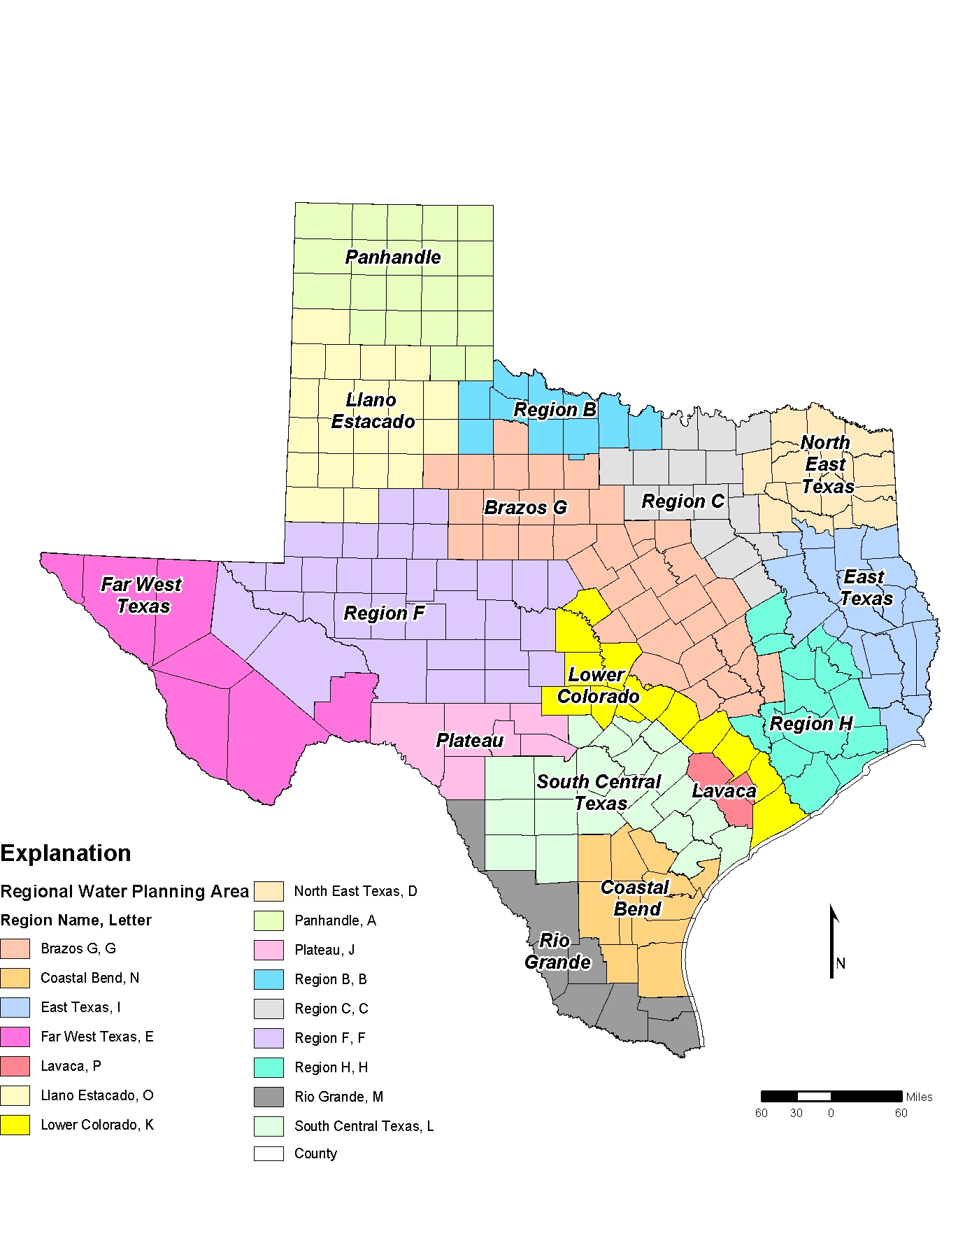
Figure 4-1. Location of the 16 regional water planning areas in Texas.

