6.0 Environmental Planning
Key Finding
The Planning Groups evaluated all new surface water management strategies for their impact on environmental flows.
Senate Bill 1 provided a new direction in water planning with a new set of environmental considerations. One highlight of this process was the provision that required that environmental interests be officially represented on each of the Planning Groups. However, significant involvement and input by environmental interests were not evident until very late in the planning effort.
The Planning Groups considered the environmental impacts of water management strategies with the goal of providing adequate water to maintain instream flows and freshwater inflows to bays and estuaries. One of the Planning Groups (Region H) also included a list of recommended river and stream segments of unique ecological value. The Planning Groups considered environmental impacts in varying detail. Some Planning Groups had comprehensive analyses, whereas others conducted more limited evaluations. The more comprehensive analyses addressed all items on the environmental checklist and described overall ecological impacts on habitats, fish and wildlife, water quality, instream flows, freshwater inflows to bays and estuaries, and cultural resources.

6.1 Environmental Flow Needs and Unique Stream Segments
Environmental issues that challenged Planning Groups the most were determining environmental flow needs for new diversions and reservoirs and recommending ecologically unique river and stream segments.
State and regional water planning requires use of consensus criteria to assess the environmental flow needs of all new water development strategies when site-specific field studies are not available or feasible during regional planning efforts. The criteria were developed through extensive collaboration among scientists and engineers from the State’s natural resource agencies (TWDB, TPWD, and TNRCC), as well as academics, consultants, and informed citizens. The criteria are composed of multistage rules for environmentally safe operation of impoundments and diversions during above-normal streamflow conditions, below-normal conditions, and drought conditions (Figure 6-1). The criteria provide balance by sharing the adverse impacts of drought so that neither human nor environmental needs prevail over the other. However, it should be recognized that State and Federal permitting processes may require different environmental flow constraints based on the results of intensive field studies or other permitting considerations.
There are two distinct methods for determining environmental flow needs: statistical “desk-top” techniques and intensive field studies. The first method is used in water planning, particularly when several alternative water management strategies are being evaluated for meeting a water supply need. This method uses a statistical analysis of existing hydrological records for a potential water development site. The second method involves a field study and modeling assessment of the actual flow needed for environmental maintenance. The second method is generally recognized as more accurate than the statistical method and is generally required during the State and Federal permitting process.
Because many streams in Texas are fully or almost fully appropriated, opportunities are limited for making new water appropriations for the environment or for new water development projects that alone would provide flows sufficient to maintain a healthy ecosystem. In most cases, water rights issued before 1985 for development of water supply projects have no environmental requirements.
The TPWD proposed a list of ecologically unique river and stream segments for each regional water planning area for the Planning Groups to consider when developing their regional water plans. However, the Planning Groups were concerned about the legal implications on future use if a river or stream were designated as ecologically unique. All but one region (Region H) chose not to make any recommendations because there was no clear legal interpretation of what restrictions might be imposed on private landowners, municipalities, or agricultural and industrial interests. The Planning Groups unanimously agreed that the Legislature needed to better define the legal implications and limit any restrictions to the development of new reservoirs in a designated segment. Senate Bill 2 clarifies that a State agency or political subdivision of the State may not finance reservoir construction in a river or stream segment of unique ecological value (Texas Water Code 16.051(f)). This clarification is anticipated to help Planning Groups in their next round of planning.
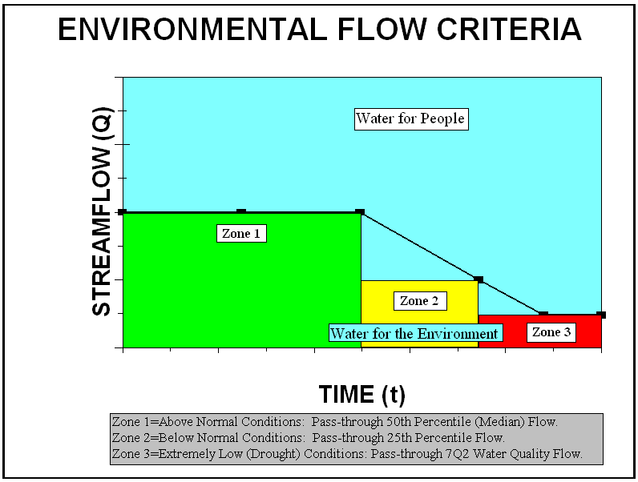
Figure 6-1. Environmental flow criteria for regional and State water planning.

6.2 New Environmental Assessment Tools
TWDB rules responded to Senate Bill 1 by requiring a range of environmental assessments, from environmental flow needs to wildlife habitats and cultural resources. To assist the Planning Groups as they made these assessments, the TWDB developed an environmental checklist of required and optional environmental issues to guide the regional water planning effort (Table 6-1).
Some of the Planning Groups developed new environmental assessment tools to evaluate the impacts of regional water supply projects on environmental and cultural resources. The South Central Texas Region developed a procedure to assess and compare the potential effects of 77 possible water supply options. For each category in the environmental checklist, they developed a protocol to consider regional context, relative value of resources, and the expected probability and magnitude of project-associated impacts. Within each resource category, impact scores for water management strategies were ranked, normalized, and then aggregated over the different categories to produce a total relative-impact score for each of the strategies. The East Texas Region developed a similar assessment tool on the basis of a score of the composite impacts for each strategy. The overall result is a tool that can be implemented, improved upon, and applied to future regional plans throughout the State.

Table 6-1. Environmental checklist.

Required assessments
- Description of Regional Planning Area
- Description of water sources, including major springs
- Description of natural resources
- Identification of water quality problems
- Identification of threats to natural resources
Evaluation of alternative management strategies for effects on
- Instream flows
- Bay and estuary inflows
- Wildlife habitat
- Wetlands
- Threatened and endangered species
- Cultural resources
- Evaluation of impacts of water management strategies on threats to natural resources
- Specific recommendations for water management strategies so that strategies that are environmentally sensitive are considered and pursued
- Use of environmental planning criteria or site-specific environmental information
Conditional considerations
- Recommendations for ecologically unique river and stream segments
- Recommendations that are needed and desirable to protect natural resources

7.0 Identification of Needs
When current water supply is less than projected demand, there is a need. The Planning Groups identified future needs by comparing current supplies with projected demands. Needs were identified for both individual water user groups and major water providers.
Water user groups are cities having populations of 500 or more and an aggregate of demand by county for other sectors, including manufacturing, irrigation, steam-electric power generation, mining, livestock, and county-other. Major water providers are entities that deliver and sell a significant amount of raw or treated water for municipal or manufacturing use on a wholesale or retail basis. Each region selected the quantity considered major for including entities in this category.

7.1 Water User Groups and Major Water Providers with Needs
Key Finding
Total volume of needs increases from about 2.4 million AFY in 2000 to 7.5 million AFY in 2050.
Regionally, 438 water user groups and 18 major water providers had needs in 2000 (Figure 7-1 and Table 7-1, respectively). The number of water user groups nearly doubles by 2050, increasing to 883 (Figure 7-1), and major water providers with needs increases to 31 (Table 7-1). Region C and Brazos G Region identified the most water user groups with needs in 2050, closely followed by Region H and East Texas Region (Figure 7-2). East Texas Region, South Central Texas Region, and Region C identified the most major water providers with needs (Table 7-1).
The volume of needs for water user groups increases at varying rates over the 50-year planning horizon. In 2000, the largest volume of needs for water user groups by region was 652,441 AFY for the Rio Grande Region, followed by 494,873 AFY for the South Central Texas Region. By 2050, the largest volume of needs for water user groups moves to the most populous regions, with 1,203,947 AFY in Region C and 1,375,455 AFY in Region H (Figure 7-3). The volume of needs shown for the South Central Texas Region in this figure may be an underestimate because the final water availability value for the Edwards aquifer has yet to be finalized by the Edwards Aquifer Authority and the U.S. Fish and Wildlife Service. On a Statewide basis, the total volume of needs increases from about 2.437 million AFY in 2000 to 7.512 million AFY in 2050 (Figure 7-4). Throughout the 50-year planning horizon, irrigation and municipal are the categories with the greatest need (Table 7-2).
Not all identified needs were met, either in whole or in part, by the Planning Groups throughout the 50-year planning period. In 2050, 78 counties in Texas had at least one water user group with unmet needs (Figure 7-5).
7.2 Needs by River Basin
Out of the 23 basins, the Nueces and Nueces-Rio Grande Basins had the highest volume of needs for water user groups in 2000 (Table 7-3). The Trinity, Canadian, and San Jacinto Basins have the largest increases in needs between 2000 and 2050. By 2050, the Trinity, Nueces-Rio Grande, and Canadian Basins have the highest volume of needs for water user groups. Only four basins experience declining needs through 2050.

Table 7-1. Number of major water providers with projected needs in regional water planning areas.

Region 2000 2010 2020 2030 2040 2050
A 0 0 0 0 1 1
C 3 5 5 4 4 5
E 2 2 2 3 3 3
G 1 1 2 2 2 2
H 1 1 1 1 1 1
I 6 9 8 8 8 9
K 1 1 1 1 2 2
L 4 6 6 6 6 6
N 0 0 0 0 2 2
Total 18 25 25 25 28 31

Table 7-2. Volume of needs for different water use categories (AFY).

Use 2000 2010 2020 2030 2040 2050
Municipal 310,094 710,612 1,280,291 2,080,184 2,574,946 3,037,646
Manufacturing 69,639 314,129 446,008 850,867 1,008,734 1,178,889
Steam-electric power 21,747 151,589 191,247 264,561 380,211 435,786
Mining 39,239 38,312 41,795 55,668 56,924 61,479
Irrigation 1,993,454 2,119,853 2,013,409 2,514,264 2,688,123 2,756,636
Livestock 2,847 3,956 5,386 14,677 35,174 41,731
Total 2,437,020 3,338,451 3,978,136 5,780,221 6,744,112 7,512,167

Table 7-3. Volume of needs for water user groups in river basins (AFY).

Basin 2000 2010 2020 2030 2040 2050
Canadian 0 1,813 24,492 499,244 648,488 674,297
Red 7,884 9,083 11,198 21,888 98,150 140,043
Sulphur 4,009 6,840 8,599 14,563 15,830 16,709
Cypress 289 10,025 10,105 10,511 11,878 12,218
Sabine 23,051 57,498 84,512 113,879 144,000 198,468
Neches 37,116 143,716 165,062 193,377 217,117 247,723
Neches-Trinity 24,928 380,220 385,553 389,825 398,455 407,278
Trinity 91,862 340,267 600,766 847,496 1,052,349 1,221,249
Trinity-San Jacinto 0 6,755 89,671 111,773 121,295 131,404
San Jacinto 10,912 97,823 234,567 546,578 612,273 664,365
San Jacinto-Brazos 47,122 88,700 117,372 244,111 290,302 346,890
Brazos 233,556 285,794 350,734 428,408 537,411 602,935
Brazos-Colorado 189,308 184,469 178,797 173,018 169,522 168,276
Colorado 200,702 221,148 226,101 259,792 269,833 299,060
Colorado-Lavaca 138,374 132,918 128,791 124,876 121,084 117,450
Lavaca 86,216 82,965 79,196 75,718 72,450 69,443
Lavaca-Guadalupe 148 917 906 1,000 1,117 1,241
Guadalupe 16,913 30,391 40,029 53,721 66,972 88,655
San Antonio 166,722 198,112 239,817 309,418 368,976 413,885
San Antonio-Nueces 96 33 0 0 7,773 18,738
Nueces 324,739 305,723 286,202 322,753 309,026 301,435
Nueces-Rio Grande 574,129 513,268 477,441 478,815 613,884 727,422
Rio Grande 258,944 239,973 238,225 559,457 595,927 642,983
Total 2,437,020 3,338,451 3,978,136 5,780,221 6,744,112 7,512,167
Figure 7-2. Number of water user groups with projected needs in regional water planning areas in 2050.

Figure 7-1. Number of water user groups with projected needs Statewide.
Figure 7-3. Volume of needs in regions in 2050.

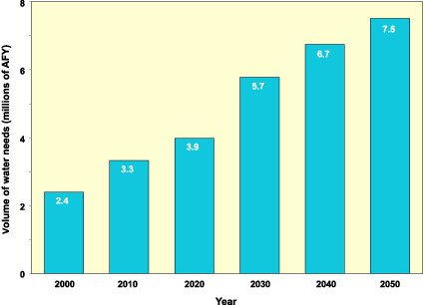
Figure 7-4. Volume of needs Statewide in 2050.

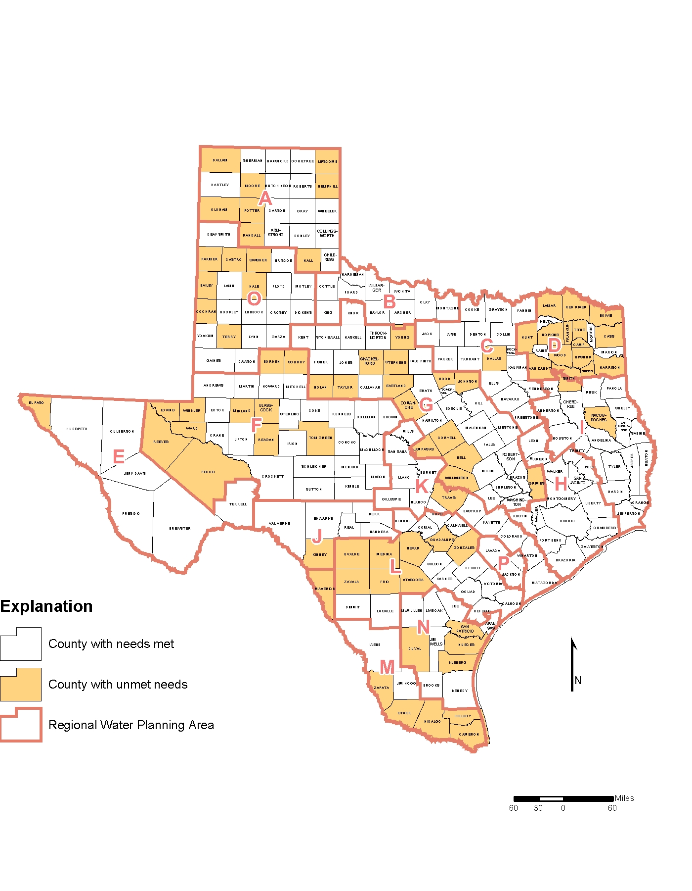Figure 7-5. Counties in Texas with unmet needs in 2050.

8.0 Recommended Water Management Strategies
A water management strategy is a specific plan to increase water supply or maximize existing supply to meet a specific need. For example, if a Planning Group determines that a city has a need for additional water supplies in 2050, the Planning Group identifies, evaluates, and then recommends a strategy or strategies to meet that need. The Planning Groups evaluated and recommended strategies for cities, major water providers, and other water uses, including rural, manufacturing, irrigation, steam-electric power generation, mining, and livestock. Sometimes it was not possible to identify a strategy to meet a need or at least some portion of that need. In these cases, the Planning Groups were required to identify those needs for which no water management strategy was feasible.
This section describes water management strategies recommended by the Planning Groups and also a few alternative strategies suggested for consideration by the TWDB. Recommended water management strategies are presented in two ways: a Statewide summary of strategies is presented in this chapter and a region-by-region summary of strategies adopted by the Planning Groups is included in Chapter 11.0. The region-by-region summaries include (1) information on the location of cities with needs; (2) a comparison of industrial, municipal, and agricultural demand with current supplies and supplies implementing water management strategies; (3) a comparison of water user groups with needs; (4) a comparison of types of water management strategies used to meet needs; and (5) a list of key elements included in the regional water plan. If all of the water management strategies recommended in the regional water plans are implemented, then at least on a volumetric basis, available supplies will be greater than projected demands in 2050 (Figure 8-1).
The Planning Groups evaluated the following water management strategies:
- water conservation,
- demand management,
- reuse of wastewater,
- expanded use of existing supplies (including systems optimization and conjunctive use of resources),
- reallocation of reservoir storage to new uses,
- subordination of existing water rights through voluntary agreements,
- enhancements of yields of existing sources,
- improvement of water quality (including control of naturally occurring chlorides),
- new supply development (including construction and improvement of surface water and groundwater resources),
- brush control,
- precipitation enhancement,
- desalination,
- aquifer storage and recovery,
- interbasin transfers, and
- other strategies.
The Planning Groups evaluated and compared all identified water management strategies on the basis of quantity, reliability, cost of water, and environmental impacts. These evaluations also included factors for calculating infrastructure debt payments, present costs, and discounted present-value costs. During the Planning Groups’ evaluations, effects of strategies on environmental water needs were considered. Impacts on other water resources of the State, including other water management strategies and groundwater/surface water interactions, were also evaluated. In addition, the Planning Groups were required to consider provisions for interbasin transfers, including any social or economic impacts.
After evaluating different strategies, the Planning Groups then chose which strategies to recommend for meeting needs. As much as possible, the Planning Groups chose strategies that satisfied the directives and existing plans of water users in their region. This process implements the concept of Senate Bill 1 to have the water planning process conducted at the local/regional level and to improve local entities’ participation in the implementation of recommended strategies.
Texas Water Code §11.134(b) includes a provision that the TNRCC grant a water rights application only if the proposed appropriation addresses a water supply need in a manner that is consistent with the State Water Plan and an approved regional water plan. Texas Water Code §16.053(j) includes a provision that the TWDB provide financial assistance to political subdivisions only if the proposed project addresses needs in a manner that is consistent with a regional water plan that has been approved by the TWDB. Both the TNRCC and the TWDB may determine that conditions warrant a waiver of these requirements. After the regional water plan is approved by the TWDB and the TWDB has adopted a State Water Plan, the projects included in the recommended water management strategies meet the criteria.
Summaries of the recommended water management strategies are included in the next section. Details of recommended strategies are included in Volume II and in the individual regional water plans included in Volume III.

8.1 Water Conservation
Regional water plans indicate that the current water supply will not be able to meet the demand for water over the next 50 years. The Planning Groups recommended that water conservation be utilized to meet the needs, at least partly, of 205 water user groups. Fifty-nine of these are irrigation water user groups. Thus, about 21 percent of the water user groups with needs recommend conservation as a water management strategy. The total projected savings from these conservation-based water management strategies are approximately 987,914 AFY by 2050. Based on a volumetric comparison, approximately 13.5 percent of the water to meet needs in the regional water plans will result from a variety of water conservation strategies (Figure 8-2).
In addition to the conservation-based water management strategies, the plans project that if conservation practices are improved on a continuing basis, Statewide municipal water demand will decrease by an average of 22 gallons per capita per day (GPCD), from 181 GPCD in 2000 to 159 GPCD in 2050. This 12 percent reduction in municipal demand, due in part to more efficient plumbing fixtures, is equivalent to 976,000 AFY by 2050. When combined, these recommended and required conservation efforts are projected to result in savings of 2.0 million AFY by 2050.
The decline in irrigation water demand from 57 percent of the State’s total demand in 2000 to about 42 percent in 2050 is due to reductions in groundwater supplies, more water-efficient irrigation practices, and the voluntary transfer of surface water rights from agricultural users to municipal users. The Planning Groups recommended changing of crop varieties and types, utilizing genetic engineering, voluntarily converting irrigated acreage to dry-land production, utilizing conservation tillage methods, installing efficient irrigation equipment, and lining of irrigation canals to ensure efficiency of delivery systems for meeting future irrigation demands. Additional conservation techniques include laser leveling of fields and automated water delivery control systems.
Awareness and understanding of water conservation and water use efficiency have grown since the 1997 State Water Plan because drought conditions have impacted most regions of the State. So-called water-rich regions often could not meet demands because of rapid growth, and arid regions were pushed to extreme limits with hot, dry weather. This awareness can be a starting point in helping to meet future water demands in Texas.
Per capita demand projections vary greatly around the State. Although most regions of the State project a decrease in per capita use, some areas project an increase. Water demand can change because of population growth and changes in the socioeconomic characteristics of a community. Although water demand may increase, ensuring that water is being used as efficiently as possible is still prudent. Many communities around the State have taken great strides in ensuring wise water use and have found conservation programs to be a cost-effective method of meeting increased water demands while postponing expensive supply or capacity expansion. Austin, Corpus Christi, El Paso, Houston, and San Antonio all have active conservation programs that promote water use efficiency. Each of these cities has used water conservation for different reasons: Austin wants to lower demand to meet a growing customer base; Corpus Christi wants to postpone the need for additional supply; El Paso has a limited long-term supply; Houston needs to reduce its use of groundwater to reduce subsidence; and San Antonio has limited water availability, especially during drought conditions.
Water conservation is not limited to the larger cities. Many small and medium-size systems are committed to increasing water use efficiency. Programs such as bill explanation, plant tours, school programs, and working with local Cooperative Extension offices in educational and outreach activities have proven beneficial. Many smaller systems have partnered with neighboring water systems in public-awareness campaigns to increase exposure, limit confusion, and reduce costs by providing a unified conservation message.
Strategies identified for reaching levels of conservation needed to meet water demand in the 2002 State Water Plan include aggressive plumbing fixture replacement programs and water-efficient landscaping codes.

8.2 Groundwater
Groundwater management strategies recommended by the Planning Groups would result in an additional 779,000 AFY of water supply in 2050.
- The most common groundwater management strategy was installing new wells. These new wells would produce about 631,000 AFY by 2050.
- Regional plans recommended strategies for additional pumping of existing wells, which would produce approximately 122,000 AFY of additional supply.
- The Lower Colorado and South Central Texas Regions recommended artificial recharge strategies that would result in 26,000 AFY in 2050.
- Two Planning Groups proposed groundwater transfers (long distance transfers through pipelines) that would result in transfers of 173,000 AFY by 2050. This volume is included in other items in this list.

8.3 Surface Water
Surface water management strategies would result in approximately 4.8 million AFY of additional water supply in 2050. Some strategies may be included in more than one item in this list.
- Expanded use or acquisition of existing supplies, including systems optimization, and conjunctive use of surface water and groundwater, was recommended in 8 regions and will provide an additional 390,000 AFY of water supply.
- Five regions used reallocation of reservoir storage for new uses for an additional water supply of 107,000 AFY.
- 2,456,000 acre-feet of surface water supply comes from voluntary redistribution of existing water resources, including water marketing, sales, leases, and options in 12 regions.
- Two regions will utilize 151,000 acre-feet of water supply by enhancing yields of existing sources.
- Four regions recommended major interbasin transfer as water management strategy that will generate additional surface water supplies of 2,444,000 AFY by 2050.
- Seven regions included major reservoir development in their surface water management strategies that increase firm yield by approximately 1,116,000AFY. Eight reservoirs having greater than 5,000 acre-feet of storage capacity are recommended as water management strategies to meet needs (Figure 8-3):
- Prairie Creek and Marvin Nichols I Reservoirs in the North East Texas Region,
- Lower Bois d’Arc Reservoir in Region C,
- Little River Reservoir in Brazos G Region,
- Allens Creek Reservoir and Bedias Reservoir in Region H,
- Brownsville Weir and Channel Dam in the Rio Grande Region, and
- Lake Eastex in the East Texas Region.
In addition, 10 reservoirs having less than 5,000 acre-feet of storage capacity are recommended as water management strategies to meet needs (Figure 8-3):
- Muenster Reservoir in Region C;
- New Throckmorton Reservoir, Meridian Off-Channel Reservoir, Groesbeck Off-Channel Reservoir, Somervell County Off-Channel Storage Reservoir, and Brushy Creek Reservoir in the Brazos G Region; and
- Llano Off-Channel Reservoir, Goldthwaite On-Channel Dam, Goldthwaite Off-Channel Dam, and Mills County Reservoir in the Lower Colorado Region.
The total capital costs for the 8 major and 10 minor reservoirs is estimated at approximately $3.05 billion.

8.4 Reuse
Reuse of wastewater was recommended as a water management strategy in 10 regions. These recommended strategies would result in 423,268 AFY of additional water supplies by 2050. This estimate compares with current (1999) reuse estimates from 190 utilities located in 115 counties reporting approximately 180,000 AFY of municipal reuse.

8.5 Desalination
Desalination was recommended as a water management strategy in four regions. In the Far West Texas Region and Coastal Bend Region, desalination of brackish groundwater was used as a strategy to provide 66,954 AFY in additional supplies. The desalination of coastal waters was recommended by the South Central Texas Region as a water management strategy to provide an additional 84,012 AFY. Region B included desalination in two recommended water management strategies for a total of 28,808 AFY. Currently in Texas, municipal desalination capacity is 25,750 AFY.

8.6 Brush Control
Brush control was utilized as a recommended strategy in only two regions (Brazos G Region and South Central Texas Region). Because this is a water management strategy that cannot be relied upon to produce reliable water supply during drought conditions, no capital costs or estimates of additional water supply were included in the regional water plans.

8.7 Major Conveyances
In order to deliver water supplies to the areas of need identified and addressed in the regional water plans, several new water conveyance systems will need to be constructed. Although precise determination of conveyance routes is beyond the level of detail required for regional water planning, the general location of the recommended conveyance structures illustrates that most of the water supplies will be conveyed to the larger urban areas of the State (Table 8-1, Figure 8-4).

Figure 8-1. Statewide comparison of demands versus supplies with and without implementation of the regional water plans.

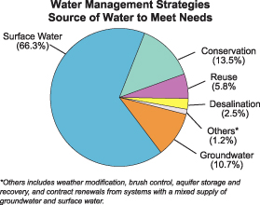

Figure 8-2. Volumetric comparison of the various sources of water utilized by recommended water management strategies to meet needs in the regional water plans.

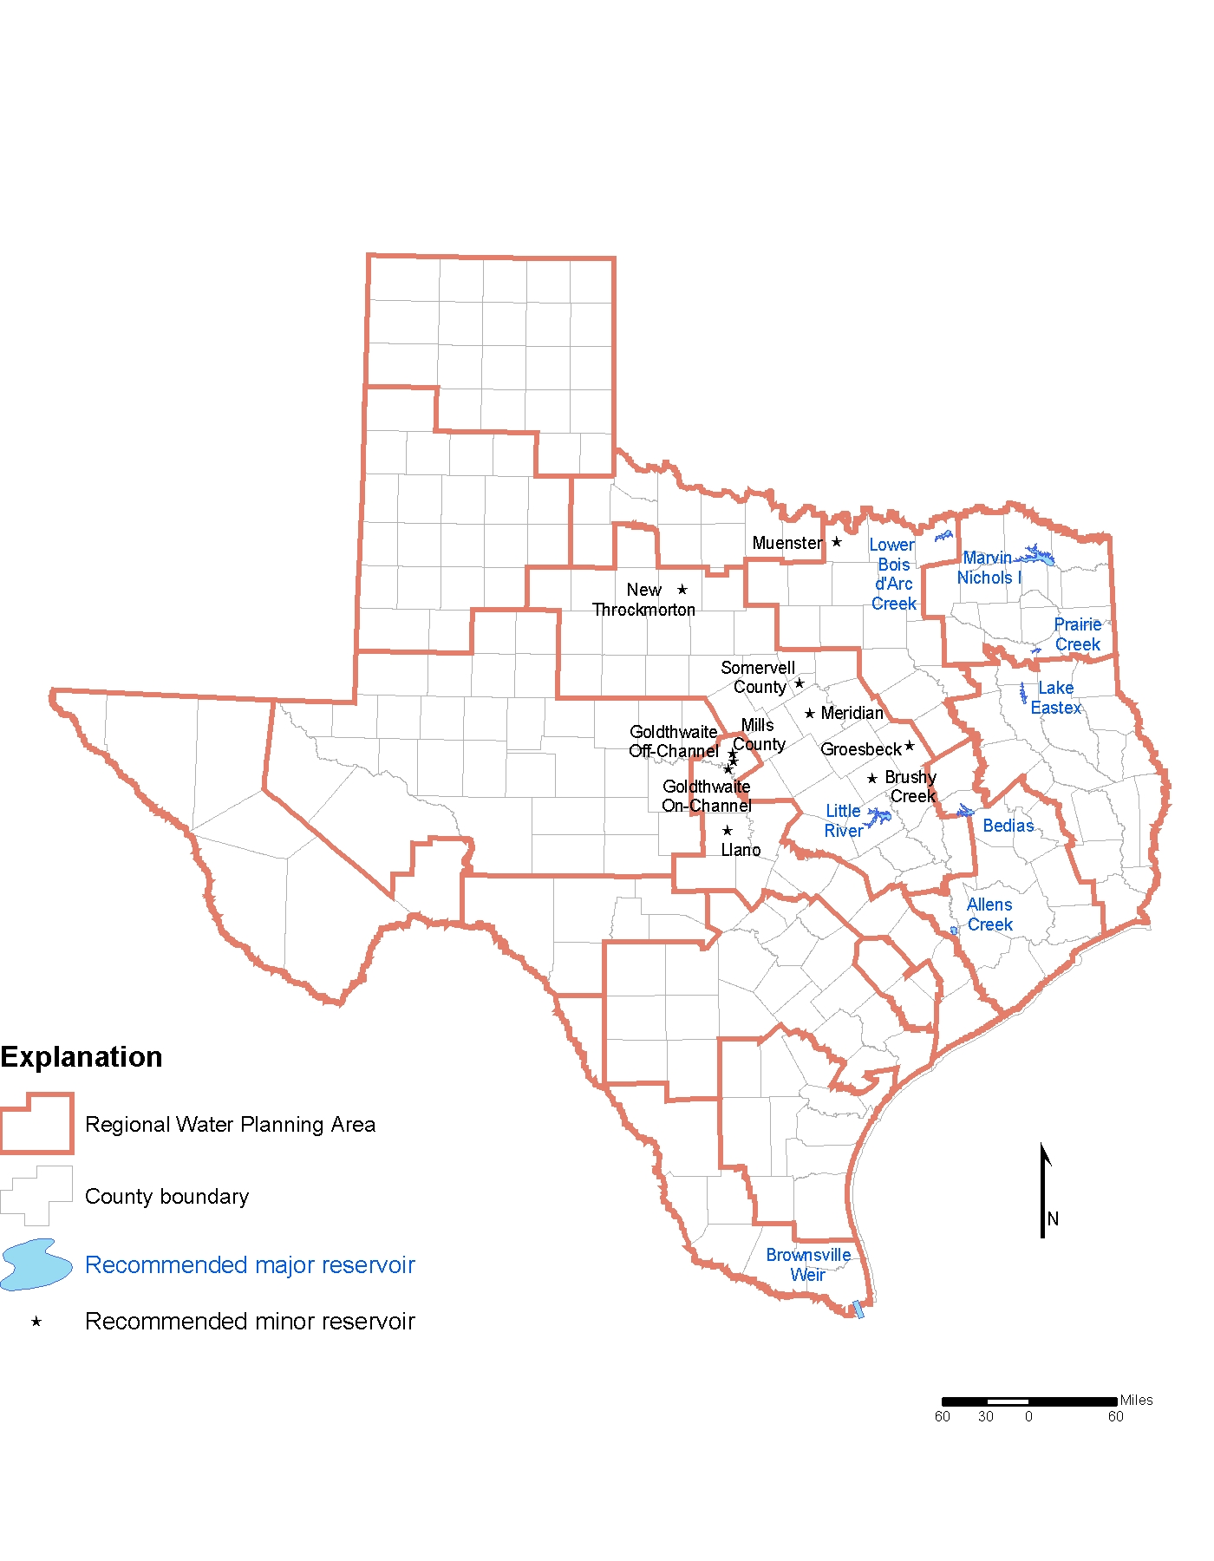
Figure 8-3. Major and minor reservoirs recommended in the regional water plans to meet needs.
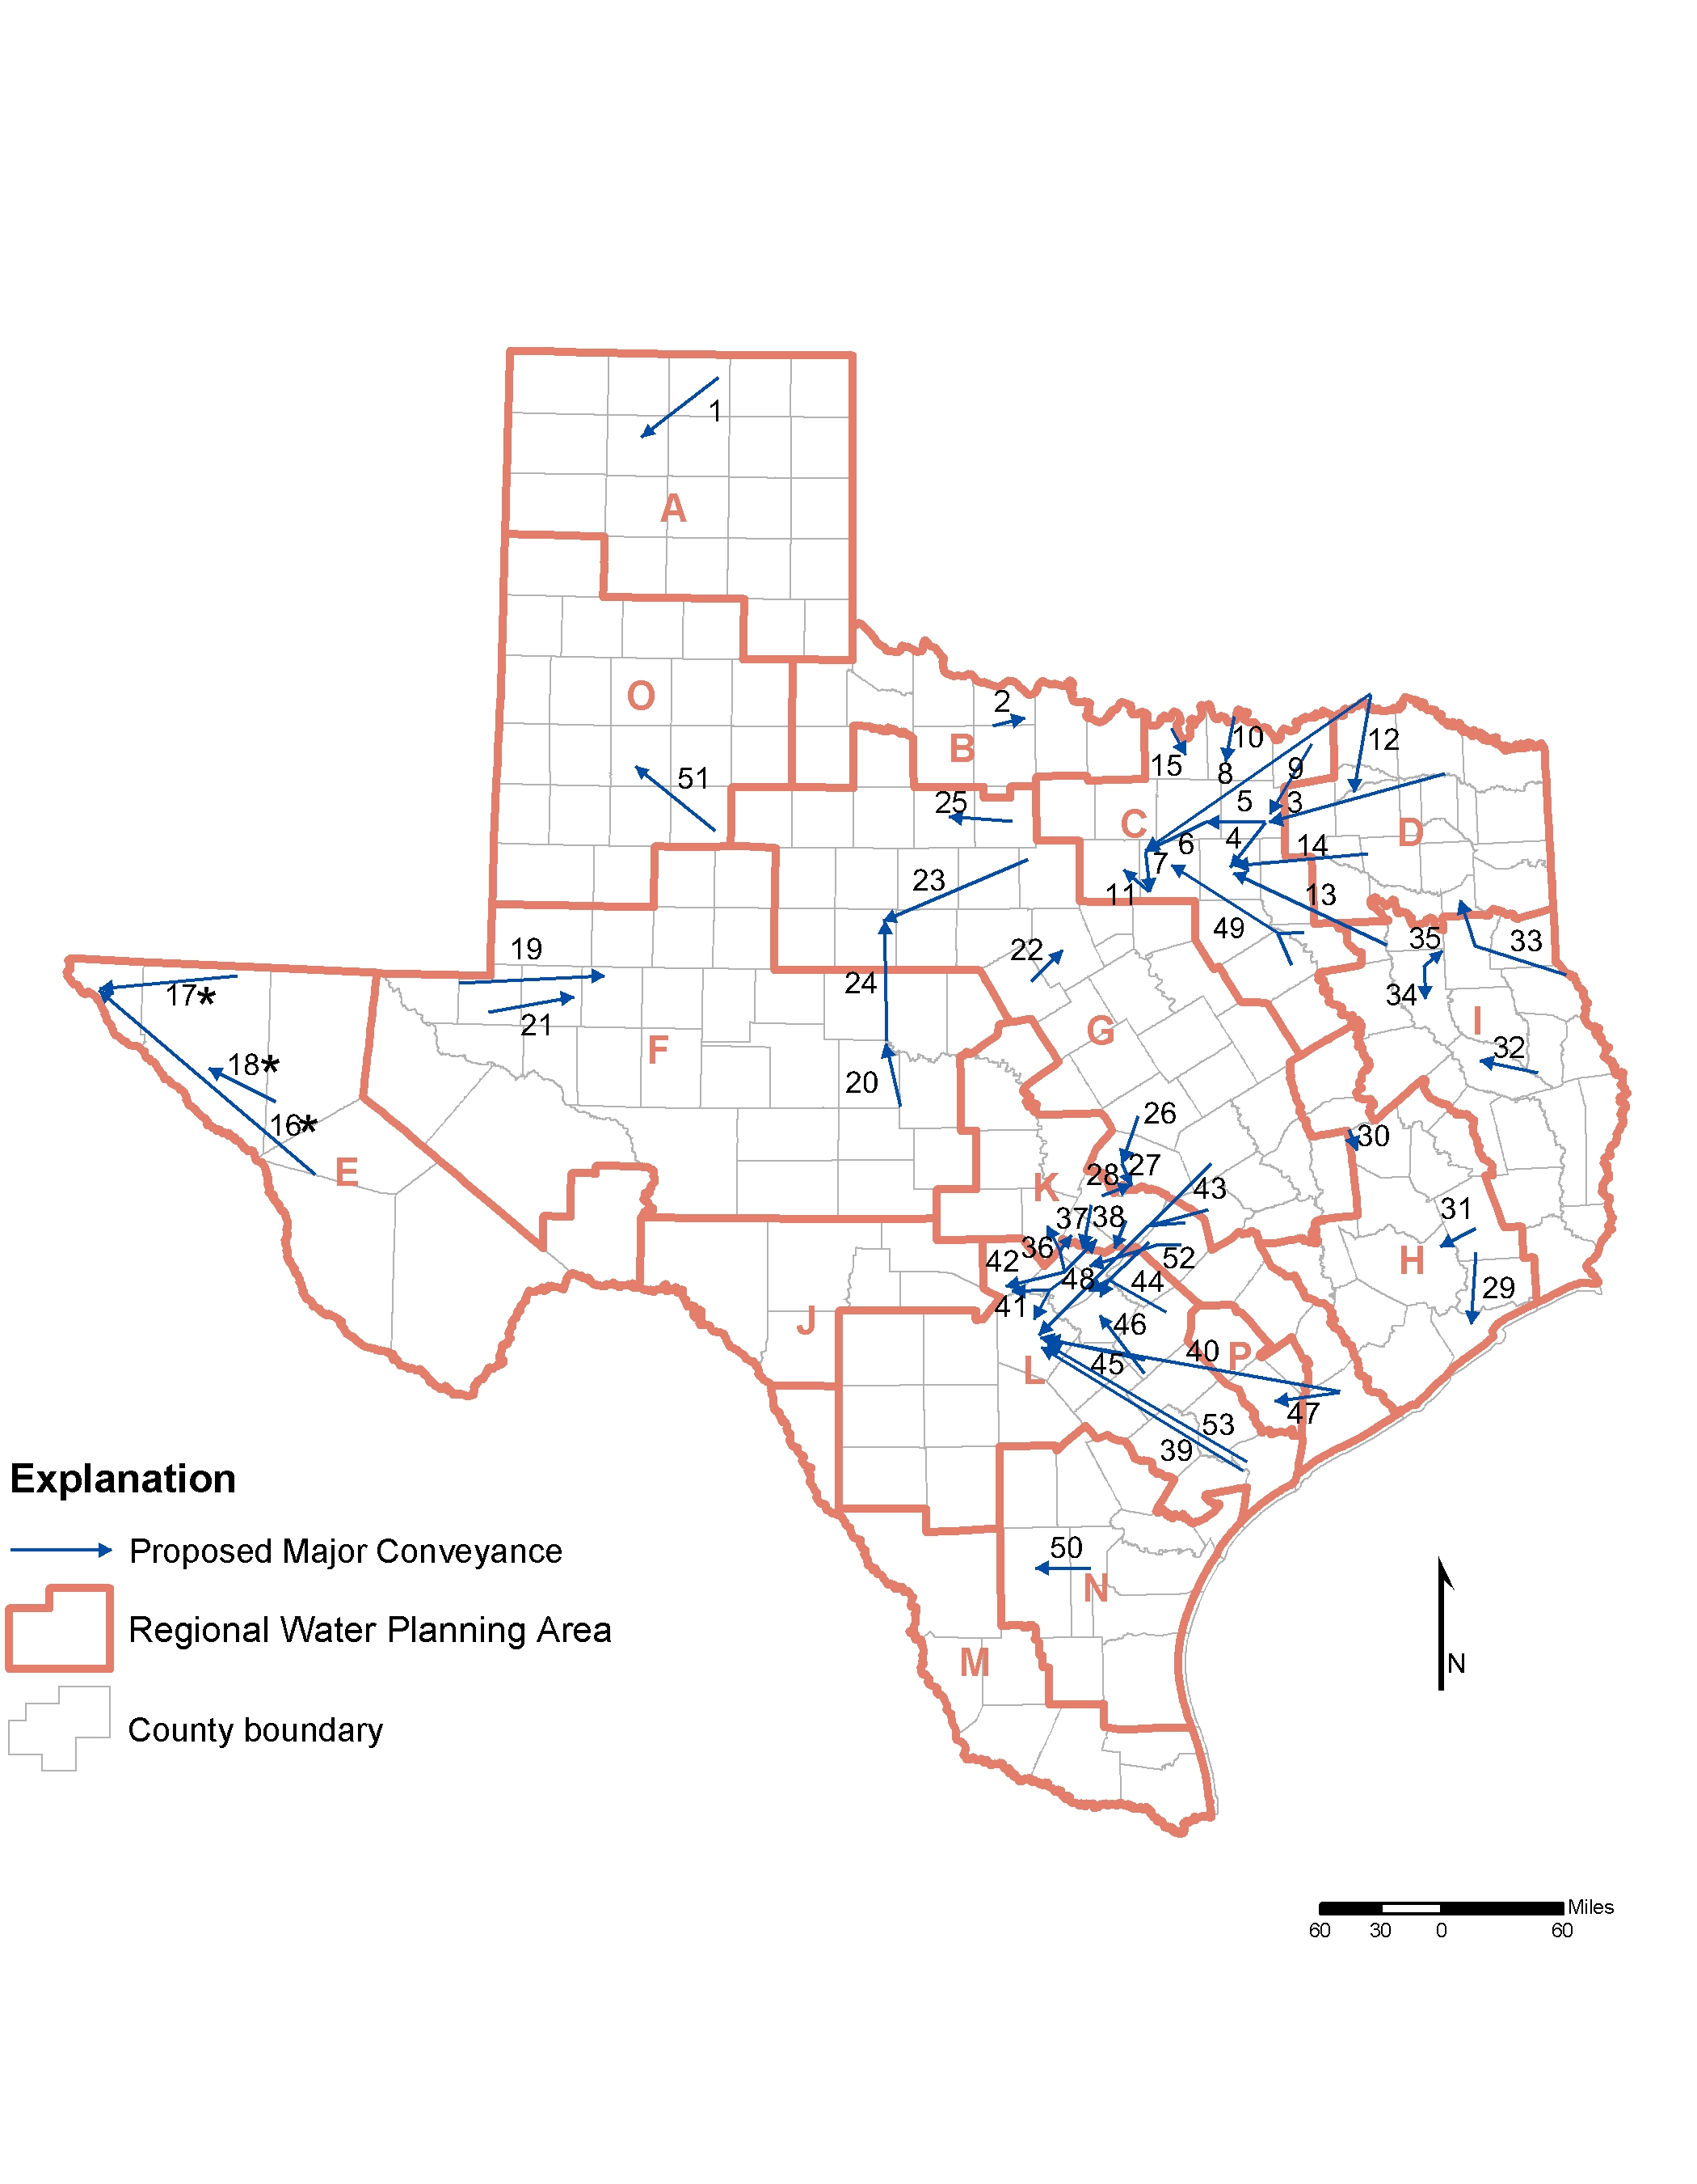
Figure 8-4. Major water conveyances proposed by Planning Groups.
Table 8-1. Major water conveyances proposed by Planning Groups.
ID Conveyance from To
1 Palo Duro Reservoir Hansford, Hutchinson, and Moore Counties
2 Lake Diversion Wichita Falls
3 Marvin Nichols I Lavon Lake
4 Lavon Lake Dallas County
5 Lavon Lake Lewisville Lake
6 Lewisville Lake Eagle Mountain Lake
7 Eagle Mountain Lake Benbrook Lake
8 Oklahoma Eagle Mountain Lake
9 Lower Bois d’Arc Reservoir North Texas Municipal Water District
10 Lake Texoma Grayson County Centroid
11 Benbrook Lake Weatherford
12 Oklahoma Chapman Lake
13 Lake Palestine Dallas Water Utilities
14 Lake Fork Reservoir Dallas Water Utilities
15 Moss Lake Gainesville
16* Jeff Davis and Presidio Counties El Paso County
17* Hudspeth County El Paso
18* Culberson County Hudspeth County
19 Winkler County Midland
20 McCulloch County O.H. Ivie Reservoir
21 Winkler County Colorado River Municipal Water District
22 Proctor Lake Stephenville
23 Possum Kingdom Lake Abilene
24 O.H. Ivie Reservoir Abilene
25 Lake Graham Throckmorton
26 Stillhouse Hollow Lake Lake Georgetown
27 Lake Georgetown Round Rock
28 Lake Travis Round Rock
29 Houston Gulf Coast Water Authority
30 Bedias Reservoir San Jacinto River Authority
31 Luce Bayou: Trinity River Lake Houston
32 Sam Rayburn Reservoir Lufkin
33 Toledo Bend Reservoir Rusk and Gregg Counties
34 Lake Eastex Reservoir Cherokee County
35 Lake Eastex Smith and Rusk Counties
36 Canyon Lake Blanco, Wimberley, and Woodcreek
37 Lake Travis Hays County
38 City of Austin Hays County
39 Lower Guadalupe River Bexar County
40 Lower Colorado River (Matagorda County) Bexar County
41 Canyon Lake Bexar and Comal Counties
42 Canyon Lake Kendall County
43 Milam, Lee, and Bastrop Counties Bexar County
44 Bastrop and Gonzales Counties Comal and Guadalupe Counties
45 Gonzales and Wilson Counties Bexar County
46 Gonzales County Seguin and Schertz
47 Colorado River Lake Texana
48 Canyon Lake Hays County
49 Cedar Creek/Richland-Chambers System Tarrant Regional Water District
50 City of Alice Duval County
51 Lake Alan Henry Lubbock
52 Lower Colorado River (Bastrop County) Hays County
53 San Antonio Bay (Calhoun County) Bexar County

* The Far West Texas Planning Group approved these strategies on the condition that they be studied further before they are fully implemented.

