Rainwater Harvesting Web Quest
Created by: Cameron Turner and Linda Ruiz McCall
Conservation Division of the Texas Water Development Board

Background
A web quest is an internet-based learning activity. This web quest is targeted at individuals who are interested in learning about rainwater harvesting in Texas. By exploring the Texas Water Development Board’s (TWDB) Innovative Water Technologies frequently asked questions webpage and The Texas Manual on Rainwater Harvesting, you will gain an understanding of the history, benefits, and components of a rainwater harvesting system and learn how to start building your own system.

Instructions
For help with the answers you can follow the link to the frequently asked questions page about rainwater harvesting at
http://www.twdb.state.tx.us/iwt/rainwater/faq.html

When and where did rainwater harvesting originate?
Rainwater harvesting is an ancient technique enjoying a revival in popularity due to the inherent quality of rainwater and interest in reducing consumption of treated water. It could also be the only source of water available.
Archeological evidence attests to the capture of rainwater as far back as 4,000 years ago. Ruins of structures built as early as 2,000 B.C. to store runoff are still standing in Israel. Rainwater harvesting was being practiced 6,000 years ago in China. Nearly 10,000 years ago however, natural rainwater catchment systems were being used in Texas near present-day El Paso by whom?
(Hint: Look at FAQ #20.)

What do you need?
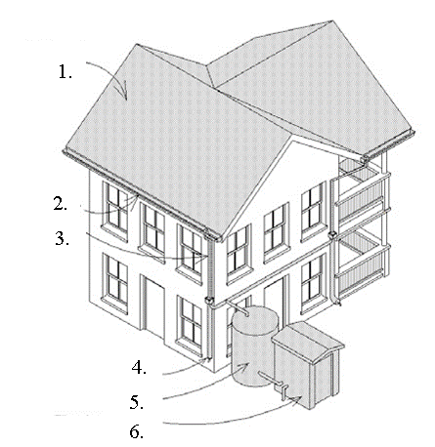The basic components of a
rainwater harvesting system are:

1.
2.
3.
4.
5.
6.

(Hint: See chapter 2, page 5 of The Texas Manual on Rainwater Harvesting. http://www.twdb.state.tx.us/publications/reports/RainwaterHarvestingManual_3rdedition.pdf)

What are the benefits?

Rainwater is practically free, the only cost is to and .
Because the end use is located close to the source, the need for costly systems can be eliminated.
Rainwater is free of sodium. It is superior for landscape use, plants naturally thrive on it. Rainwater harvesting helps utilities peak demands during summer months. By harvesting rainwater, homeowners can reduce their . (Hint: See FAQ # 16.)
There is potential for Texas to use rainwater as an alternative supply source. Two billion gallons of water could be generated annually, if only 10 percent of the roof area in the Dallas metroplex were used to harvest rainwater. If only 1 percent of the total roof area in the state were utilized to harvest rainwater, approximately, 11,650 acre-feet per year of additional water could be generated. An acre-foot is the amount of water it would take to cover an acre of land with one foot of water; it is equal to 325,851 gallons. (Rainwater Harvesting Potential and Guidelines for Texas, http://www.twdb.state.tx.us/iwt/rainwater/docs/RainwaterCommitteeFinalReport.pdf page 9.)

What does a typical system cost?
Using existing gutters and downspouts, a simple rainwater harvesting system can be constructed by adding a rain barrel for $50 or less. Many city water departments have these available at discounted rates. For a typical home, a complete rainwater harvesting system generally costs between $8,000 and $10,000. The is usually the biggest cost, but depends upon the size and construction material, often fiberglass or steel. Other components such as gutters, downspouts, and pumps add costs to the system. This is especially true if the intended use is to collect water for drinking; then cost for must be added to the total cost.
Tax breaks and rebates are available in some areas of the state. Check with your local authorities, such as your county district, for potential county property tax exemptions. Thanks to Senate Bill 2, passed in 2001, rainwater harvesting systems are also exempt from . (Hint: FAQs # 7 & # 8.)

How much could you collect?
The amount of rainwater you can collect varies with the area of your collection surface and with the amount of rainfall you receive in your area. Rainfall totals vary across the State of Texas. The map below shows the annual average rainfall totals in inches. Red represents the least amount of annual rainfall averaging around 10 inches in El Paso; the dark blue represents 60 inches in the Beaumont area.
With an assumed 85% system efficiency, the collectible volume of runoff is about 0.62 gallons per square foot of roof for every inch of rainfall. If you had a 2,000 square foot home in Austin where annual rainfall is about 32 inches, approximately how many gallons could you collect?
(Hint: Multiply collection rate, efficiency, square footage, and rainfall. See FAQ # 5)

gallons
By obtaining your average annual rainfall from the following map and using this same formula, you can estimate how much rainwater you could harvest from the actual square footage of your roof.
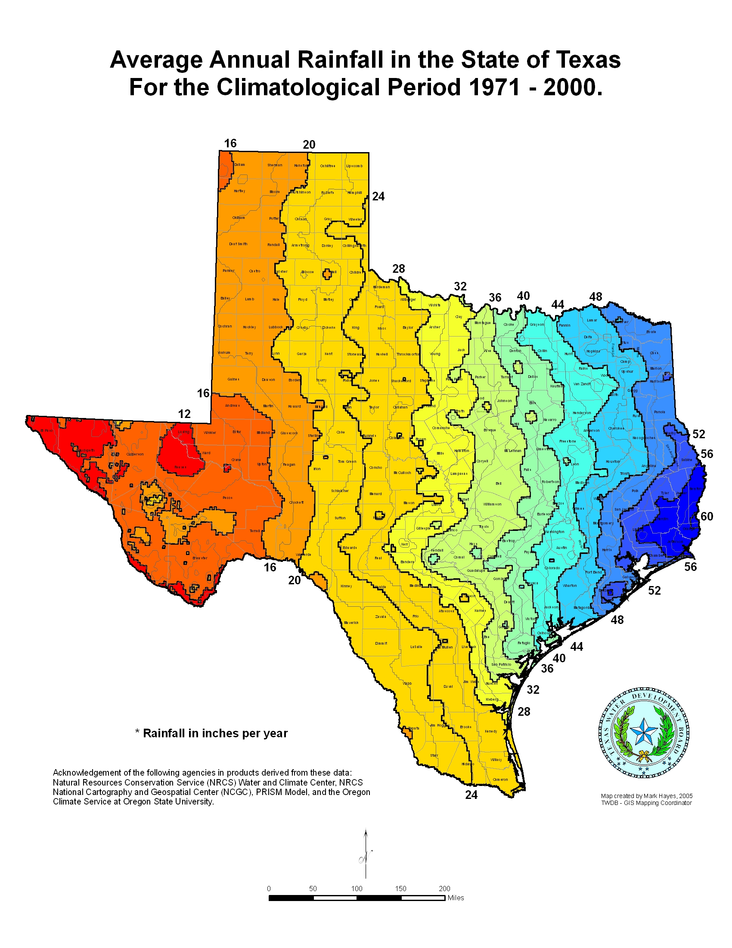

Who is leading by example?

In October 2007, TWDB announced the Texas Rain Catcher Award. The winners of this award have demonstrated the potential of rainwater harvesting as an alternative source of water supply. The many varied applications of this technology can be seen in each of the previous winners systems. We look forward to seeing your application. Follow this link to find out more about this award. http://www.twdb.state.tx.us/iwt/rainwater/raincatcher/
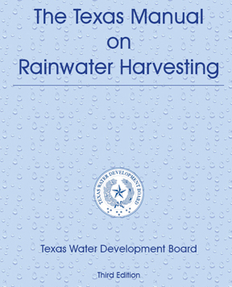
Where can I get more information?

The TWDB has a manual which presents the basics of residential or small-scale commercial rainwater harvesting systems design. This is available on-line and is intended to be the first step in considering your options for building your own rainwater harvesting system.

What other resources are available?

http://www.twdb.state.tx.us/iwt/rainwater/links.asp
http://www.tceq.state.tx.us/permitting/water_supply/rainwater/
http://rainwaterharvesting.tamu.edu/index.html
http://www.ci.austin.tx.us/watercon/rbfaq.htm
http://rainwater.sustainablesources.com/
http://rainwaterharvesting.org/
http://www.watercache.com/
http://www.rainharvest.com/
http://www.texrca.org/
http://www.arcsa.org/

The Texas Water Development Board’s (TWDB) mission is to provide leadership, planning, financial assistance, information, and education for the conservation and responsible development of water for Texas.

